Python 3 Fundamentals
https://www.python.org/downloads/
python –version

python3 –version

In this video, we're going to show how to install Python and Visual Studio Code.
Before we start installing Python,
we should check if we have Python already installed.
On Windows, open a command prompt from the Start menu under Windows System.
Then, enter python --version, and you'll see either a version number,
like Python 3.11, or you'll see Python was not found,
which is what we see, meaning it's not installed.
If you're on a Mac,
open the terminal from your Applications menu and type python --version.
You should see that Python 2 is already installed by default on most Macs,
but we definitely want Python 3 and latest and greatest version.
So now type in python 3 --version.
If you have Python 3 installed,
you will see a version printed out like I do here.
If you don't have Python 3 installed, you'll see command not found.
I can demonstrate that by putting in a typo as pythonz --version,
and that's what it would look like if you didn't have Python 3 installed.
Since I already have Python 3.11 installed,
and that's the latest and greatest, I don't need to install it.
But if you did need it or wanted to install a later version,
open a web browser and go to python.org/downloads.
There will be a big Download button that detects your operating system so
it has the latest Python version for Windows or Mac.
Click on that button to start the download.
Then, you would run the installer and click through the default options.
Let's hop back over to my Windows computer to actually go through the installer.
Again,
we'll go to python.org/downloads and click on the big
button for the Windows Installer, then run the download.
On Windows,
I always make sure to click Add python.exe to PATH so you
don't have to edit your path variable later.
After it's done installing, reopen your terminal or command prompt,
and if you're on Windows, type python --version again to check it installed,
and then type python and press Enter.
This will open the Python interactive shell.
You can tell the Python interactive shell is open
because it shows those three carets.
Now we can start typing in Python code like some mathematical calculations.
On a Mac, in the terminal,
you can also start the Python interactive shell by
typing python3 and pressing Enter.
And then you can start typing in Python code.
At this point, we could start writing Python programs in a simple text editor,
but instead, we're going to use Visual Studio Code,
which will let you grow into bigger applications.
To install that, go to code.visualstudio.com,
and you should see another big Download button.
The steps are the same on Windows or Mac,
and we're just going to choose the default installation option.
Once it's installed, open it up from the Applications menu or the Start menu.
Usually,
we'll want to create a project folder or a folder where
we want to store our Python programs.
So click Open Folder,
then I'm going to create a PythonCourse folder on the desktop.
But you can create it wherever makes sense for you.
Then I'll close this welcome file and we can see the
project explorer window for our project,
which usually shows all of the programs or directories for your project.
Ours is currently empty because we don't have any files created yet,
but we can create a new one now called hello.py by pressing the New
File button next to the Python course heading.
Before we write any Python code, we want to customize VS Code for Python.
First, we'll go to the extensions view by selecting the squares icon,
then you can see which ones you have installed and search.
We'll search for python. And we want to install the first
Python extension that comes up by Microsoft.
I already have it installed, but otherwise,
I would click the green button next to it to install it.
Then we want to tell VS Code how to run our Python programs by
selecting which Python interpreter we want to use.
So go to View, Command Pallete, and search Python: Select Interpreter.
We want our newly installed Python 3.11,
so we'll select that, and you can see it was already selected by default,
but you may have many different Python versions installed,
so this is how you can select which one you want.
Now we can run our Python hello.py program by clicking
on the Play button in the top right.
But first, let's write some Python code.
I'm going to add a print statement with "Hello World" in quotes inside of it.
After we click the run button,
we can see Hello World was printed and it's working.
We can also type python hello.py to run our program from the terminal directly,
but we actually have to restart Visual Studio Code to get that to work.
And if we try again, we see Hello World printed again.
Or just run your scripts with the run button.
I just wanted to show you that the terminal works just like a regular terminal. Now we're ready to start programming in Python.
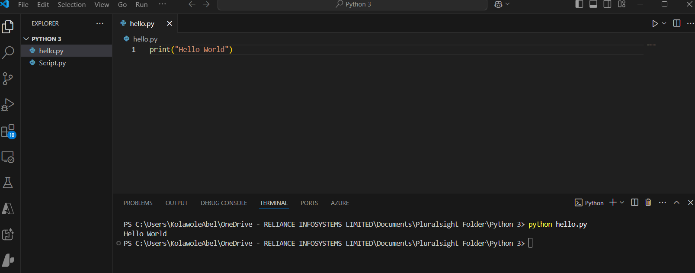
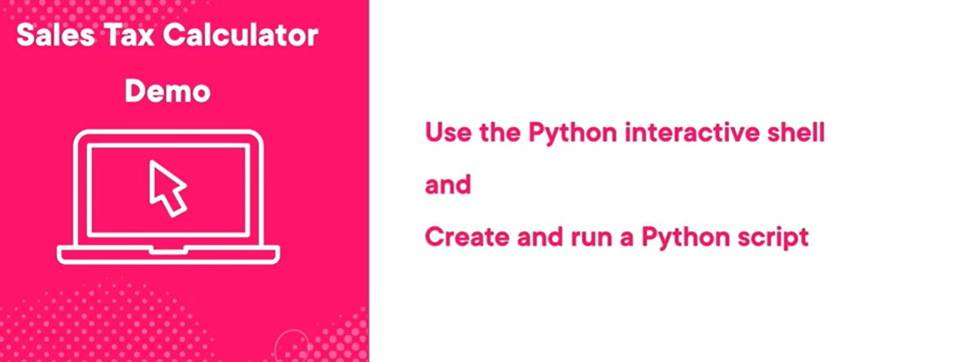
Now that you have Python and Visual Studio Code installed,
follow along with me as I create a sales tax calculator program.
Let's open a terminal and enter python3 if you're on a
Mac to start the interactive shell.
If you're on Windows, open a command prompt and enter python.
Now let's enter in two variables, amount = 10,
and press Enter, that will be the purchase amount, and then type tax = 0.06,
and press Enter.
That will be our sales tax as 6%.
Now we can use those variables to calculate the total.
On the next line, let's enter total = amount + amount*tax, and press Enter.
Then we can type just total into the shell and press Enter to see its value,
which is 10.6, or $10.60.
Great!
We created a little tax calculator program.
The nice thing about the interactive shell is that we could
easily test out a few lines of Python code.
But the bad thing is if we want to try new values for amount or tax,
we have to type out the whole thing again.
For example, let's assign a new value to amount.
We'll do amount = 100.
We'll leave tax alone, it can stay as 6%,
which is still in memory, but then to calculate the total again,
we need to enter total = amount + amount*tax again.
Then to see what the new total is, let's enter total, and we see it is $106.
The way we can save programs like this so that we can reuse
them is to create a Python script like we just saw when we
installed Visual Studio Code.
So let's open VS Code and open the PythonCourse folder we just
created, or whatever folder you want to use.
Then we'll create a new file with this button here and name it tax.py.
A file with the .py extension is either called a Python
program, or a Python script is also fine.
Then we can copy and paste the lines of code we entered into the shell before.
And if we run this with the Play button,
we can see we actually don't get any output.
That's because we can't just type the value we want like in the shell,
we have to use the print function to see a result.
So instead of just total, we type print,
followed by parentheses, and then put the total variable inside the parentheses.
Now if we run this, we can see $106 printed to the screen.
Great!
Now we have our working Python program saved to a file,
and we can easily change the values if we want.
Let's change amount to 200 and sales tax to 7%, and we can run it again easily.
From now on,
we'll write our programs in Python scripts instead of using the shell,
but it's nice to know it's there if you ever need it to experiment.
In the next video, let's take a closer look at the print function and how to use text in Python.

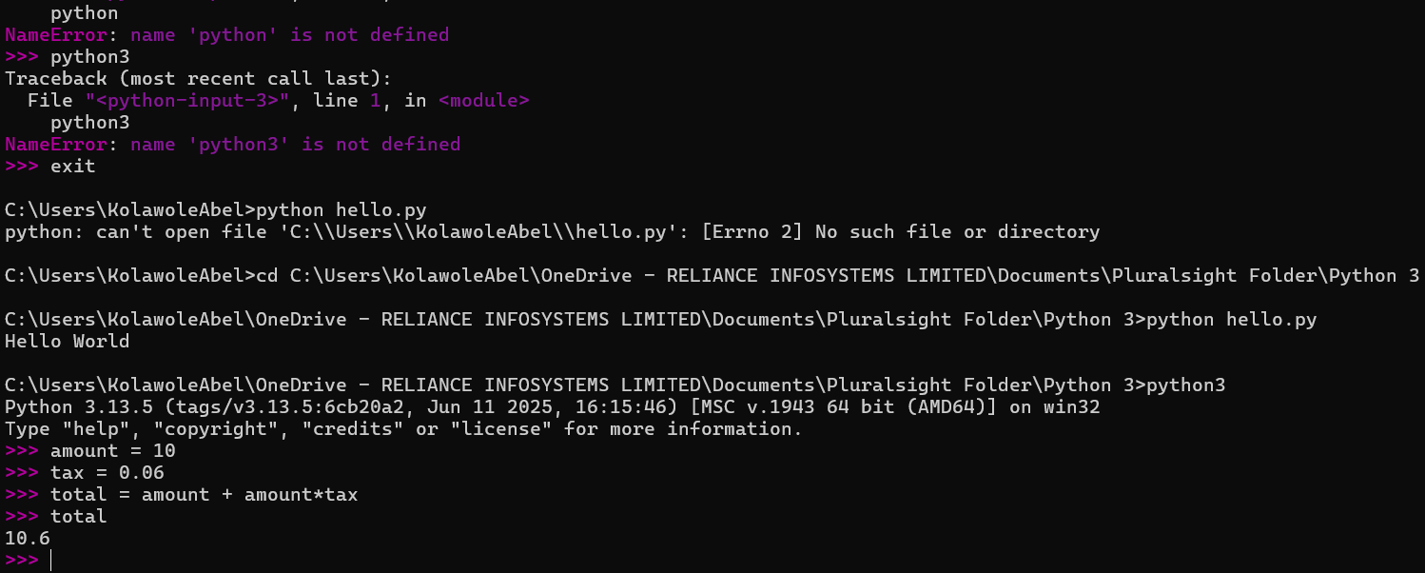
Go to your VS code
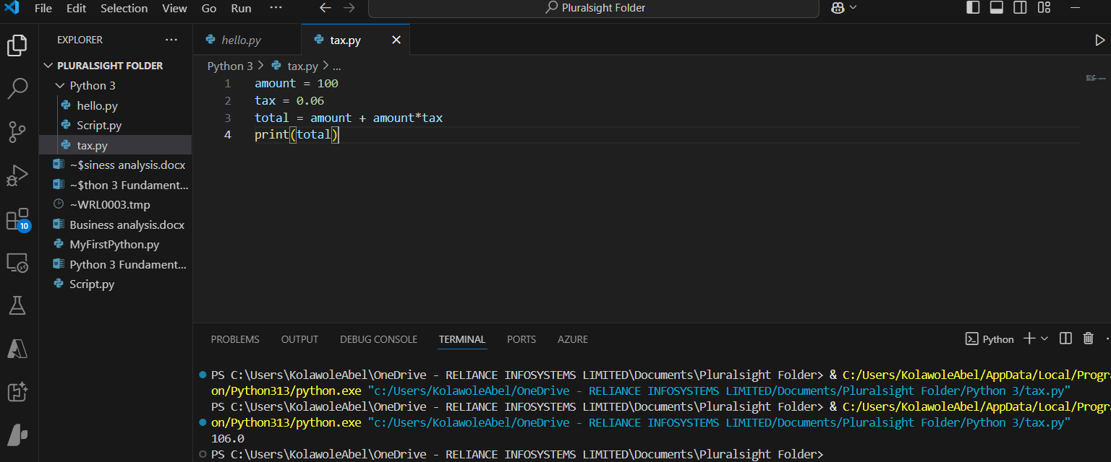

STRING AND INPUT AND OUTPUT
As we saw in the previous demo,
we can call the print function to output values to the screen.
If we run the sales tax program we just created,
we'll see 10.6 is printed, which means $10.60.
Print is a built-in function in Python. We use it by typing
print and then the value we want to print,
which
is called the argument, in parentheses.
You can think of this function as a black box machine.
We don't know how it works, but we do know when it's called with an argument,
it will output the given value to the screen.
What if we need to convert a float to an integer?
We can wrap it in a call to the int function, which will try and convert
10.6 here to an integer by chopping off the decimal part.
And if we print the result, we're left with the whole number 10.
And if we want to force an integer to be a float,
we can wrap the number in a call to the float function,
which will try and convert 10 to a decimal.
And if we print the result again, we have the decimal 10.0.
Now that we've looked at numbers, what data type does Python use for text?
Anything inside of double or single quotes is
called text and is called a string.
Here the string Sarah is saved to the variable name, and if we print it,
we can see it prints without the quotes since the quotes are only used
to tell Python that anything inside them is a string.
Since we can use single or double quotes to create a string, here
we're creating a string using double quotes for a store name. Using
double quotes here makes sense since Sarah's Store has a single quote
inside of it for the apostrophe.
If we instead had used single quotes to create the string, that would
cause an error because the second single quote,
which is the apostrophe, would end the string, and then Python wouldn't know
what to do with the rest of the letters of the string.
What if we want to concatenate or put two strings together? We
can join two strings with the plus operator.
If we have the string hello and the string name,
we can concatenate them by using the plus operator and
saving them to the variable greeting.
If we then print greeting, we see.
HelloSarah.
It looks a little funny because the two strings are smooshed
together, and they need a space between them.
Let's add that now. We can fix this by concatenating a space character
inside the greeting as well using the plus symbol. This looks just like
if we were adding multiple numbers together.
If we run this, we can see the space is added.
How could we customize this program to work with other names? Let's ask
the user to input their own name. Just like print, input is a built-in
function in Python. We use it by typing input and then a string, which is
a message to prompt the user for input.
Here we're asking, What's your name?
When we run this line of code,
the message What's your name gets printed to the screen, and then the program
waits for the user to input something and press Enter. I entered Alice, so that
string is saved to the original my_name variable.
Now that we know how to use input,
let's add it to our program. If we run our program again,
we can see What's your name? is printed to the screen, and
it's waiting for the user to type a response.
Once they type Bob and hit Enter, the string Bob is saved to the name
variable, and the final greeting is printed as Hello Bob.
You may be wondering if you have to enter the input right next to the prompt
message because it looks a little cramped with no spacing.
Let's ask the user to enter their name on the next line instead.
Python and programming languages in general have a few special
characters, and one of those is \n, which means new line.
Now if we run our program, you can see that we enter the name on the next line,
which looks a lot better.
So far,
we've learned about the basic, or also called primitive, data
types, ints, which are whole numbers; floats, which are decimals;
and strings, which are used to store text.
We've also learned how to get input from the user and how to print output
to the console. Now we know how to do all of the things needed to create
this age calculator that we showed at the beginning of the module. We
know how to get input from the user, save the input to a variable, do
simple math calculations,
convert numbers to text, and print the results to the screen. So I'll see you in the next demo so we can create this age calculator.
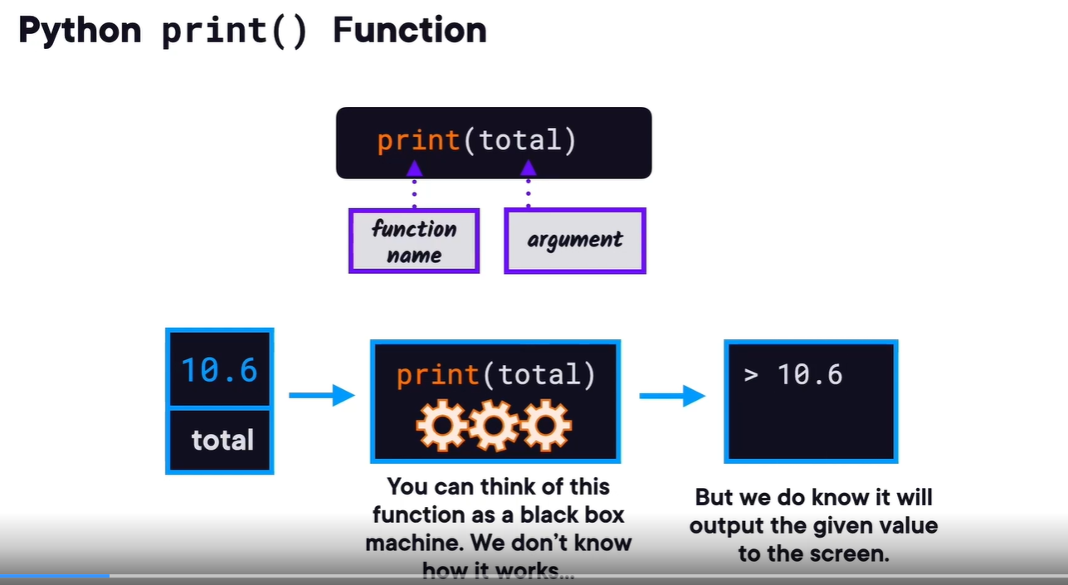
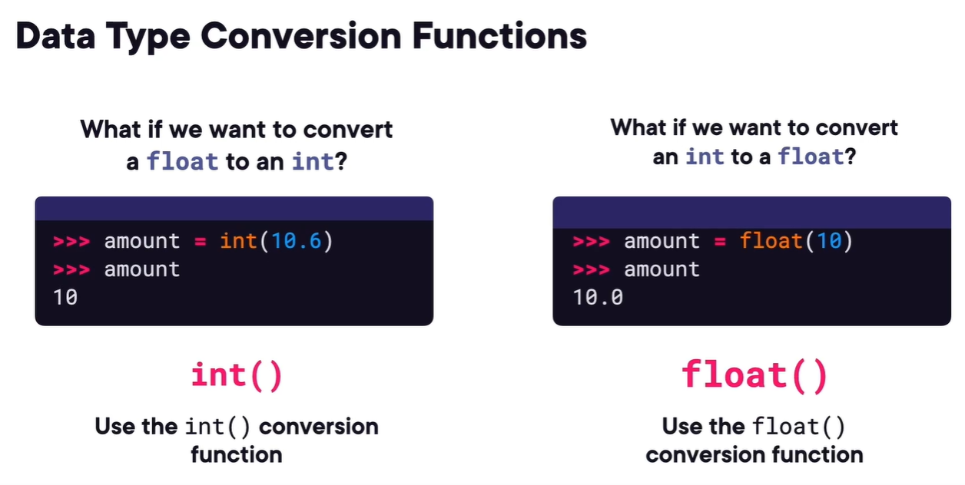
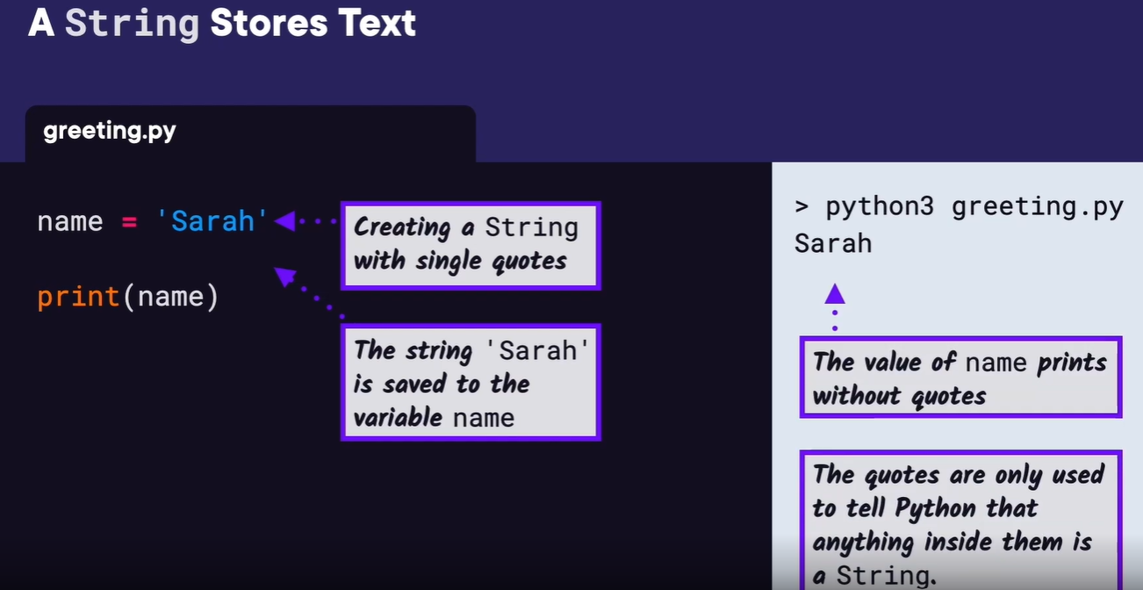
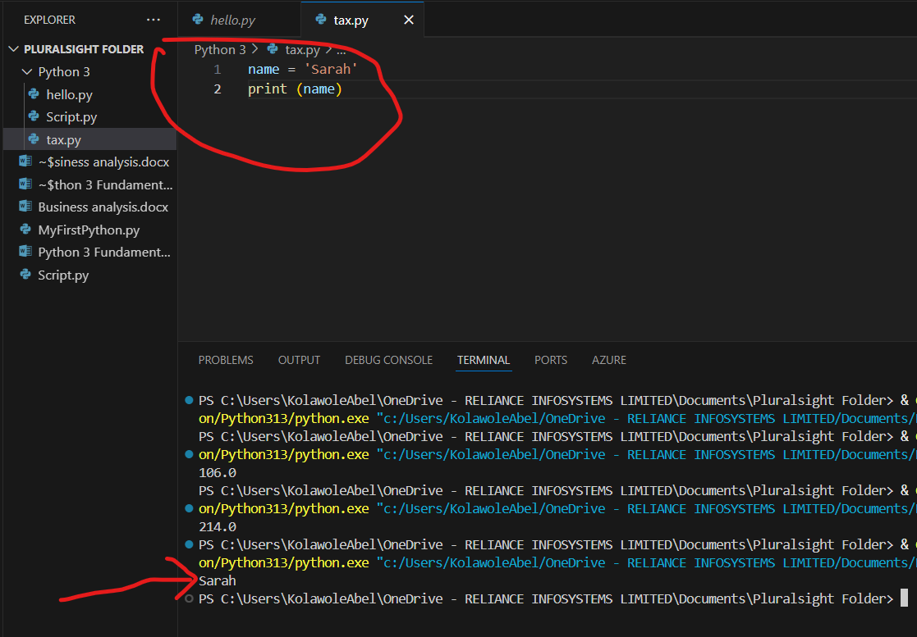
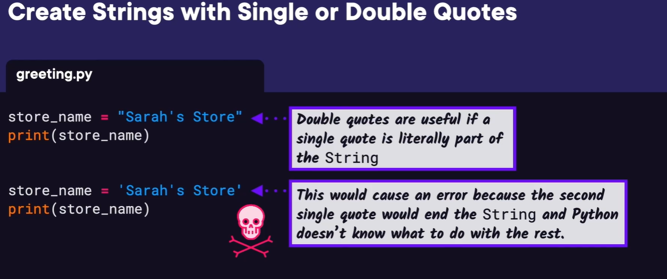
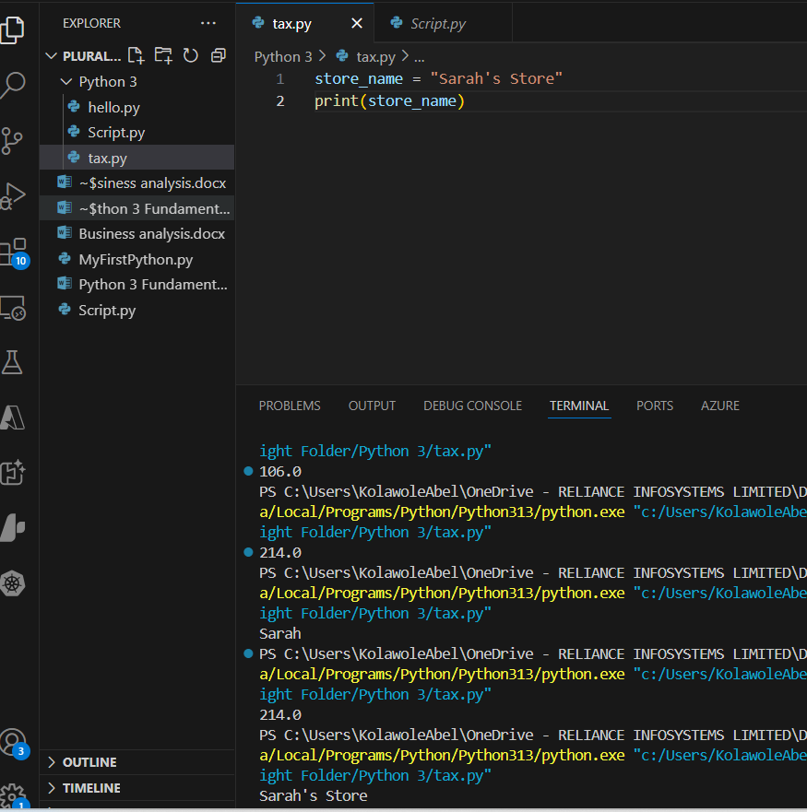
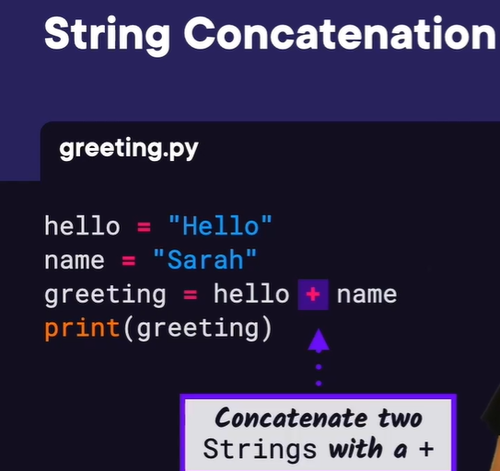
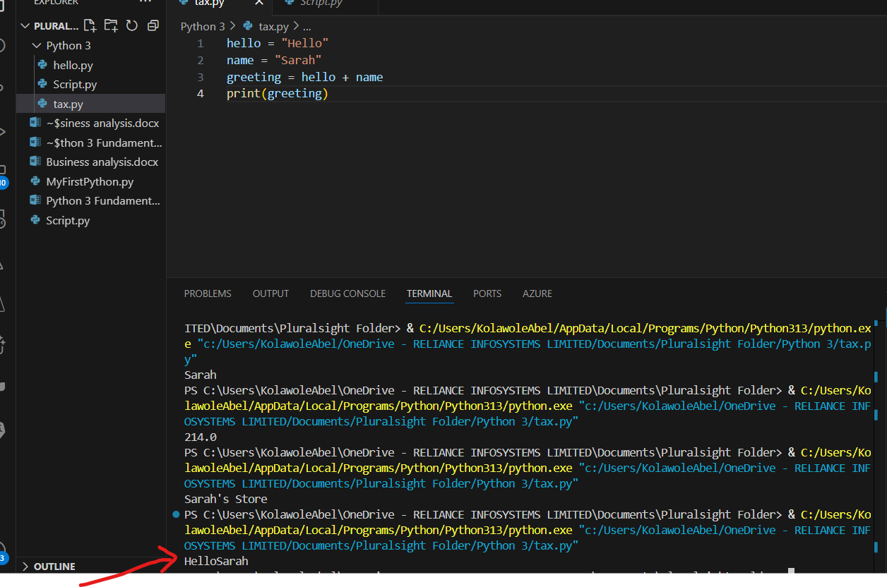
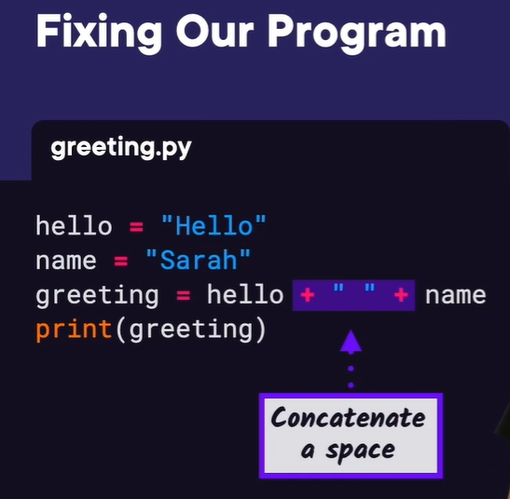
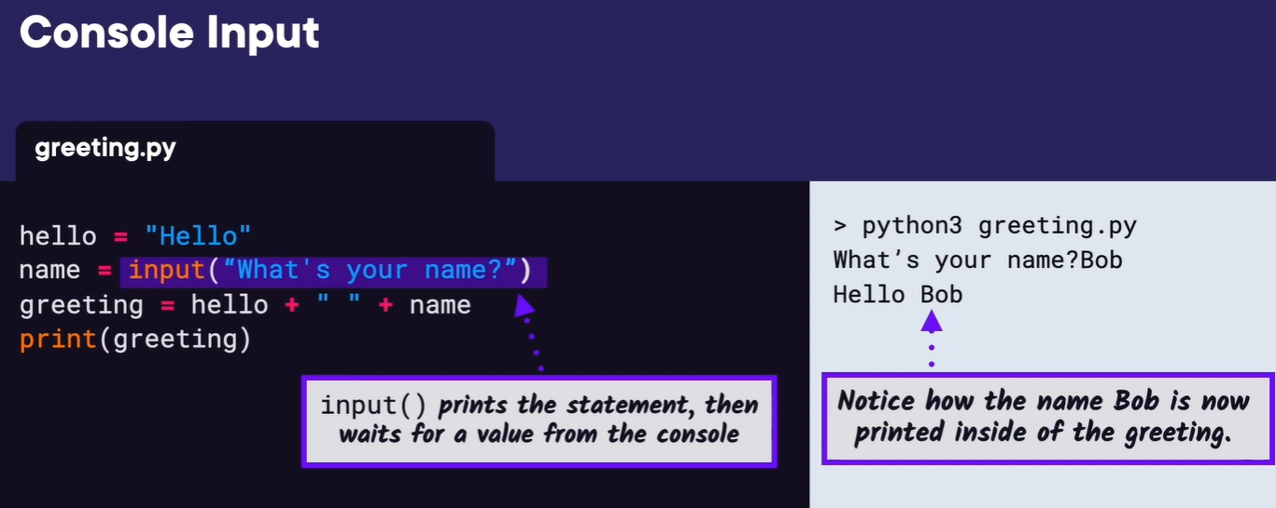
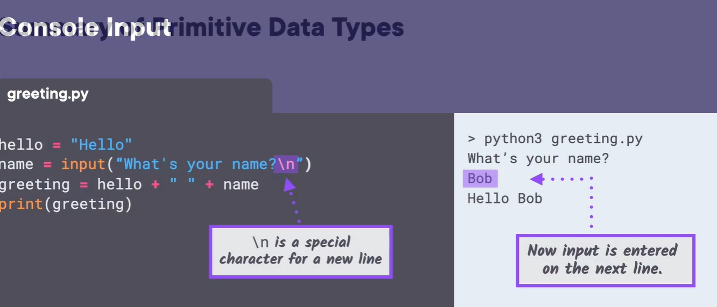
Demo: Age Calculator
Do you know how many decades old you are? Let's make a program to find out.
We want our program to ask us how old we are and then output how old we are
in decades and years. To get started, let's open our code editor. And I
have a folder for my code called PythonCourse, and we'll go ahead and open
that. Then inside there,
I'll create a new Python script named decades.py. To start our program,
we first want ask the user how old they are using input. Then we'll
save their answer to a variable called age.
Next, we can calculate decades with age/10.
If this is not a multiple of 10,
we might get a float or a decimal, but that's okay for now. Let's
run what we have so far and see if it's working.
Remember, it's better to test our program early so we can make sure
our program works and we aren't getting any errors.
The program asks us how old we are, so that's great, but we see we get an
error. It says TypeError unsupported operand types for /: str and int. That's
because everything that input returns is a string.
So this input line is the same as typing age = "37". Then, Python
doesn't know how to divide the string 37 by a number,
which is why it says unsupported. What we can do is convert the
result of input to an int by wrapping the whole expression
inside a call to the int function.
Now if we run it again, we don't get any errors.
Let's also add in a print statement for You are blank decades old. We'll
use string concatenation. If we run this, we see we get another
TypeError. It says you can only concatenate strings,
not float to string.
So let's convert our float to a string,
and we get 3.7 decades old. But we actually wanted our
program to calculate decades as a whole number and then
print out the remaining years.
So how can we do that? Lucky for us, Python has a special operator
for whole number division or integer division,
which is two back slashes. Then, if you remember division from back in school,
we want to get the remainder after the whole number division that will be
the leftover years that didn't evenly divide by 10.
Python also has an operator for that, which is the % sign.
It's also called modulus.
Now let's update our output message to say you are
blank decades and blank years old.
Remember to convert the years to a string.
Let's run this and see what we get. It says You are 3 decades, and 7old.
Let's correct the grammar, and add a years in the there.
Great.
You are 3 decades and 7 years old. We finished our program. Great job.
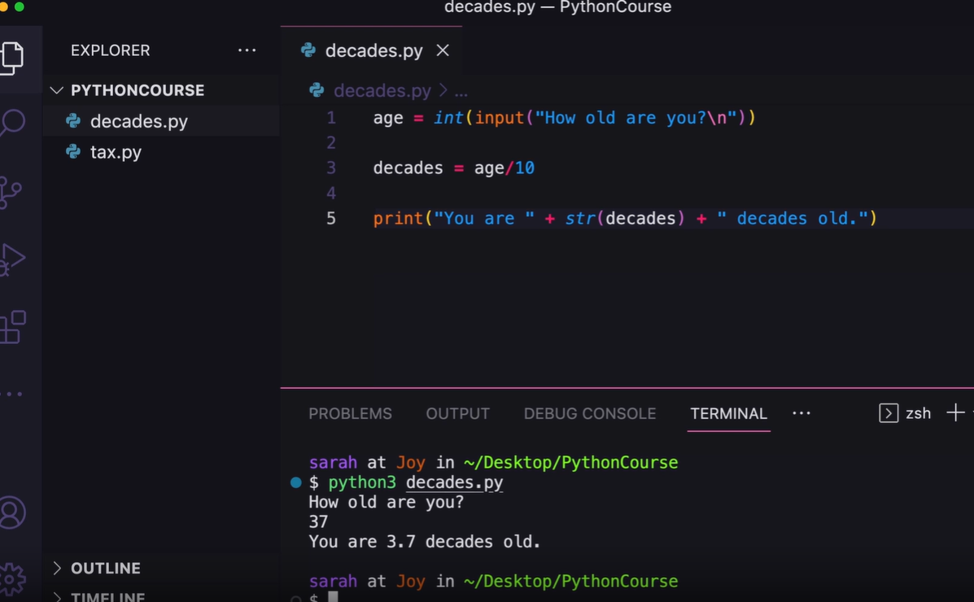
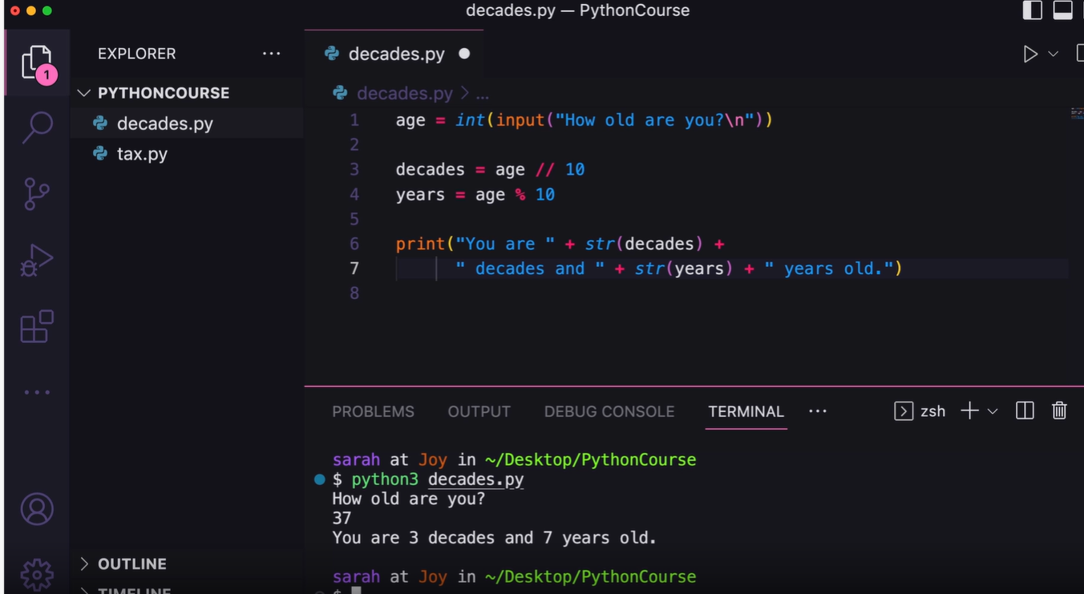
Conditionals
Computer programs need to be able to make decisions,
but how do we make those decisions?
A conditional statement or an if statement lets us make decisions in Python.
As a simple example,
let's say we want to go hiking and we want a computer program to
tell us if that weather is good for hiking or not.
You may say that's not a very realistic example, but let's think of a
hiking app that needs to show a weather advisory. To start on our program,
let's say if it's sunny and 90 degrees or higher,
it's too hot, and we're going to stay inside.
Also, if it's raining, we want to stay inside as well.
And otherwise, let's go and enjoy the outdoors. To make these decisions, we
actually had to compare the temperature and the forecast, and we'll see how
to make comparisons in Python now. There are six comparators in Python: less
than, less than equal to, equals, greater than, greater than equal to, and
not equals. From the shell, let's assign the value 95 to the temp variable,
short for temperature,
then we can enter temp == 95 for checking if the temp is equal to 95, and
we can think of this comparison as asking if the temperature is equal to
95, and we get true because 95 is equal to 95.
Also notice that assignment is one equal sign and the
equals comparator is two equals sign.
Next, we'll check if temp is less than 90, and we get false.
Now let's look at how these comparators are used inside
an if statement to make a decision.
An if statement lets us decide what to do.
It's like saying if this comparison is true,
then do this chunk of code. In our program, again,
we'll set the temperature equal to 95, then we have the
keyword if followed by the comparison is temp greater than
80, which evaluates to true.
So let's add something to do inside the if block. We'll add
two print statements inside that if statement. Since this if
statement evaluates to true,
then the following print statements are run. After running this,
we can see it's too hot and stay inside are printed to the screen.
Any indented code that comes after an if statement is called a code block,
and that's what's run if the if statement is true like we just saw. If we
instead set the temperature to 75, the if statement evaluates to false
because 75 is not greater than 80, so the indented code block is not run.
If we run our program again, we can see there's no output.
If we add another line of code that prints have a good day
after the if statement and its code block,
we can see that's where the program continues running after the
if statement. For indenting code in Python,
usually four spaces are used, but if you then use two
spaces for indenting somewhere else, you'll get an indentation error.
Most IDEs take care of this for you when you tab over so you don't have to worry
about being consistent, it's just something to be aware of.
In our previous example, when the if statement is false,
we'd like to do something else.
So how do we do something else after an if statement is
false? We can use an else statement.
So if an if statement is true, we run the code block that's indented below it.
Otherwise, we'll run the indented code block beneath the else statement.
So in this case,
our temperature is not greater than 80, so the else
block is run. When running our program,
we can see the enjoy the outdoors is printed to the screen.
This is working great so far, but what if we want to check
another condition like if the temperature is less than 60,
print it's too cold, stay inside.
We can check another condition by adding an else if
check, or elif for short in Python. Here,
we'll check if temperature is less than 60, then we'll
print it's too cold, stay inside.
Since we updated the temperature to be 50, the if statement is false,
but the elif statement is true since 50 is less than 60, so we see
it's too cold and stay inside printed.
If instead the if and the elif statements were false,
the else block would still run.
What if we wanted to change our program to only print
stay inside or enjoy the outdoors?
We can see that we're actually repeating this line of
code that says print stay inside twice.
Is there a way we could combine the first two if statements? The keyword or
lets you combine multiple comparisons. At least one of those comparisons needs
to be true for the whole if statement to be true.
Since our temperature is set to 75, the greater than 80
comparison is false. Less than 60 is also false,
making false or false a combined false result.
So if we run this,
we can see the else statement is run and enjoy the outdoors is printed.
The temperature is now set to 50, so 50 is not greater than 80, but
is less than 60, which becomes false or true,
which evaluates to a true, so print stay inside is run.
Since we want to look at the forecast and not just the temperature,
let's add another variable that stores the forecast
as a string and stores rainy,
cloudy, or sunny as the values. Like, or, and lets
you combine multiple comparisons,
but all comparisons need to be true for the whole and if statement
to be true. Since the temperature is 75, it's less than 80, which
is true, but if we check the forecast,
it is rainy so we get false which becomes true and false,
which evaluates to false overall because both need to be true
for an and statement to be true overall.
So here, the code block below the else statement would be run.
Now we updated the forecast to be sunny.
The temperature is still 75, which is less than 80, so we get
true first, and if we check the forecast,
it's not equal to rainy,
so we get true there, so the overall if statement is true and true,
which is true.
So this time, print go outside would be run. Another keyword not lets you negate
a comparison and can make your code a little more readable.
Now our if statement can read as if not forecast equal to rain. Still
sounds a little like a caveman, but maybe getting a little bit more
readable? Since forecast is equal to rain,
this evaluates to true and then we can take the opposite of that because
not is in front of it, and the whole statement is false. Since not
negates a comparison or makes the opposite of it,
not true becomes false and not false becomes true.
So the else code block would be run and stay inside would be printed.
In summary, we just saw three logical operators in Python. Or and an lets you
combine comparisons, and not lets you negate a comparison.
And as you may remember,
the primitive data types we've seen before are int, float, and string.
Another data type that can be used in comparisons is called a
Boolean which can store either a true or false value.
Now that we have a Boolean data type to use,
let's use it to store whether it's raining or not.
Now the if statement reads if raining, print stay inside,
which is getting even closer to reading like English. If we run
this, raining is true, so the print statement is run and stay
inside is printed to the screen.
We could also change this to say if it's not raining,
then print, go outside, otherwise, print stay inside.
Since raining is true, the if statement becomes if not true,
which is false, so the else statement is run and stay inside is printed.
Now that we've seen a wide array of if statements or conditional
statements, let's practice what we've learned so far in a demo for creating the game, Rock, Paper, Scissors.
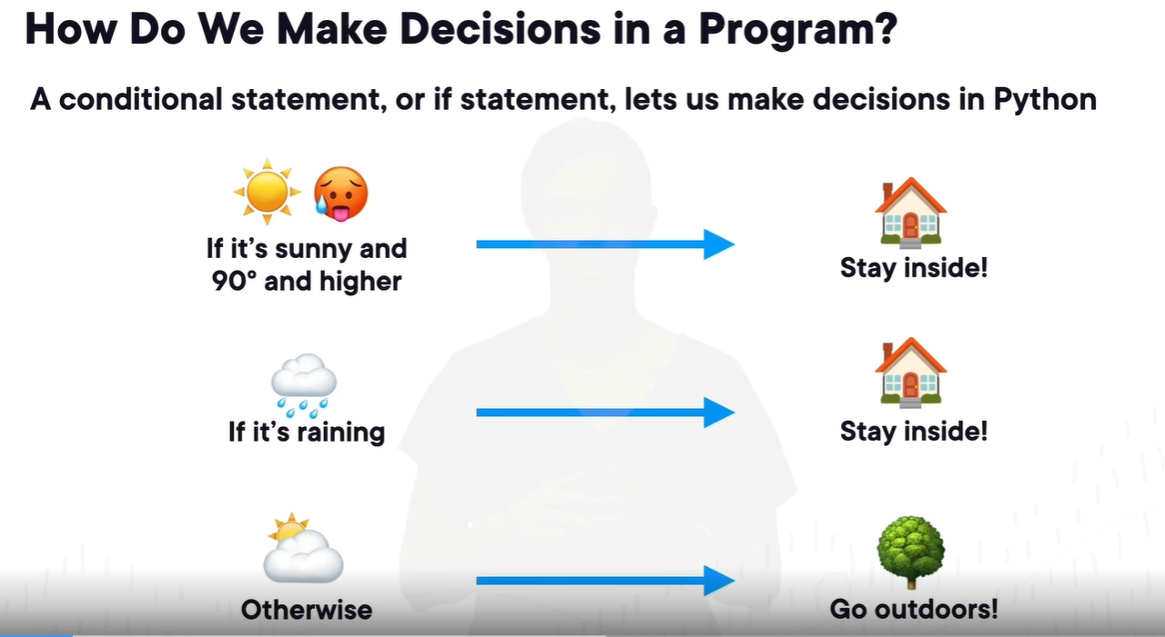
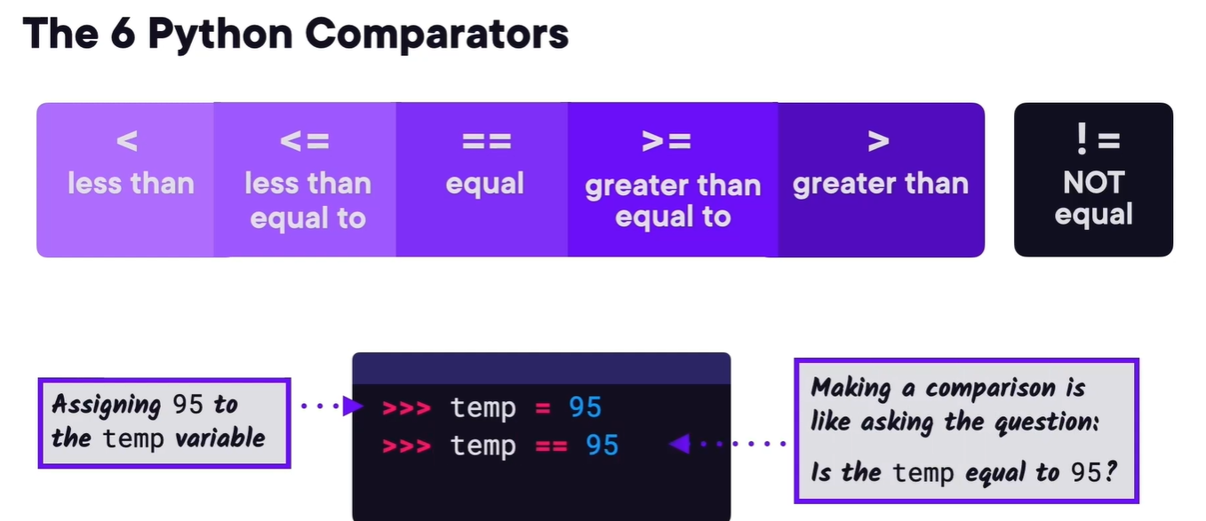
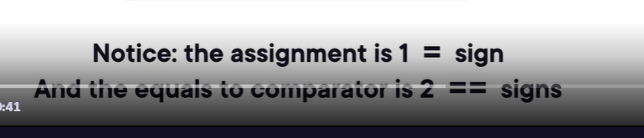
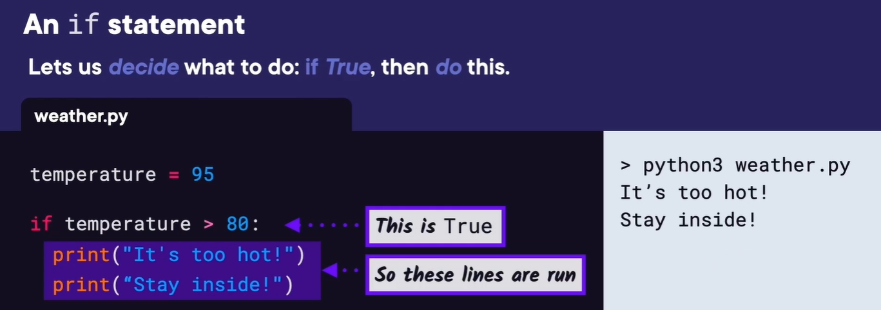
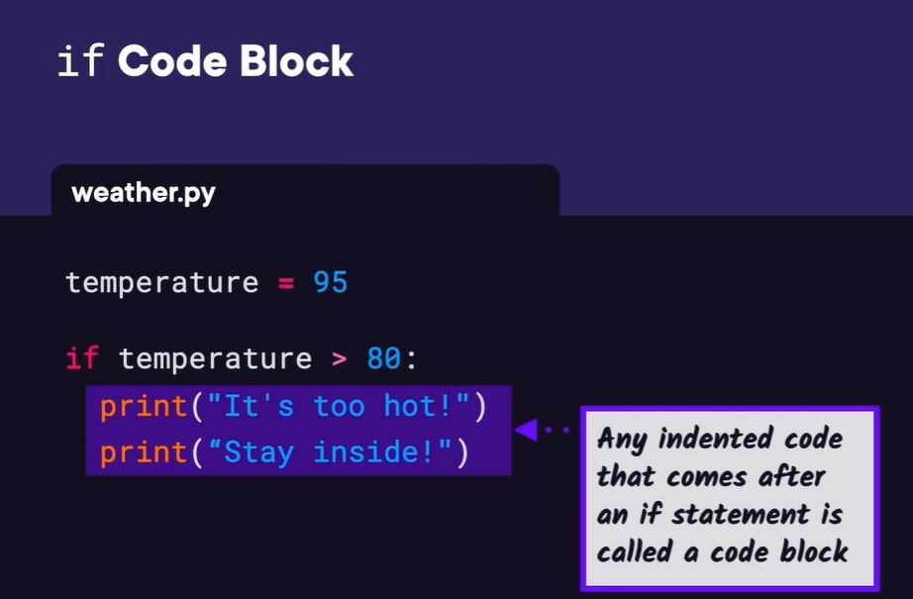
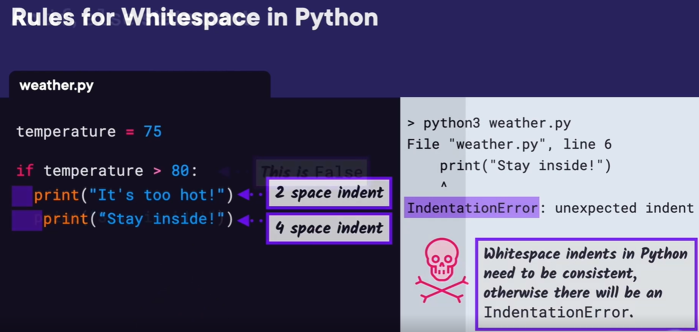
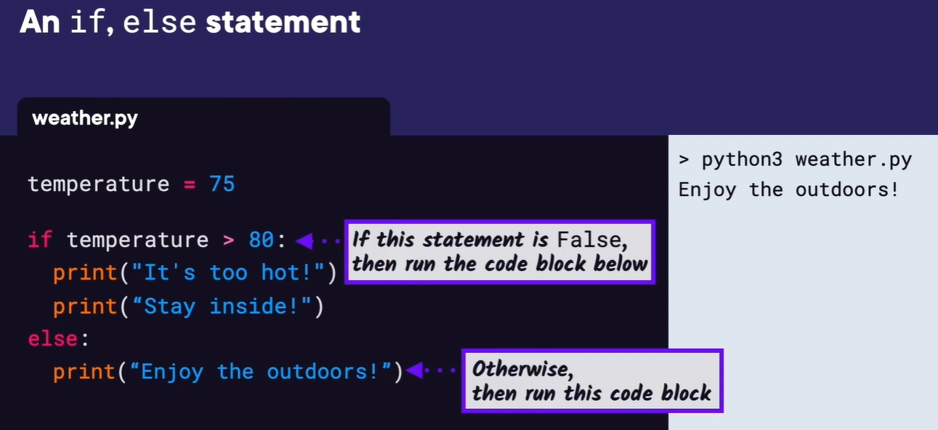
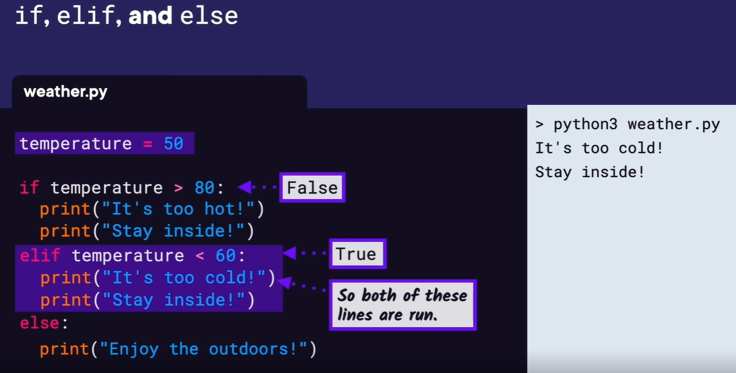
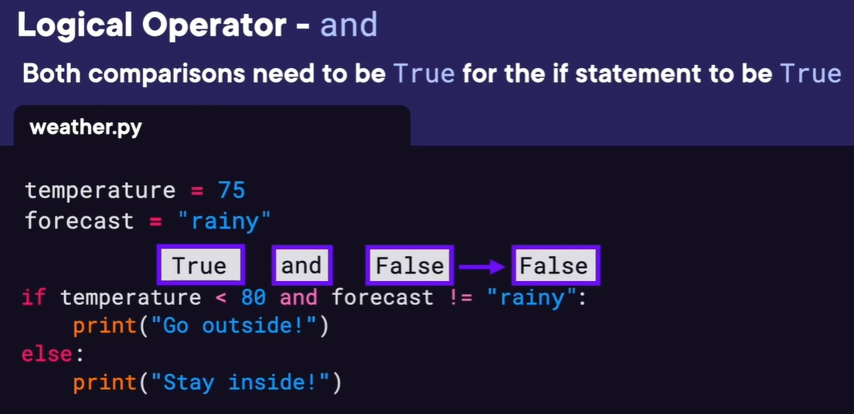
Demo: Rock, Paper, Scissors Game
In this demo, we're going to create the game Rock, Paper, Scissors.
Let's get started by opening VS Code, then we can create a new file
called rock_paper_scissors.py. We want our game to have the
computer play against the user. So first, let's get the computer's
choice and then the users choice.
We'll create a computer_choice variable,
and we'll set it to a string with the value either rock, paper, or scissors.
And we'll just set it to scissors for now. For the user_choice
variable, we'll let the user either enter rock, paper, or
scissors by using the input function.
And we'll pass in the message, Do you want rock, paper,
or scissors? Once we have the choices,
now we need to figure out who the winner is. One of the
easier places to start is with them both picking the same
thing, which would make it a tie.
So we'll start with an if statement for if computer_choice == user_choice,
then we'll print TIE.
Let's go ahead and run what we have so far to make sure it's working.
We'll click the run button, and then we'll type in scissors as
our choice. Since the computer choice is also set to scissors,
this will make TIE get printed.
It seems to be working so far.
Let's just run it again and put something else for our choice,
like paper. And we can see nothing happens.
That's because the if statement was false. So print TIE didn't get run
and then there's nothing after our first if statement. Now that TIE is
working, let's figure out the ways the user can win. If you're familiar
with the Rock, Paper, Scissors game,
there's three ways the user can win. The first is if the user has a rock
and the computer has scissors. We'll create an elif statement that checks
if the user_choice == rock and computer_choice == scissors. Then we'll
print you WIN. The next way the user can win is if they choose paper and
the computer chooses rock. Since we're going to use an elif block again,
let's copy the previous elif block, and we'll change the if user is equal
to paper, and we'll change computer_choice == rock. Then we'll print WIN again.
And for the last way the user can win, we'll copy that elif
code block again and replace user_choice with scissors and
computer_choice with paper.
Now that we have TIE covered and all of the ways the user can win, the
only other thing that can happen is the computer wins.
So we'll create an else statement and print in the
there, You lose, computer wins.
Now, let's run this and see if it works.
Let's enter rock, which should beat scissors, and we
see WIN is printed to the screen.
Let's run again and select something that should lose. We'll
select paper, which should lose to scissors,
and we see, You lose, computer wins printed to the screen. Great.
Our game seems to be working.
But you may be wondering if we can make this game any better by
letting the computer select a random choice each time. And we'll see how to do that in the next demo.

Demo: Rock, Paper, Scissors Game
In this demo, we're going to create the game Rock, Paper, Scissors.
Let's get started by opening VS Code, then we can create a new file
called rock_paper_scissors.py. We want our game to have the
computer play against the user. So first, let's get the computer's
choice and then the users choice.
We'll create a computer_choice variable,
and we'll set it to a string with the value either rock, paper, or scissors.
And we'll just set it to scissors for now. For the user_choice
variable, we'll let the user either enter rock, paper, or
scissors by using the input function.
And we'll pass in the message, Do you want rock, paper,
or scissors? Once we have the choices,
now we need to figure out who the winner is. One of the
easier places to start is with them both picking the same
thing, which would make it a tie.
So we'll start with an if statement for if computer_choice == user_choice,
then we'll print TIE.
Let's go ahead and run what we have so far to make sure it's working.
We'll click the run button, and then we'll type in scissors as
our choice. Since the computer choice is also set to scissors,
this will make TIE get printed.
It seems to be working so far.
Let's just run it again and put something else for our choice,
like paper. And we can see nothing happens.
That's because the if statement was false. So print TIE didn't get run
and then there's nothing after our first if statement. Now that TIE is
working, let's figure out the ways the user can win. If you're familiar
with the Rock, Paper, Scissors game,
there's three ways the user can win. The first is if the user has a rock
and the computer has scissors. We'll create an elif statement that checks
if the user_choice == rock and computer_choice == scissors. Then we'll
print you WIN. The next way the user can win is if they choose paper and
the computer chooses rock. Since we're going to use an elif block again,
let's copy the previous elif block, and we'll change the if user is equal
to paper, and we'll change computer_choice == rock. Then we'll print WIN again.
And for the last way the user can win, we'll copy that elif
code block again and replace user_choice with scissors and
computer_choice with paper.
Now that we have TIE covered and all of the ways the user can win, the
only other thing that can happen is the computer wins.
So we'll create an else statement and print in the
there, You lose, computer wins.
Now, let's run this and see if it works.
Let's enter rock, which should beat scissors, and we
see WIN is printed to the screen.
Let's run again and select something that should lose. We'll
select paper, which should lose to scissors,
and we see, You lose, computer wins printed to the screen. Great.
Our game seems to be working.
But you may be wondering if we can make this game any better by
letting the computer select a random choice each time. And we'll see how to do that in the next demo.
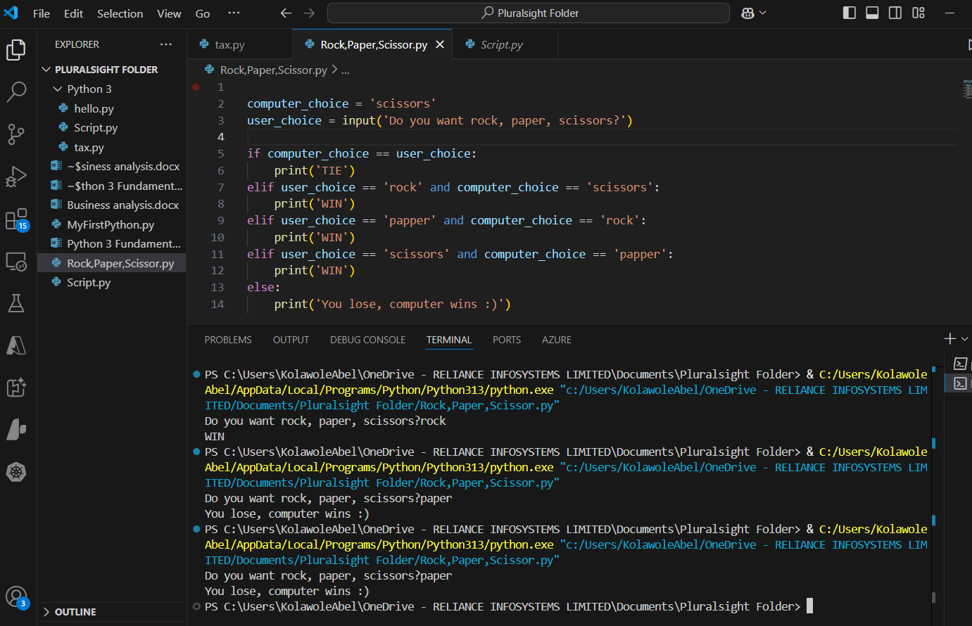
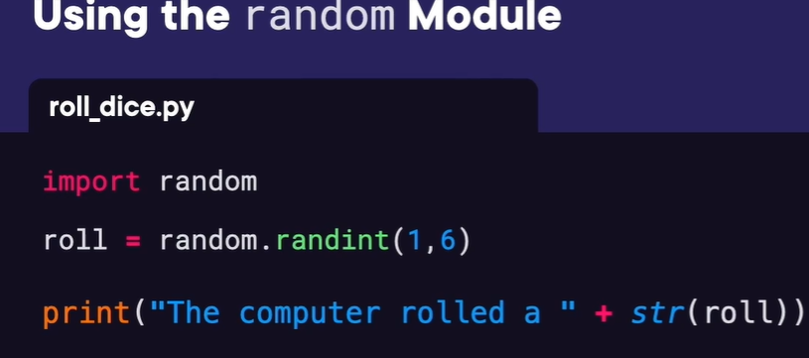
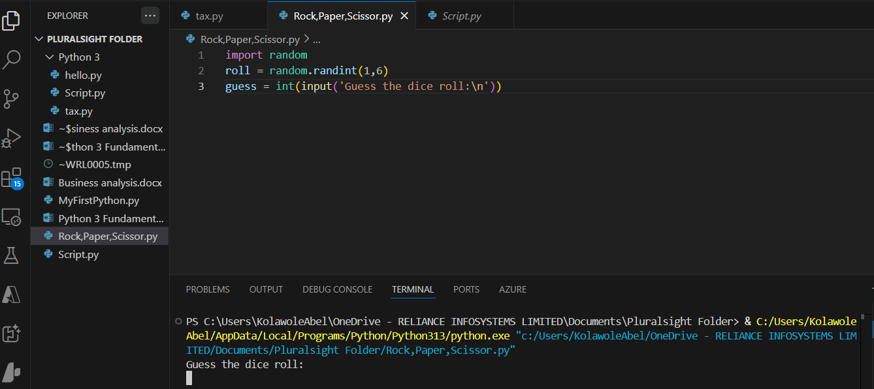
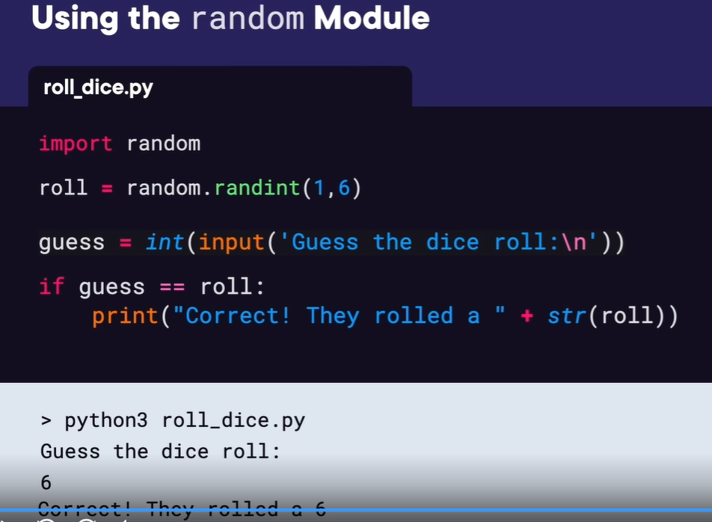
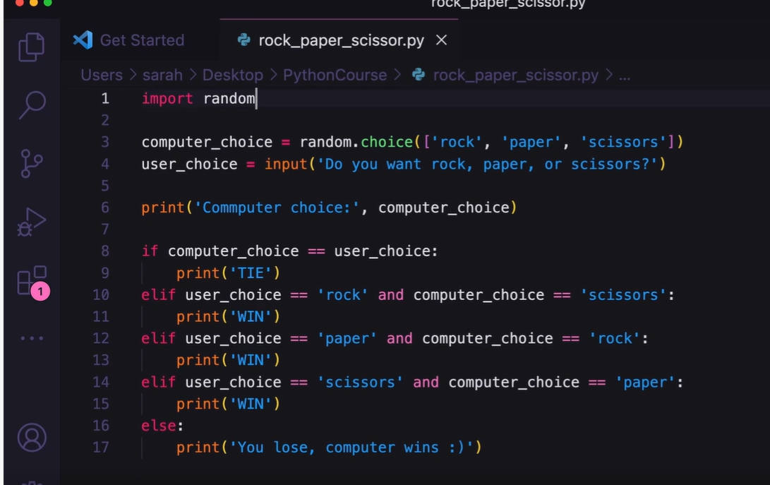
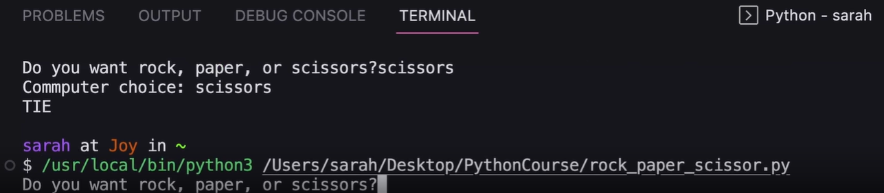
Hello, everyone, and welcome back to Python 3 Fundamentals.
I'm Sarah Holderness.
And in this module, we're going to cover lists and loops.
A list is a Python container that can store anything we want.
You can have an empty list, a list of strings,
a list of numbers, and a list of mixed items,
like numbers and strings, and even a list of lists.
We want to create a translation app for acronyms on the
internet like LOL means laugh out loud.
So we're going to use a list to store our acronyms.
If you don't know what these acronyms mean,
don't worry, we're going to define them later.
In a list, the index corresponds to an item's position in the list.
In Python, and in many programming languages, the index numbering starts at 0.
So if we wanted to get the first acronym in our list,
we type the name of the list followed by square brackets and the index 0.
Then the fourth acronym is at index 0.
And, in general, if you want the nth item in a list, you use the index [n-1].
To create a list, you use square brackets.
We'll start with an empty list, so we'll have empty square brackets,
and then we'll use the append method to add items to our list.
If we run this, we can see the two extra items we added, LOL and IDK.
We could have also started by creating a list with a few items already in it.
Then to add items, we would use the append method in the same way again.
If we run this, we can see the two extra items we added.
We haven't called a method like the append method before,
so let's take a closer look.
We've used functions, but methods are called on objects,
like the list object we have here.
Here we have the list we want to change, then a dot, then the append method.
Then as an argument, we have what we want to add to the list in parentheses.
Just like append, to remove an item,
we call the remove method and pass in the value we want to remove.
Here we pass in BFN, and then you can see BFN was removed.
Or if you don't know the value, but you do know its position,
you can remove an item by a specified index.
To use that, use del followed by the item at the specified index.
How can we check if an item is already in a list?
Maybe we don't want to add an item if it's already in the list.
We can use an if statement.
In this example, we want to check if one is in the list,
and if it is, print True.
You can see that the format of our if statement uses if,
and then the item you're checking for, then the keyword in,
and then the list that you're checking.
Let's check if the variable word is in the list acronyms,
so we'll type if word in acronyms.
Below, we'll print(word + ' is in the list').
Otherwise, we'll print(word + ' is NOT in the list').
And if we run this, since BFN is not in a list,
we can see BFN is NOT in the list is printed.
As we've seen before,
we can print our whole list, and it prints similar to how we
created it with square brackets around it.
So what if we want to print each item in the list
on a separate line individually?
We would need a for loop to do that to process and print
each item of the list individually.
The syntax for a for loop looks kind of similar to the if statement we just saw.
We have the keyword for, the loop variable that we can choose a name for,
the keyword in, and then the list for checking.
Here,
the loop variable acronym is a temporary variable that holds one of
the acronyms in the list for each run of the loop.
You can think of this loop like saying,
do this block of code for each string acronym in our list.
If we then run this code, we see LOL printed for the first loop,
IDK printed for the second loop, SMH printed for the third loop,
and TBH printed for the fourth.
Notice how the code block that you want repeated for each iteration of the
loop is indented, just like inside of an if statement.
Now that we know how to use lists and loops, let's take what we've learned and code an example together next.
List and Loop in python
In the this demo, we're going to create a loan calculator.
This will calculate how much of a loan or a mortgage we paid off
after a given number of months. We have VS Code open,
and we're going to create a new file called loan.py.
First,
we need to get the details of the loan from the user, so I'm going to
put a comment here to explain what we're doing, Get details of loan.
In Python, you use the pound or # symbol for a comment. The Python
interpreter doesn't run comments.
They're only used by us humans to explain what we're doing.
The first detail we need to get from the user is how much
money do you owe in dollars.
So we'll use the input function to prompt the user with
that question. Then we need to convert the result to a
float since input returns a string,
and we'll assign the value to a variable called money_owed.
Also,
to make this a little easier to think about, I'm going to put a comment
for an example value that we can use to check our work.
So I'll put $50,000 for the loan amount here.
This could potentially be an expensive car or an inexpensive apartment.
The second value we want is the annual percentage rate. Three percent
Is about the current mortgage rate, so we'll put that in the
comments. Third, what will your monthly payment be in dollars? Let's
say we'll be paying $1000 a month in the comments. And finally, how
many months do you want to see the results for? Let's say 24 months,
or 2 years. Now,
to make this easier, let's look at this in terms of the first month, and then
we'll see if we can repeat the calculations for all of the months the user wants
to see results for. Since 3% is the annual interest rate for the whole year, we
can divide that by 100 to get a decimal,
and then we'll also divide it by 12 for the 12 months in the
year to get the monthly interest rate.
We'll need that because we're making monthly
payments. Before we make our payment,
we'll calculate the first month's interest and add it to the amount
of money we owe. The interest we'll be paying is equal to money
owed times the monthly interest rate.
Then we'll add that interest to our money_owed value.
Now to complete the payment,
we can subtract our monthly payment amount from money_owed. At this point, our
monthly payment is complete, so we can print the results.
We'll do that by printing Paid , , of which , , was interest, so that we can
show the amount we paid and how much of that was interest.
So let's fill in those blanks here.
And let's also print Now I owe and fill it in with the variable money_owed.
We saw in the last demo that we can separate the
values we want to print with commas,
and we can also change the separator value with sep =, but I didn't show that
we can also change the end value. The end is a new line by default and comes
after the whole expression is printed, which is why print statements are
usually separated by new lines. Here,
we'll set the end to a space so both of these print
statements are on the same line.
Let's run this and see what we get.
We'll enter the example values we used before, $50,000 for
the loan amount, 3%, and $1000 payments,
and we want to see the results for 24 months.
And we see Paid $1000 of which $125 was interest.
Now I owe $49,125.
At this point, we only calculated the results for one month.
So what we need now is to add a for loop that does this for as many
months as the user wanted, say 24 months. The monthly interest rate
will stay the same, so we can add the loop before we calculate the
interest paid. The interest paid will change each month based on
how much is owed.
We can do a for loop for i in range(months), where months is the
number of months the user entered. In our example, it was 24. Then
we want indent these lines of code to be repeated inside of the
loop. Now if we run this again, we'll enter our same values, $50,000, 3% percent,
$1000 payments, and 24 months. We can see at the end of 24 months,
we still owe a little over 28,000.
I happen to know this loan gets paid off after 54 months, so
let's run this again with a value of 54. You can see Now I owe
-520 was printed to the screen.
So once the owed_value goes negative,
we know the loan payments are complete. We can fix this negative
value by adding an if statement before the full payment amount is
made. If money minus payment is less than 0, that means we owe
less than the payment amount.
So if that's the case,
let's print The last payment is money_owed and then print You
paid off the loan in i+1 months. And finally,
we don't want to run any more lines of code in this
loop, so we can use a break statement.
This will take us out of the loop and start the program
again after the loop. Now if we run this, we can see the
last payment is $479 and change, and You paid off the loan in 54 months.
Great.
We finished our loan calculator.
Good job following along.
And if we wanted to fix the program more, we should also round the dollar amount to two decimal places, but we'll leave that to fix later.

#Get details of loan
money_owed = float(input('How much money do you owe, in dollars?\n')) # $50,00
apr = float(input('What is the annual percentage rate of the loan?\n')) # 3%
payment = float(input('How much will you pay off each month in dollars?\n')) # $1,000
months = int(input('How many months do you want to see the results for?\n')) #24

monthly_rate = apr/100/12
# Calculate interest to pay
interest_paid = money_owed*monthly_rate

# Add in interest
money_owed = money_owed + interest_paid

# make payment
money_owed = money_owed - payment

print('paid', payment, 'of which', interest_paid, 'was interest')
print('Now I owe', money_owed)

Or
# Get user inputs
money_owed = float(input('How much money do you owe, in dollars?\n'))
apr = float(input('What is the annual percentage rate of the loan?\n'))
payment = float(input('How much will you pay off each month in dollars?\n'))
months = int(input('How many months do you want to see the results for?\n'))

monthly_rate = apr / 100 / 12

for month in range(1, months + 1):
# Calculate interest for the current month
interest_paid = money_owed * monthly_rate

# Add interest to the owed amount
money_owed += interest_paid

# Make the payment
money_owed -= payment

# If the debt is paid off, break early
if money_owed <= 0:
print(f"The debt is paid off in {month} months.")
break

print(f"Month {month}: Paid {payment}, interest paid {interest_paid:.2f}, remaining debt {money_owed:.2f}")

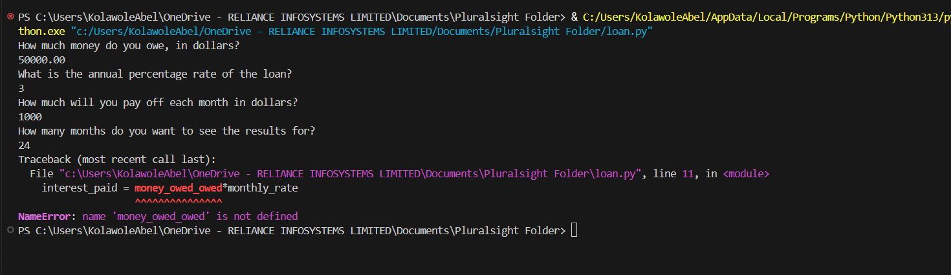

Dictionaries, Json and pip

Hi again.
I'm Sarah Holderness.
And in this module, we're going to look at dictionaries,
reading JSON data, and installing packages with pip.
Let's say we want to store a list of internet slang
acronyms and their translations.
We could use two lists, one for the acronyms and one for the translations,
but then we would have to maintain two lists.
If we add one to one list, we'd have to add it to the other,
or if we remove it, we have to make sure we remove it from the other.
And you can see how this could get messy and lead to errors.
In this example here, you can see that we're maintaining the two lists.
And it works for now, but it could lead to errors in the future.
Instead, we could use a dictionary.
A dictionary maps keys to values.
Here the keys could be the acronyms, and the values could be their translation.
After creating the dictionary acronyms,
in memory we have the key LOL assigned to the value laugh out loud,
IDK assigned to I don't know, and TBH assigned to,
to be honest.
Each item in the dictionary is known as a key-value pair.
To look up an item in a dictionary,
we send in the key in square brackets instead of the index,
like in a list, and the value is returned.
If we run this, we can see we looked up the key LOL,
so the value laugh out loud was printed.
Dictionaries, like lists, can hold anything you want.
Here we have a dictionary of strings mapped to strings like we saw
with the acronyms; strings mapped to numbers,
like a menu with items in their prices; or even a
dictionary of any type as the keys and values.
To create a dictionary, you can create an empty dictionary with curly brackets.
And then to add items, it looks similar to looking them up.
You put the key that you want in square brackets and then
assign it to the value with the equals sign.
After adding these three key-value pairs,
we can print the whole dictionary and see that our
three new key-value pairs are there.
Let's update the value for the key TBH.
You can see that a value is updated in the same way that you create the value,
the dictionary just updates the value if the key already exists.
Then if we look up the same key TBH again and print the value,
we can see the new value honestly is printed to the screen.
To delete a value from a dictionary, we use the keyword del,
short for delete, and then we use the key LOL,
just like we did when we wanted to look up that value.
If we print the dictionary again,
we can see that the key-value pair LOL was removed.
If we try to access a key that's not there, we'll get a key error.
To avoid this, we can use the get method.
Here we'll call acronyms.get and then pass in the key we want in parentheses.
If the key is not there,
then the None type is returned instead of getting an error.
None is a type that represents the absence of a value.
Again, None means the absence of value,
so it evaluates to False in a conditional.
So if we again try to get the key BTW, since it doesn't exist,
definition is set to None.
Then we can put if definition, which is basically asking,
does definition have a value or is it None?
If it has a value, then we'll print the definition.
But since it's None, the if statement is False, and the else block is run.
And if we run this, we see key doesn't exist as printed.
Now we can put our dictionaries to use by translating a sentence.
The sentence we created is IDK, what happened, TBH.
We created the acronyms as separate strings to make them more clear.
Then let's create another string called translation,
where we get the values of each of the acronyms by looking them
up in the dictionary with the get method.
Finally, let's print the original sentence and the translation,
and we can see the translation printed out correctly as,
I don't know what happened to be honest.
Now let's take what we've learned about dictionaries and
apply it to an example in the demo. Let's create a movie scheduler program.
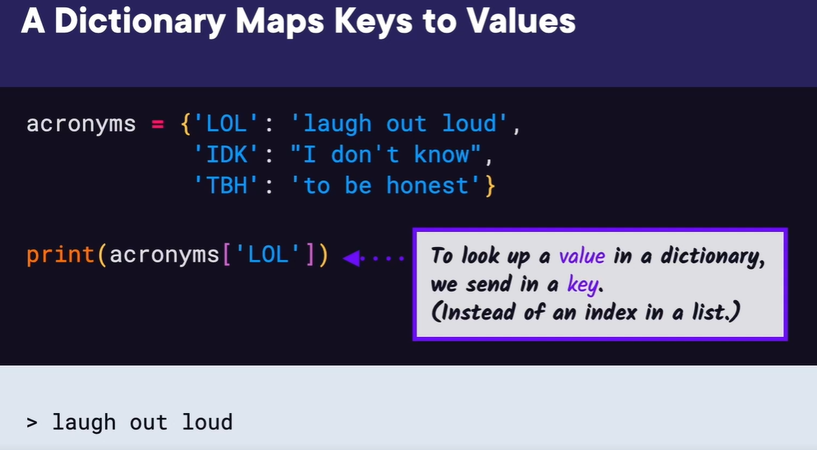
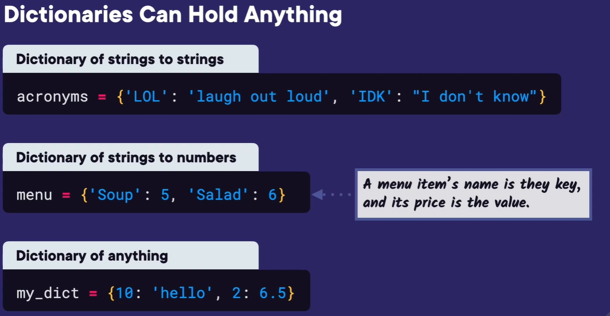
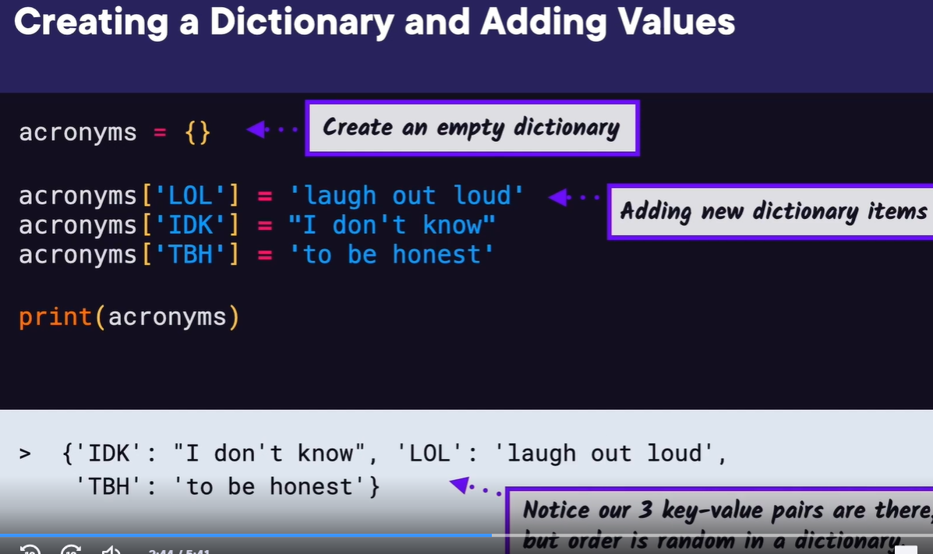
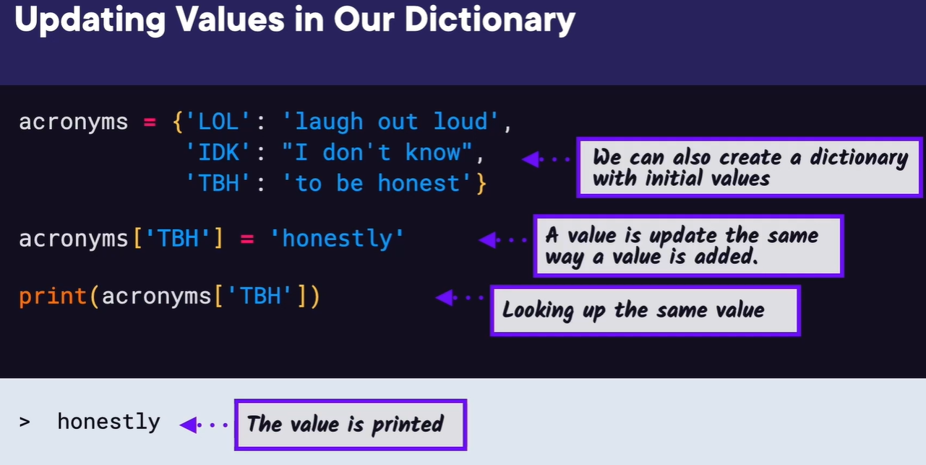
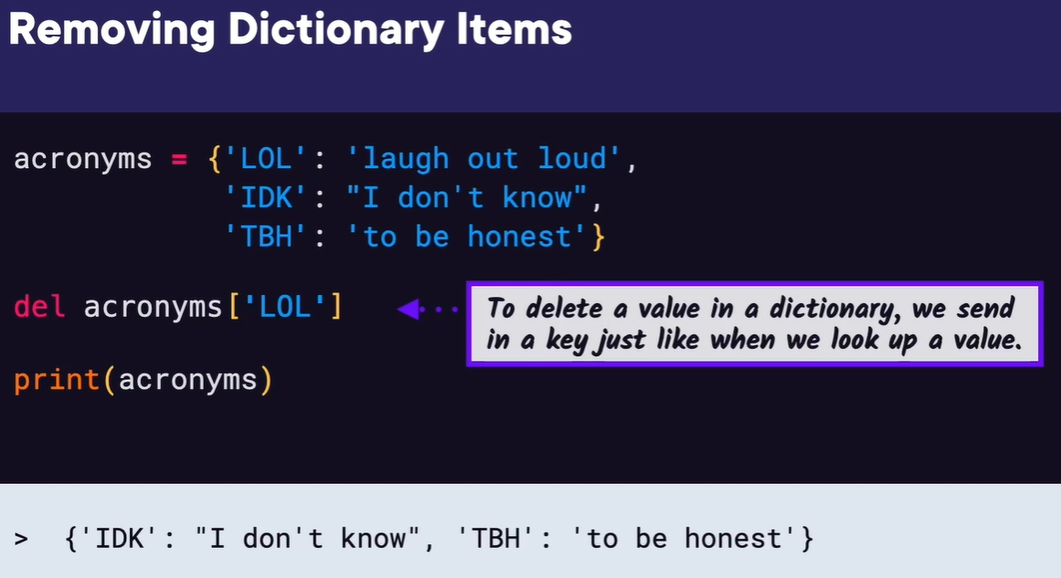
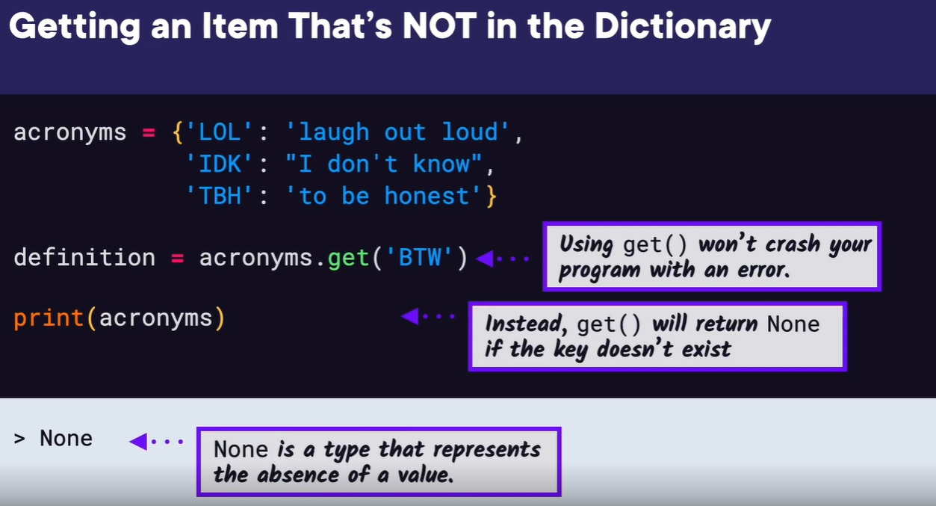
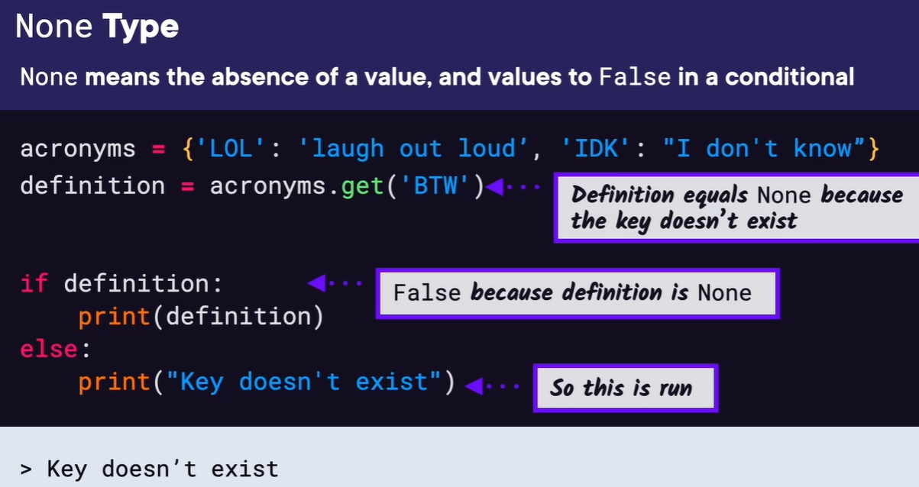
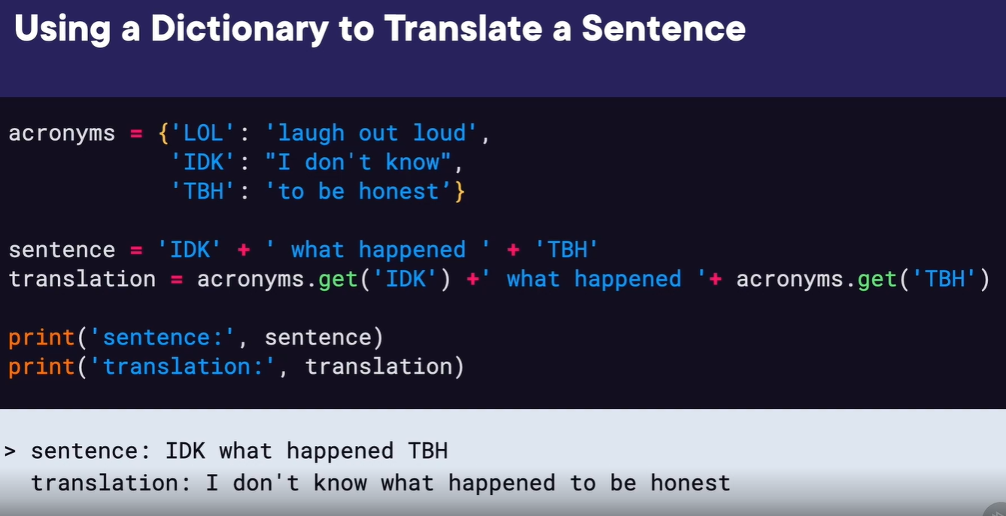


Hi again.
I'm Sarah Holderness.
And in this module, we're going to look at dictionaries,
reading JSON data, and installing packages with pip.
Let's say we want to store a list of internet slang
acronyms and their translations.
We could use two lists, one for the acronyms and one for the translations,
but then we would have to maintain two lists.
If we add one to one list, we'd have to add it to the other,
or if we remove it, we have to make sure we remove it from the other.
And you can see how this could get messy and lead to errors.
In this example here, you can see that we're maintaining the two lists.
And it works for now, but it could lead to errors in the future.
Instead, we could use a dictionary.
A dictionary maps keys to values.
Here the keys could be the acronyms, and the values could be their translation.
After creating the dictionary acronyms,
in memory we have the key LOL assigned to the value laugh out loud,
IDK assigned to I don't know, and TBH assigned to,
to be honest.
Each item in the dictionary is known as a key-value pair.
To look up an item in a dictionary,
we send in the key in square brackets instead of the index,
like in a list, and the value is returned.
If we run this, we can see we looked up the key LOL,
so the value laugh out loud was printed.
Dictionaries, like lists, can hold anything you want.
Here we have a dictionary of strings mapped to strings like we saw
with the acronyms; strings mapped to numbers,
like a menu with items in their prices; or even a
dictionary of any type as the keys and values.
To create a dictionary, you can create an empty dictionary with curly brackets.
And then to add items, it looks similar to looking them up.
You put the key that you want in square brackets and then
assign it to the value with the equals sign.
After adding these three key-value pairs,
we can print the whole dictionary and see that our
three new key-value pairs are there.
Let's update the value for the key TBH.
You can see that a value is updated in the same way that you create the value,
the dictionary just updates the value if the key already exists.
Then if we look up the same key TBH again and print the value,
we can see the new value honestly is printed to the screen.
To delete a value from a dictionary, we use the keyword del,
short for delete, and then we use the key LOL,
just like we did when we wanted to look up that value.
If we print the dictionary again,
we can see that the key-value pair LOL was removed.
If we try to access a key that's not there, we'll get a key error.
To avoid this, we can use the get method.
Here we'll call acronyms.get and then pass in the key we want in parentheses.
If the key is not there,
then the None type is returned instead of getting an error.
None is a type that represents the absence of a value.
Again, None means the absence of value,
so it evaluates to False in a conditional.
So if we again try to get the key BTW, since it doesn't exist,
definition is set to None.
Then we can put if definition, which is basically asking,
does definition have a value or is it None?
If it has a value, then we'll print the definition.
But since it's None, the if statement is False, and the else block is run.
And if we run this, we see key doesn't exist as printed.
Now we can put our dictionaries to use by translating a sentence.
The sentence we created is IDK, what happened, TBH.
We created the acronyms as separate strings to make them more clear.
Then let's create another string called translation,
where we get the values of each of the acronyms by looking them
up in the dictionary with the get method.
Finally, let's print the original sentence and the translation,
and we can see the translation printed out correctly as,
I don't know what happened to be honest.
Now let's take what we've learned about dictionaries and
apply it to an example in the demo. Let's create a movie scheduler program.
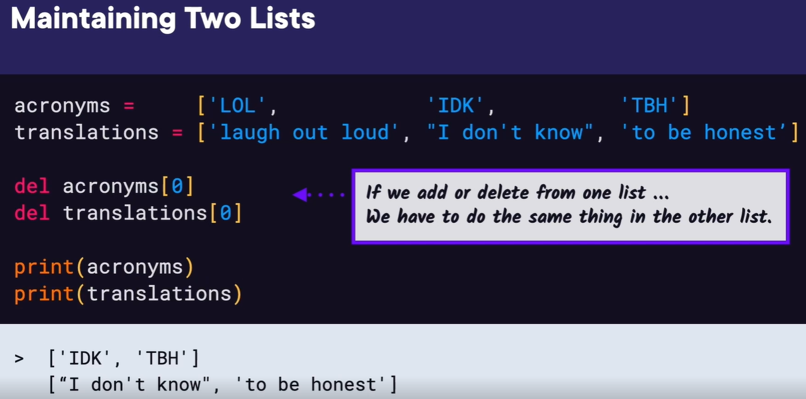
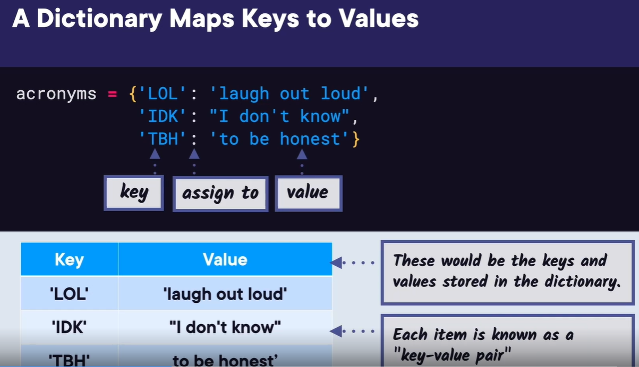
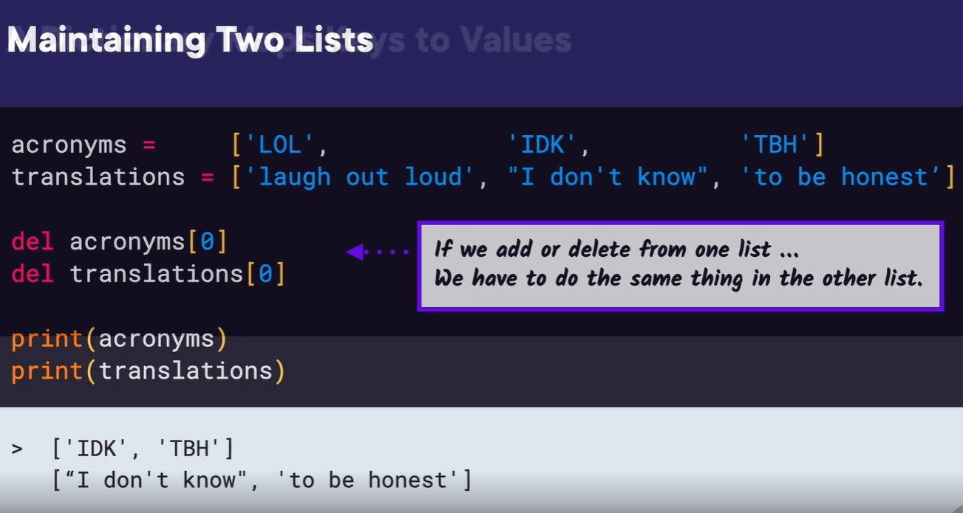
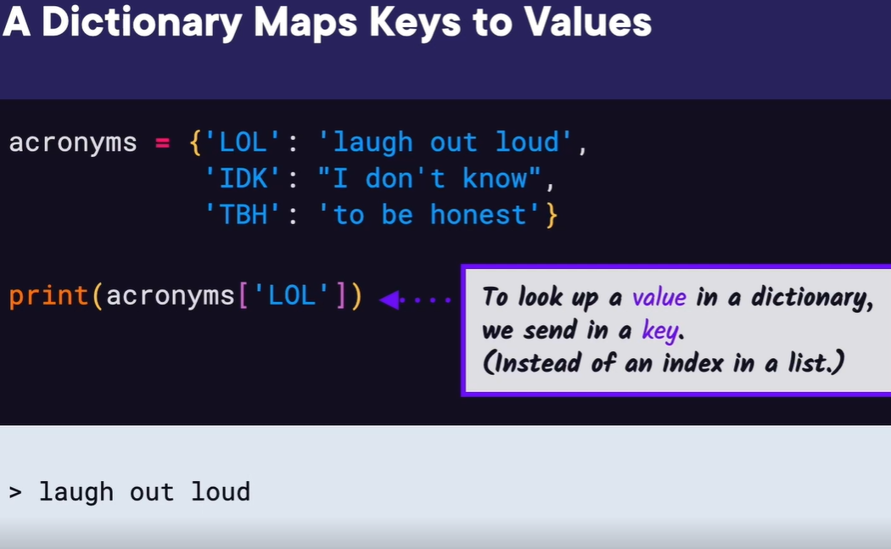
In this demo,
we're going to create a movie schedule where we'll create a
dictionary of the current movie showtimes and then ask the user if
they want to look up a certain showtime.
Back before the internet,
you used to have to call the movie theater on your phone and
listen to a list of the movies and their showtimes,
so this could be like designing that phone system.
We have VS Code open and we're going to create a new
file called movie_schedule.py.
Then we'll start out by creating our dictionary and
adding our movies and showtimes.
We can either add each key-value pair inside the curly brackets or we could
just create an empty dictionary and add them one by one,
but what we have here works well, so we'll keep this one.
To start, how can we ask the user what movie they want the showtime for?
We could use a simple input function with the prompt,
What movie would you like the showtime for?
And we'll save their response to a movie variable since
they'll hopefully respond with a movie title.
We could even be fancy and print out which movies we currently
have before we ask them which one they want.
So before the input line, let's add a print statement for,
We're currently showing the following movies.
Then to print each movie, let's do a for loop over the dictionary.
And this defaults to the keys, which is what we want,
so inside the loop we'll print each key,
which is the movie title.
Let's run this and make sure it looks as expected.
Looks good, and we can even enter a movie title.
Since this is working so far,
we want to take that movie title and look up its showtime in the dictionary.
We can create a showtime variable and set it equal to calling
current_movies.get and then pass in the that movie title in parentheses.
Now the showtimes should be there if the movie exists.
But if the user typed in a movie that isn't in the dictionary,
then the showtime is none.
We can use an if statement to check if the showtime equals None,
and if so, we'll print the Requested movie isn't playing; otherwise,
we found the showtime, so we can print movie,
'is playing at', showtime.
Now let's run this and see how it works.
We'll put in The Grinch first and we can see it's playing at 11:00am.
And if we run this again and instead put in a movie that isn't there, like Dr.
Seuss, we see the Requested movie isn't playing.
Great! Our movie schedule is working using dictionaries.
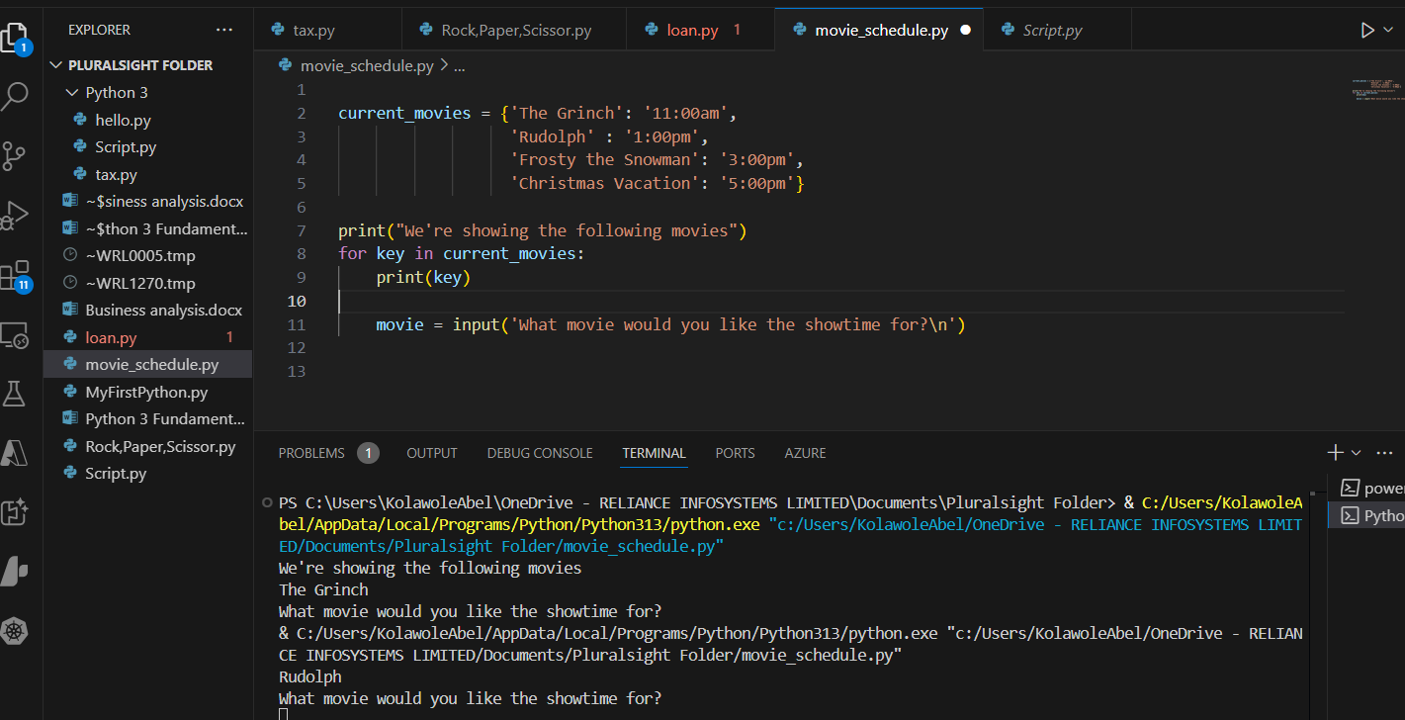
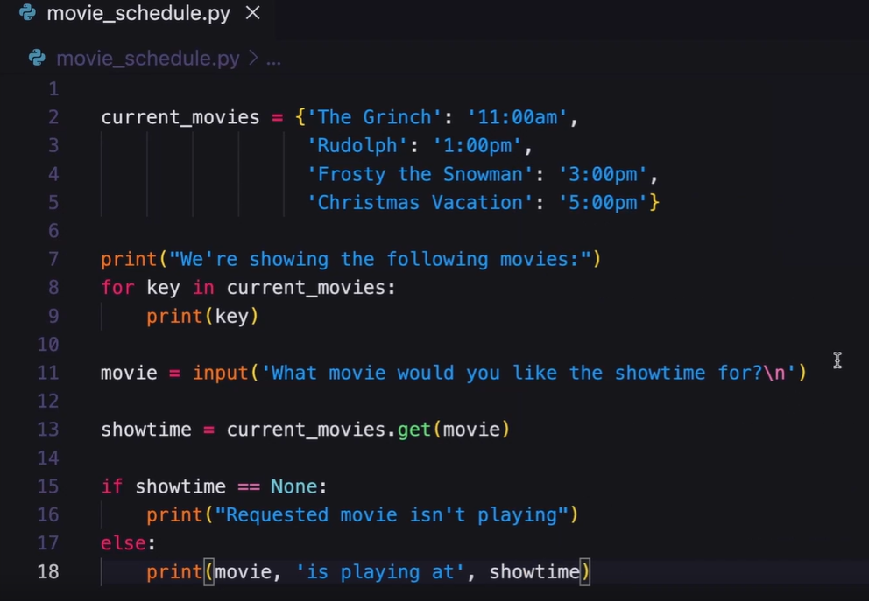

Welcome back. Now that we've seen how to use dictionaries,
let's look at more complicated examples where we try to
combine lists with dictionaries.
Let's say we have three different menu lists, one for breakfast,
lunch, and dinner.
How could we combine these lists into one list? In Python,
you can have a container of containers.
So here, we made menu a list with the breakfast, lunch,
and dinner list as the items inside the list.
And we then print each inner list by using their indices, 0, 1, and 2.
But how would you get an individual item from an
inner list? You can use two indexes.
Since the item we want is in the first list, let's use the index 0 to
print the list the item is in. This is a good start.
Now we just need to get the second item from that list. We
can add the index 1 after the index 0, so now we have the
list at index 0 in the outer list,
and then the item at index 1 in the inner list. And then if we print
the result we get, we see the item Bagel is printed,
which is what we wanted. Instead of using a list of lists, we could
use a dictionary with keys for the breakfast, lunch,
and dinner lists,
which is a little more organized. To print each menu
list, we can use the breakfast, lunch, and dinner keys.
Here we have each print statement on a separate line,
and you can see the results.
But what if we had many more menus? We wouldn't want to manually type
each key on a separate line. Is there a better way of doing this? You
may be thinking we can use a for loop for that, and let's see how to
use a for loop with a dictionary.
If we do a for loop over a dictionary, it defaults to returning just the
keys in a dictionary, but we also want the values.
If we want the keys and values,
we need to use the items method on the dictionary,
and we need two loop variables, one for the key and one for the
value, which we called name and menu here. Then inside the loop,
we can print both the name and menu, and we'll separate them by a colon.
If we print this, we can see the key Breakfast,
followed by its list value and the same for Lunch and Dinner,
which is what we wanted.
We can also use dictionaries to represent objects.
Let's say we have a person object,
and we want to represent its attributes such as name, age,
and city that they're from. We could use a dictionary where
the attributes are saved as key value pairs. The name is the
key followed by the person's name,
Sarah Smith, as the value. The city key can be followed by the value,
Orlando, and the age key followed by 100. Then we can print out how old
the person is by looking up the name key and the age key, and we get,
Sarah Smith is 100 years old.
Now that we've seen dictionaries with lists as values and using
dictionaries to store objects, let's take what we've learned and apply it to an example in the demo.
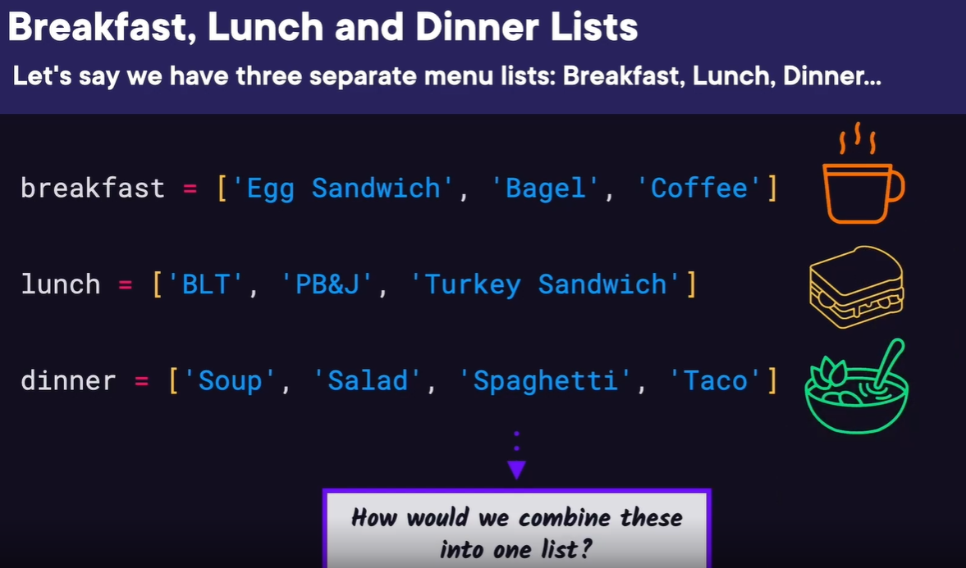
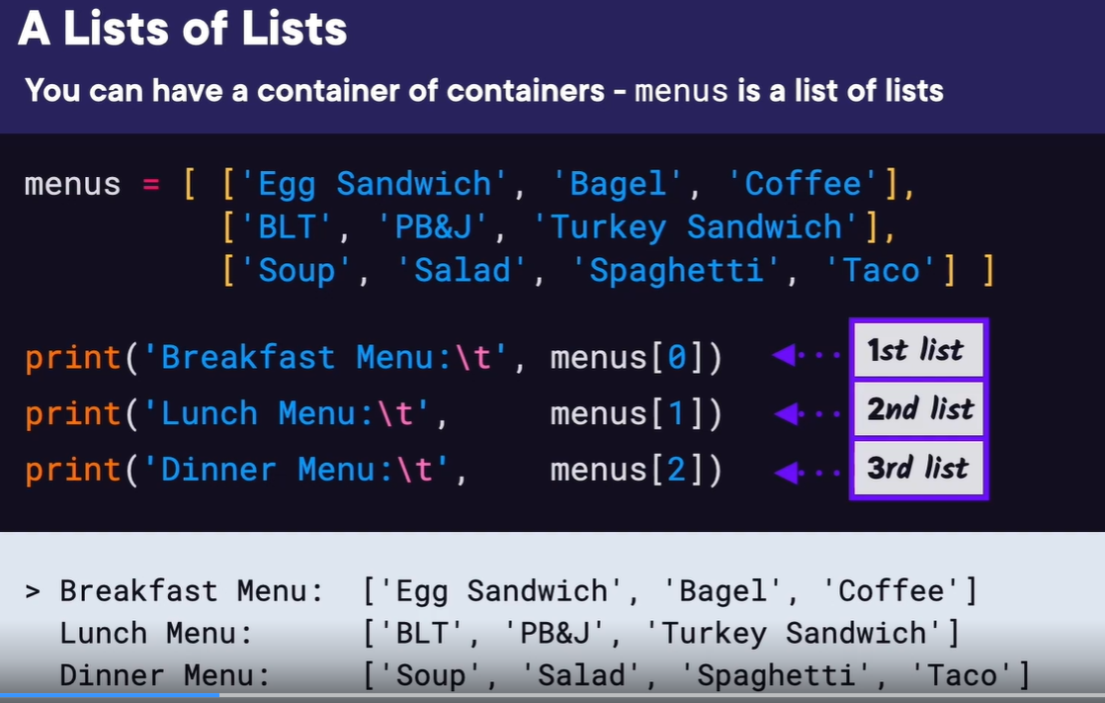
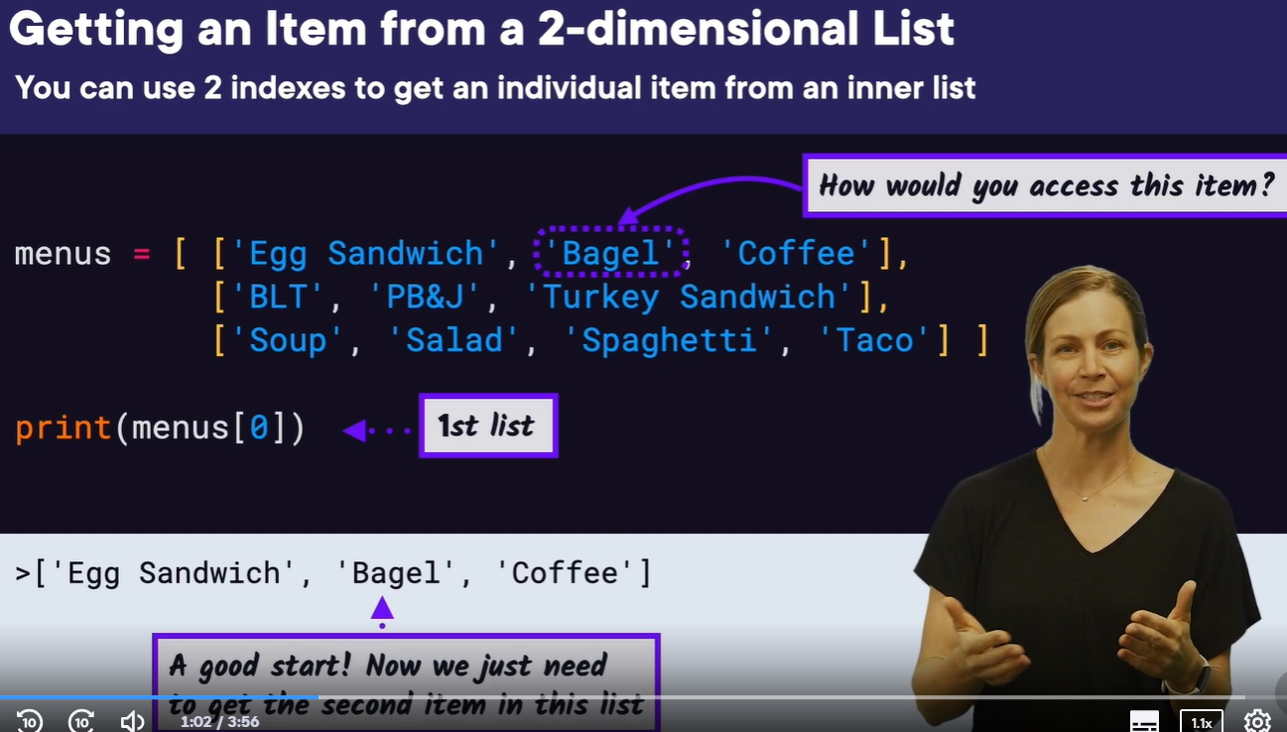
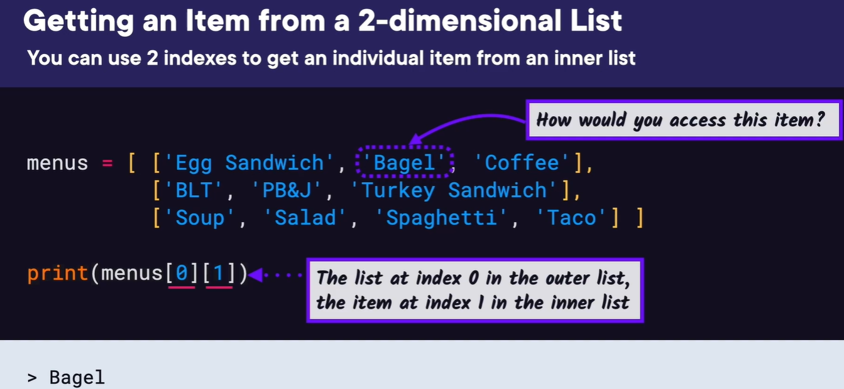
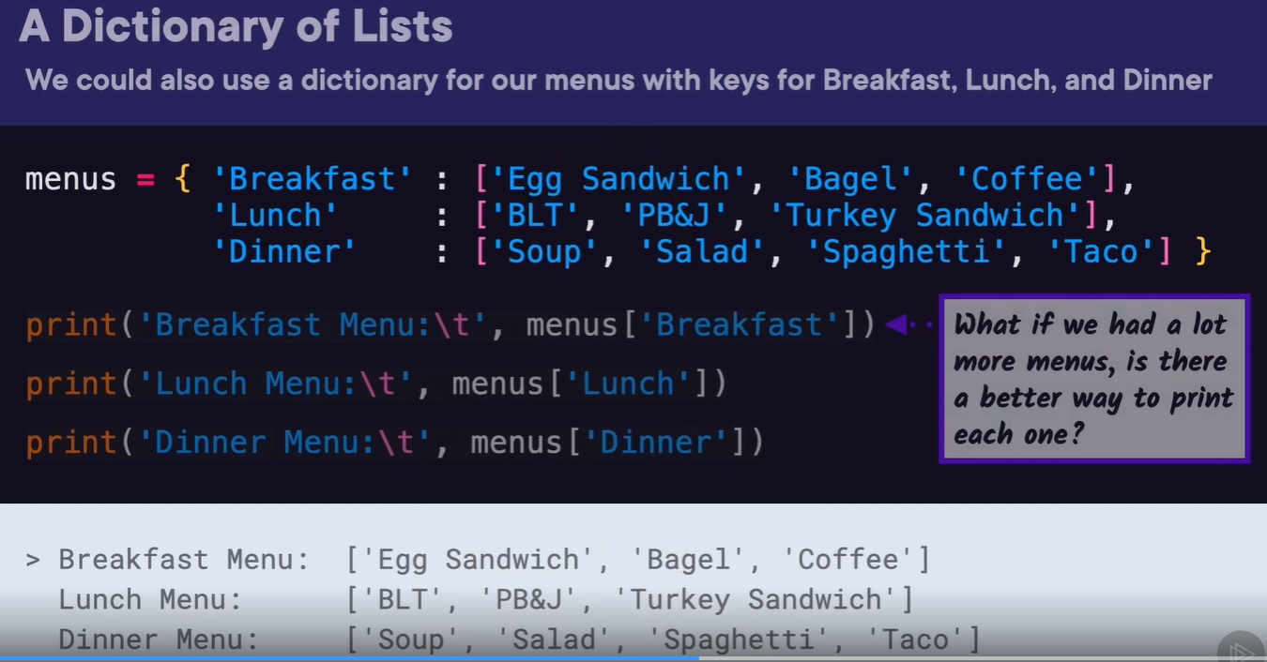
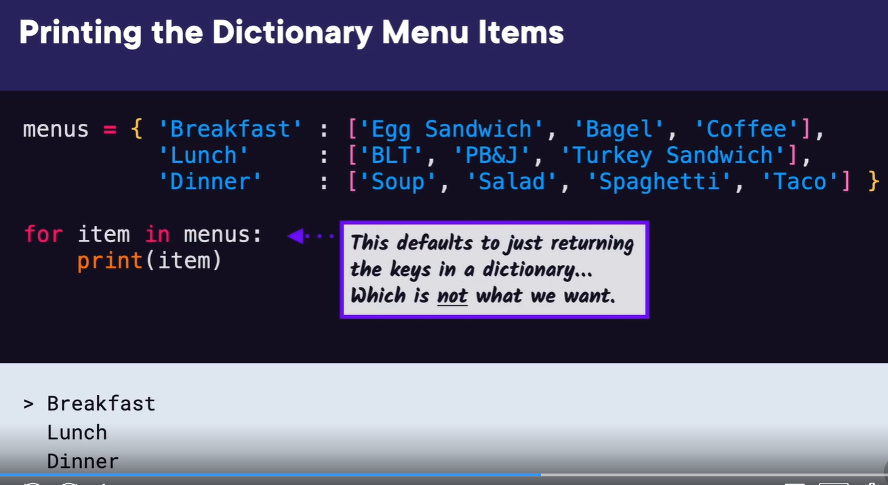
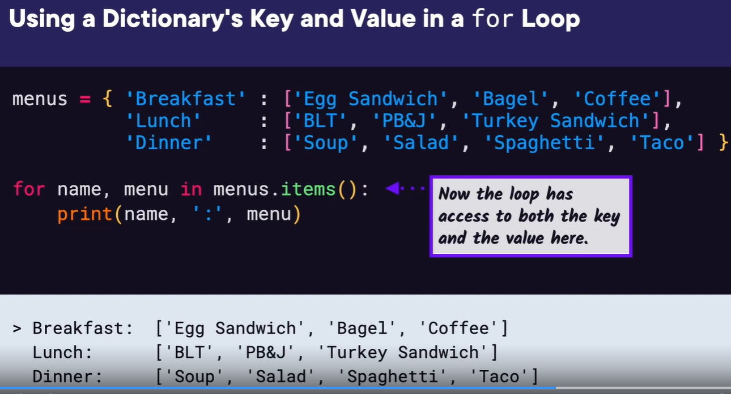
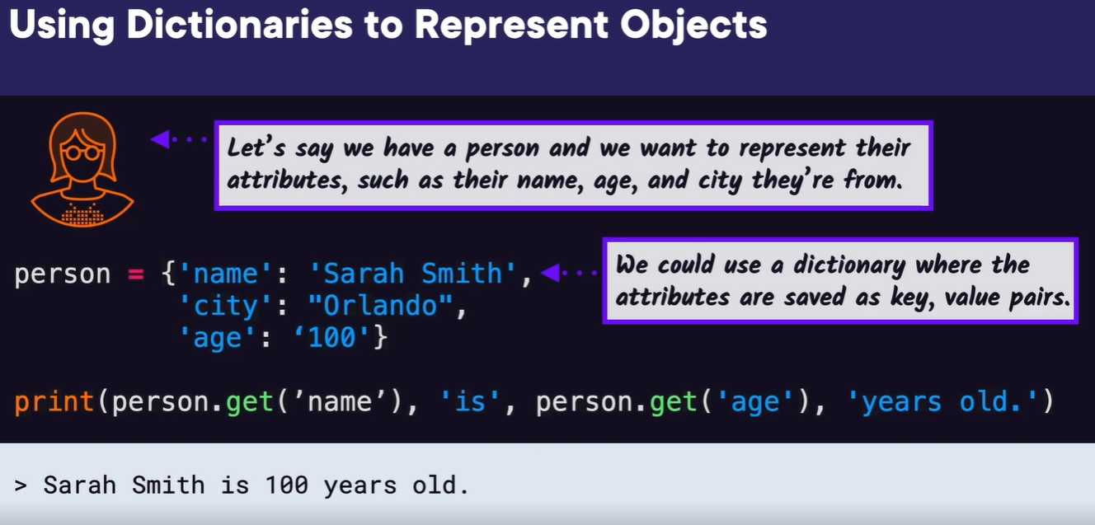

Demo: Parse a Nested contacts Dictionary
In this demo,
we're going to take the dictionary of contacts for our class
and print out a list of only email addresses so that we can
send an email to the whole class.
We have VS Code open, and we're going to create a new file called contacts.py.
To get started, the registration website gave us a contacts list as a dictionary,
so we could paste it in here,
but I'll type it in so we can all follow along with what the format is.
First, the dictionary has the key number with the value 4,
which means there are 4 students.
Then it has the key students, with a list as the value.
Inside the list are dictionaries with each student's information,
their name and email address as strings.
The first student's name is Sarah Holderness,
and their email is sarah@example.com.
And then the other three students follow the same pattern,
so we have Harry Potter with harry@example.com,
Hermione Granger with hermione@example.com,
and Ron Weasley with ron@example.com.
Now that we understand the format of the contacts dictionary,
our goal is to take this and only print out a list of the
emails so that we can create an email group.
You may be thinking there's only four emails,
so why don't you just copy and paste them into the email group?
But what if we had hundreds of students in the contacts list
that we just got from the registration website?
Then we would have to manually find the emails,
so it would be much easier if we can set up a program to do it for us.
To start, let's print each student dictionary in this students list.
We can create a for loop that loops over the student list
by using contacts with the students key.
We'll name the loop variable student.
Now let's just print student and see if we get each
dictionary with the student's information.
If we run this,
we can see we do see each dictionary printed for each student
now we want to get just the email part.
So instead of printing the student dictionary,
we want to look up the email key and print that.
If we run this, we should see a list of the emails printed.
Great.
Our program worked.
That was actually a really short program,
but it showed how to drill down into a dictionary that has a list
of dictionaries and access the values inside, which will become useful in our next examples.
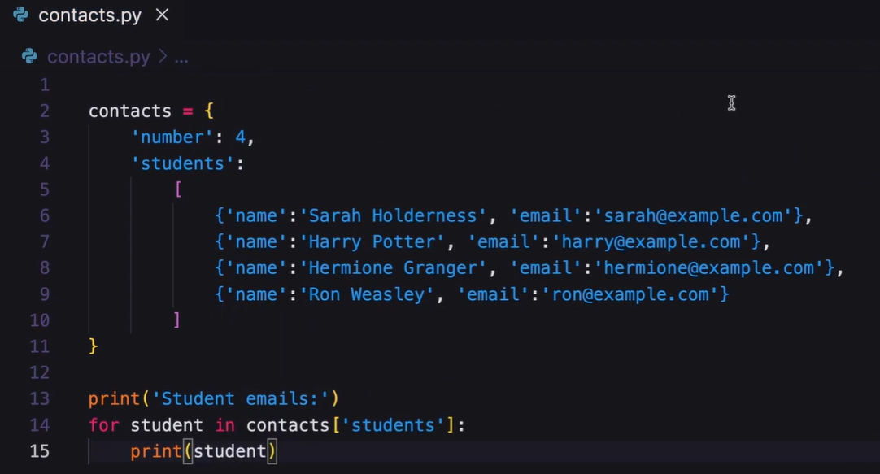
Reading Json and Installing Packages with Pip
Welcome back.
In the this module,
we're going to look at requesting data from the
internet using the Requests package,
and we'll look at how to install the Requests package using pip.
Up until this point,
we've created our own data or used data local to our own computer,
but now let's create a program that gets current data from the internet.
Some data that is openly available is the current people in space.
Let's create a program that requests that data and then
displays the current people in space.
When we're finished, if we run our program,
it would make an HTTP request or web request to the web server
for the website that stores this space data,
then the website would respond with the current people in space,
and our program would print those people to the screen.
If you're not familiar with an HTTP request,
HTTP is how you communicate with web servers that host websites on the internet.
You send a request to view a certain site,
like pluralsight.com, for example,
then the web server can return HTML that is then
displayed as a web page in your browser.
Some websites return raw data,
and usually that raw data is returned under the API,
or application programming interface, for that website.
For example, Twitter has an API at api.twitter.com.
In this case,
an HTTP request is sent to the web server and the HTTP response is returned,
but now raw data, many times in JSON format,
is returned and then different applications can do
different things with that data.
The program we're going to make is going to read that raw data
and then list the current people in space.
JSON is a data format that is usually used to
exchange data to and from a web server.
We've actually seen what JSON format looks like.
It's typically a mix of lists and dictionaries.
So if you remember our previous demo, using student contact information,
we've actually parsed JSON data before.
JSON stands for JavaScript Object Notation because it
started in the JavaScript language,
but now you can use JSON and it's widely used in any programming language,
including Python.
Since we're already familiar with the JSON format using dictionaries and lists,
now we just need to figure out how to get that JSON data,
and that's where the Requests package comes in.
If you do a web search for HTTP requests in Python,
the first result should be for the Requests library.
The Requests library lets us do an HTTP request,
which is what we want, but Requests is not installed with Python,
so we need to install it ourselves.
We also haven't installed packages with Python yet,
but there's a handy tool called pip that comes
installed with Python that we can use.
Let's check if we have pip installed correctly by opening
a terminal and typing pip --version.
If it doesn't print out the current version like I have here,
then you'll need to add pip to your Path variable.
Now we can install the Requests package by typing pip requests,
and you'll need an internet connection because it's going to
download the library from the internet.
You'll see some output related to the packages downloading.
and then finally,
you should see Successfully installed requests printed to the
screen followed by the latest version number.
Now that the Requests package is installed, we can use it in a program.
Before we can use Requests we need to know where we'll be requesting data from.
Open-notify.org is the website that has information
about the API we'll be using,
and we can see it lists the API address as api.open-notify.org/astros.json.
And that json at the end helps us know that it returns data in JSON format.
The website even shows the specific JSON format that will be returned.
There will be a message if the request was success,
there will be a number for the number of people in space,
and there will be a key people for the list of the people in space where
each person is listed with their name and spacecraft name.
Now we're ready to start our program,
and we'll start by importing the Requests package,
then we can call the requests.get method and pass in our HTTP address,
and we want to save the result to a response variable.
Then we'll call the response.json method to decode the JSON from the response,
and we'll save the result to a variable named json.
Now we can print the json variable and we see the JSON data we
were expecting in the format we just saw.
We can see it's stored as a dictionary with the keys that we mentioned earlier.
But from this JSON data,
how do we get the inner list of people so that we can print
out each of those people to the screen?
We can start by using the people key that points to that list of people.
So let's give that a try now and print out the result and see what we get.
We'll use a for loop over that list by using the
json variable with the key people, then the loop variable will be called person,
then inside the loop we'll print each person.
We can see that each person is a dictionary with the
astronaut's name and their spacecraft's name,
but we just want to print that name part.
We can do that by using the person variable followed by the key
name to get just the name part of the dictionary.
If we run the program again, we can see we got what we wanted,
we're able to print the names of the people in space.
Finally, let's add a heading that says, The people currently in space are:.
And now if we run this, we see our program is complete.
Now let's practice what we've learned so far about JSON, pip, and the Requests package in the demo.
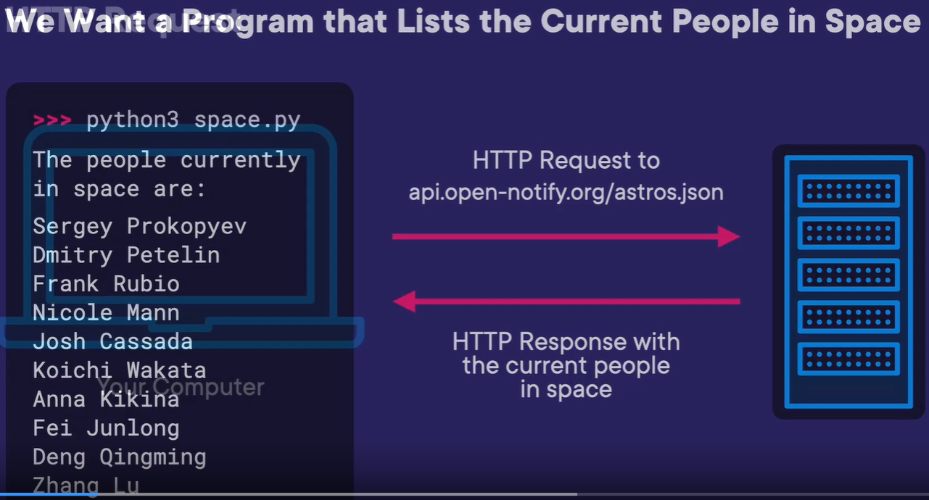
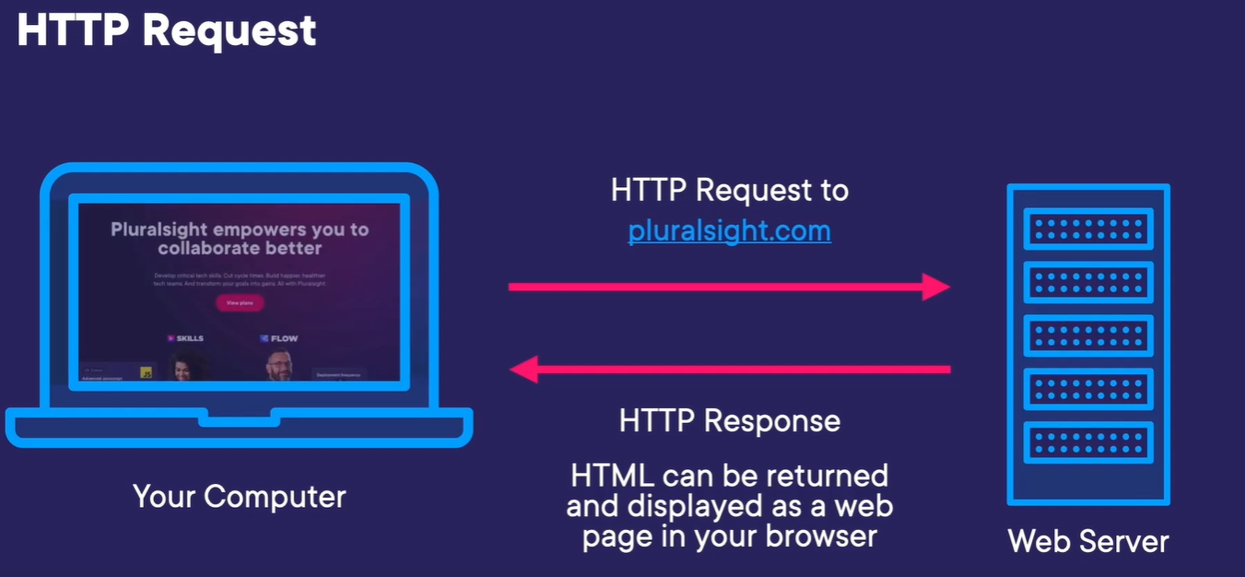
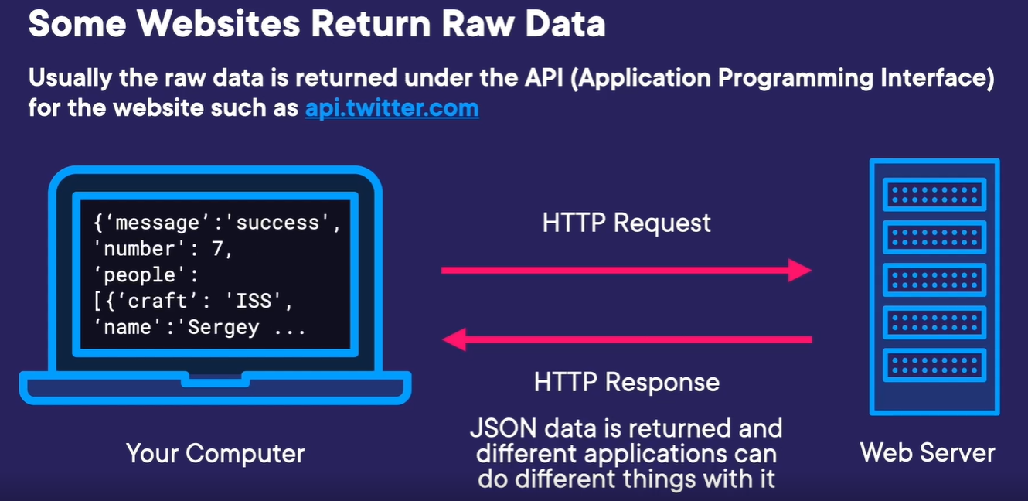
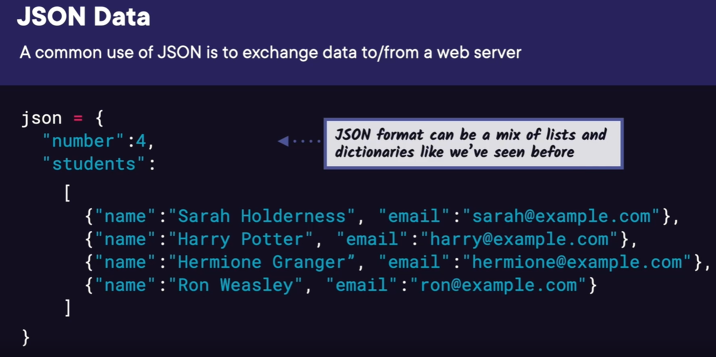
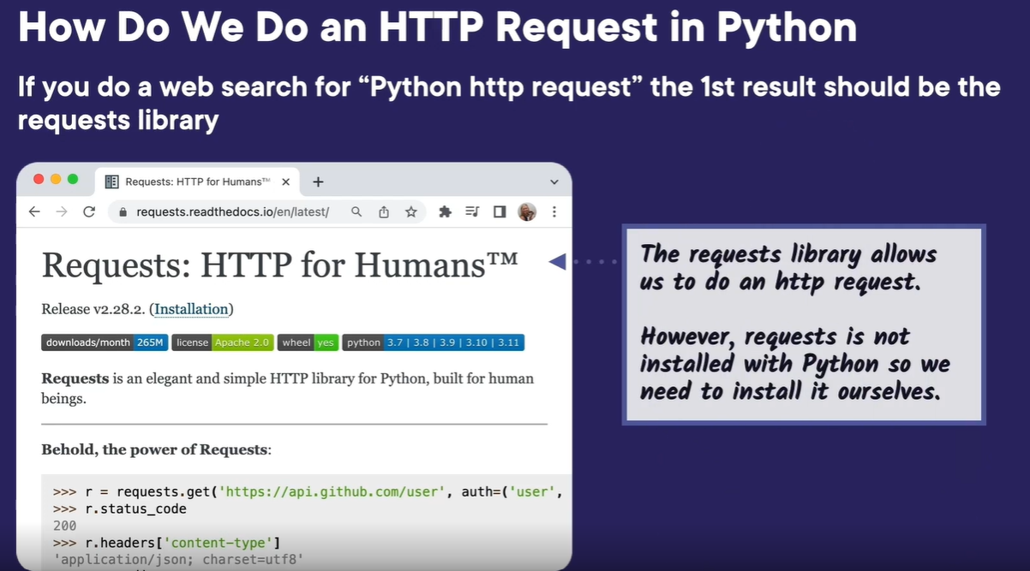
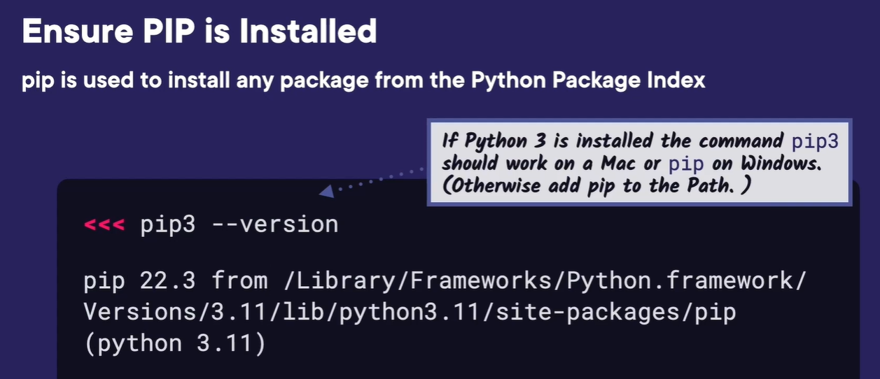
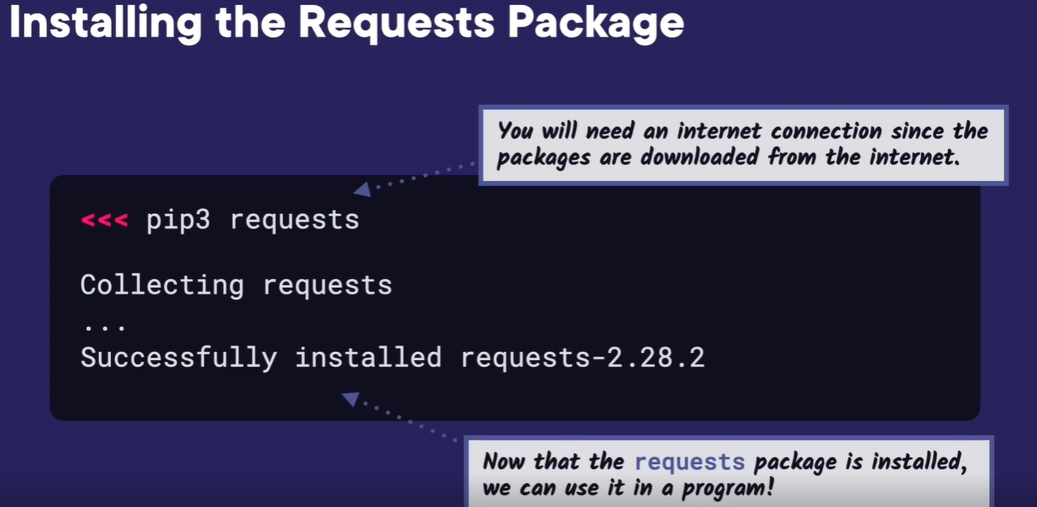
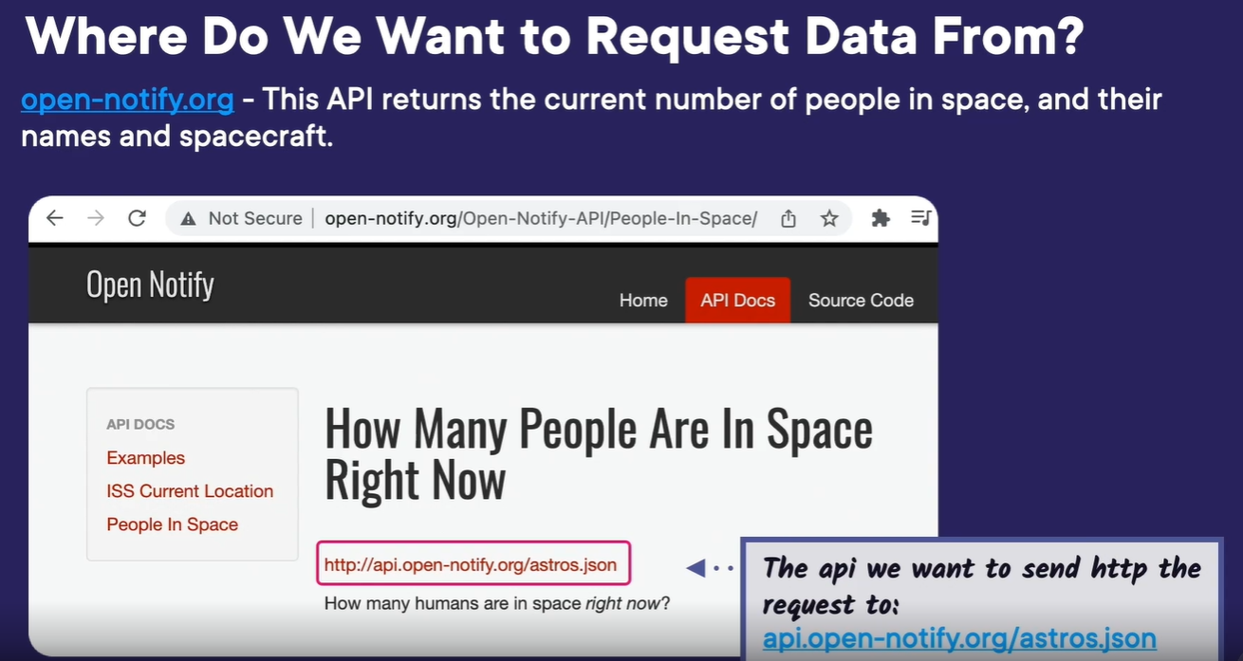
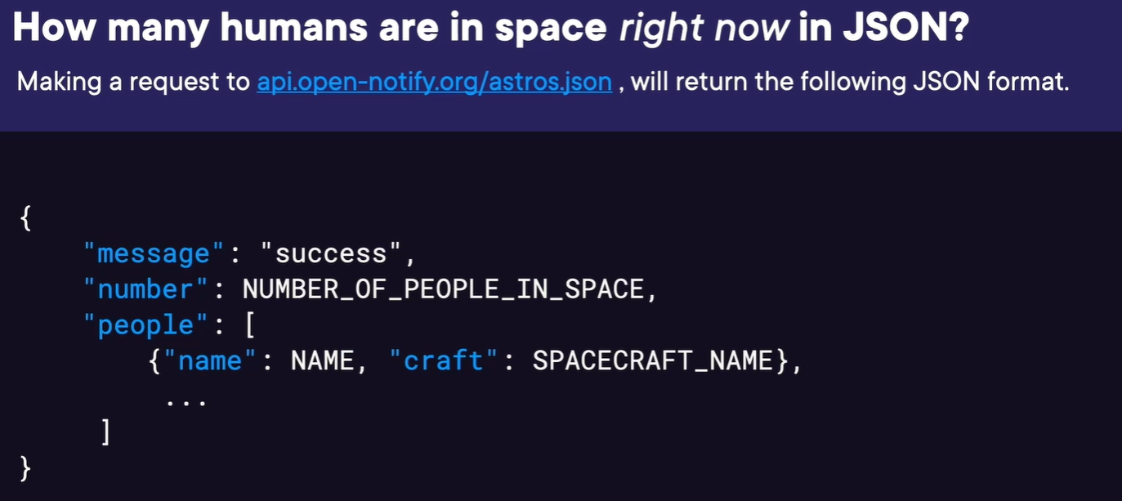
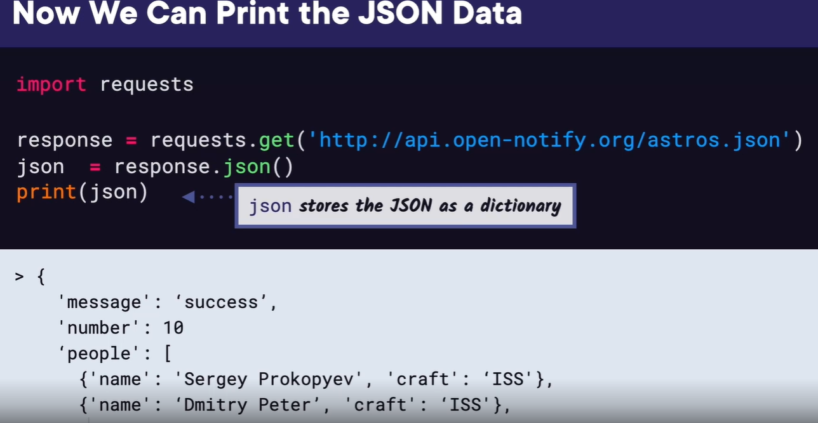
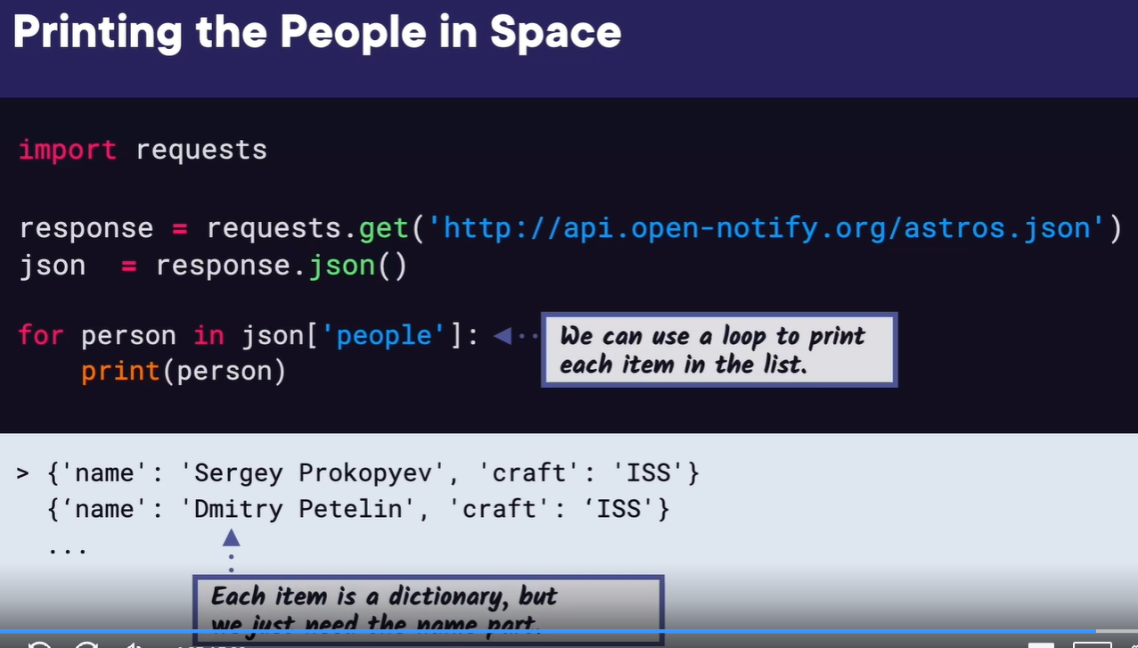
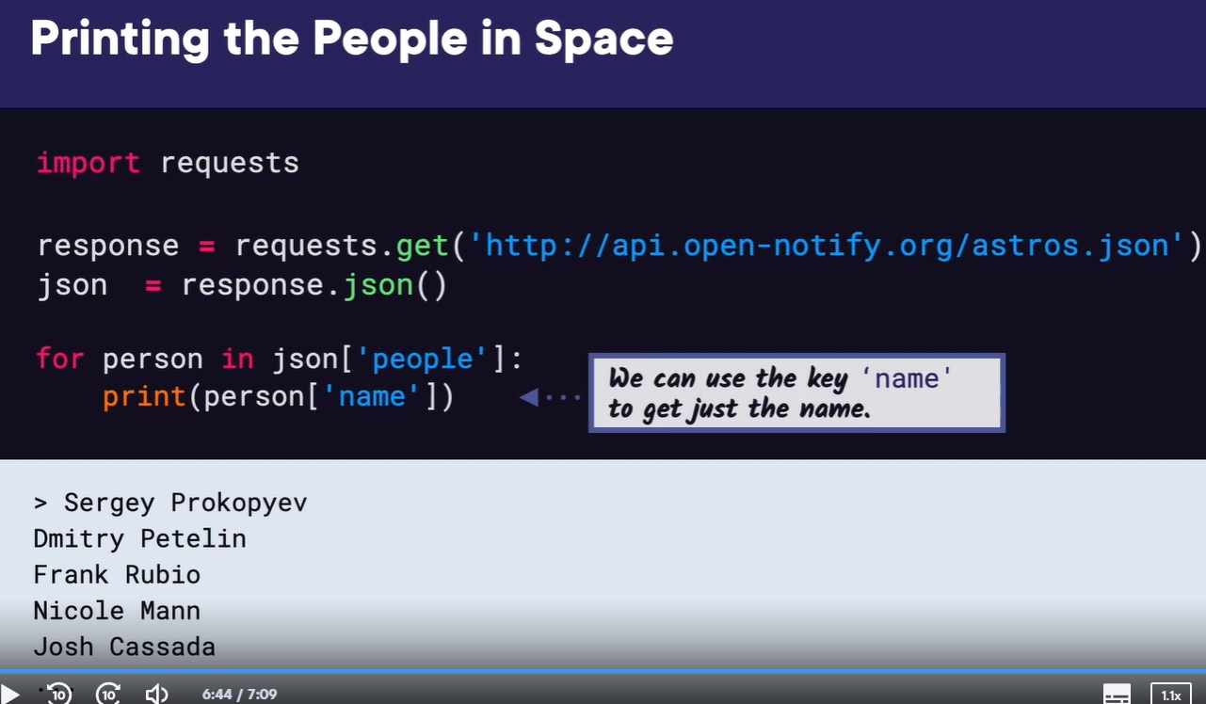
Create a python virtual environment
As we showed in the slides,
we can install the request package with pip by typing pip3 install
requests. That installed the requests version 2.28.2 globally to our
computer, which will work fine for the purposes of our previous space
people program. But in this demo,
I want to tell you about the benefits of using a Python virtual
environment. What if one Python project that you created needed
this version of the request package,
but then in the future you created a new project that used the most recent
version of requests? Then both projects might be dependent on different
versions of the requests package, and this might cause the project with the
older dependency to break. In that case,
you can use a virtual environment in Python to manage different versions of
different packages. If we go to the Python documentation for virtual
environments, we can see a more detailed explanation, but basically, you
can have a virtual environment for each project that manages what packages
and their versions are installed for each project. Now let's look at how to
do this, and I can show you it's pretty easy, you just need to use a few
commands.
If we scroll down,
you can see the command to create a virtual environment is python3 -m venv,
and venv, v-e-n-v,
is short for virtual environment. Then after that, you put the
directory name you want for your virtual environment.
Now let's go back to VS Code, and in the terminal we can give this a try.
But before we create our venv, let's uninstall the requests package globally
so that we can show the requests package working in our new virtual
environment. First let's create our venv with the command python3 -m venv,
and then the name of our virtual environment we will also name venv, and then
hit Enter. This created a directory called venv, because that's what we named
it, inside of our project folder. In the bin directory, we can see the
activate script, and the versions of Python and pip that are installed there.
Now if we go back to the docs,
we can find the command to activate the venv, which is what we need to do
before we can install packages with it, or use packages with it.
The command for Mac is source, the directory name, then /bin/activate.
Once it's activate,
you can see the venv in parentheses in front of the command prompt, so it
helps remind you that it's already running. Now this is when we want to
install the requests library with the same command, pip3 install requests.
Now the requests package is installed locally for our venv only. To see
further that this is working, let's create a Python script with our
space_people program copied over from the slides, and you'll remember that
also imports the requests library, so it's important that it's already
installed.
Now we want to run our program and verify it works, but VS Code
doesn't know to run Python with our new venv. Actually,
it did prompt us to select the venv when we created it,
but I'm showing you the manual way to set it up just in
case it doesn't prompt you. Go to View, Command Palette,
then search for select interpreter,
then scroll down to use the Python version you want
with the venv in parentheses.
Now if we press Run, we can see our program working,
and it's using our venv to run it.
If we ever need to deactivate our venv, we just type in the command
deactivate into the command prompt and hit Enter. And that's how you
use a venv, or virtual environment, in Python, and I highly
recommend trying and using venvs to manage packages that are installed for your projects.
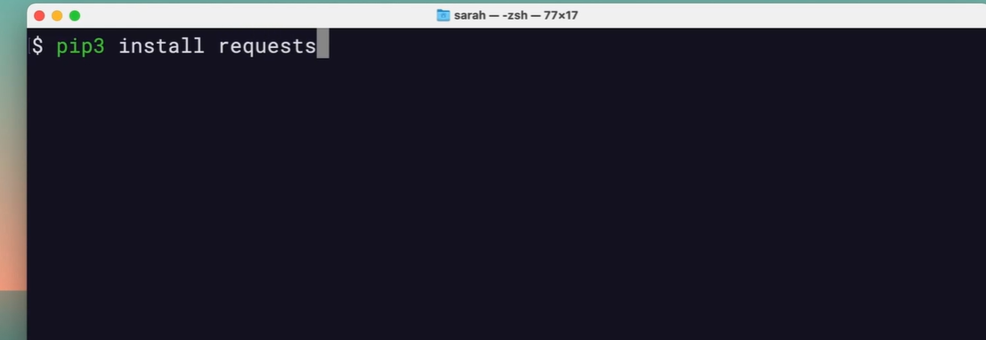
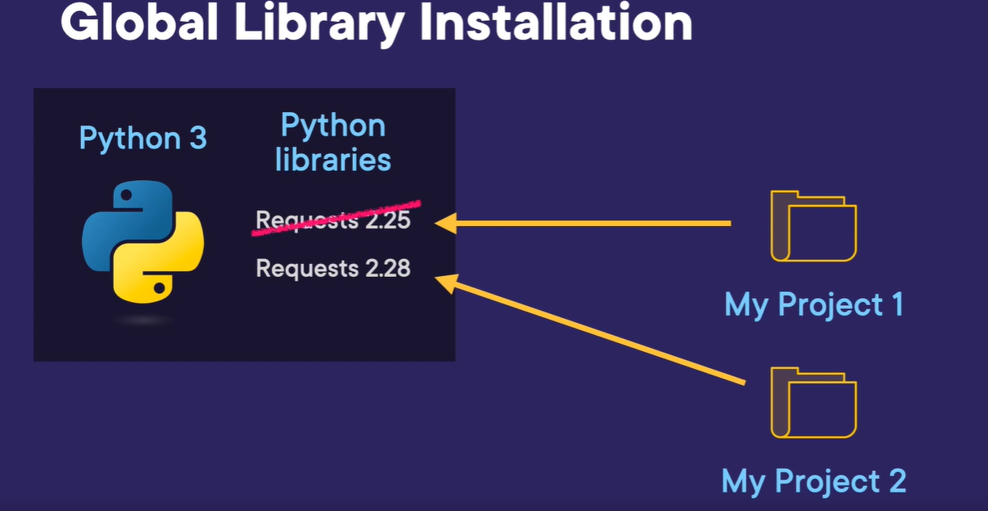
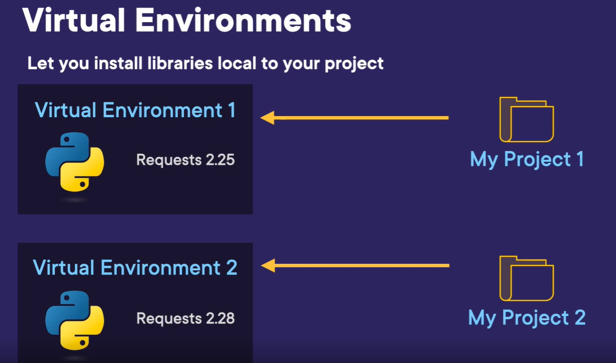
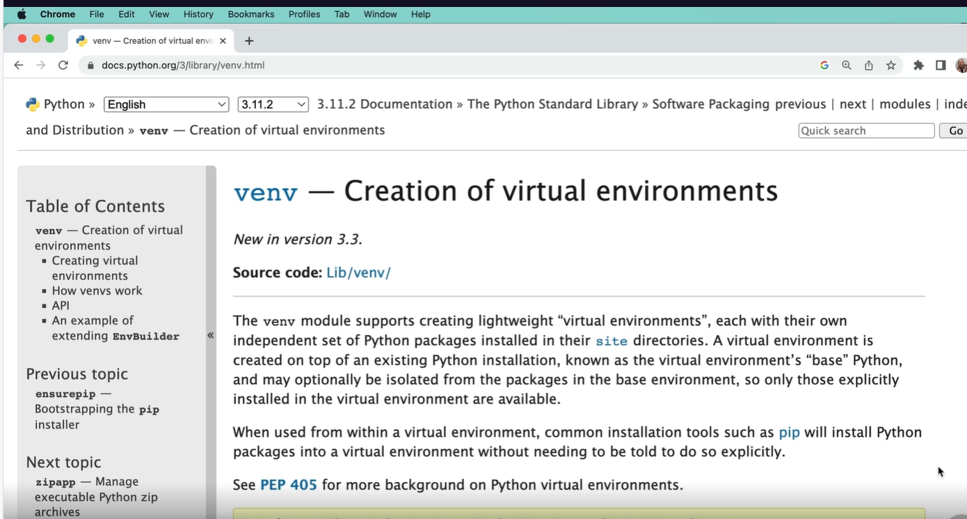
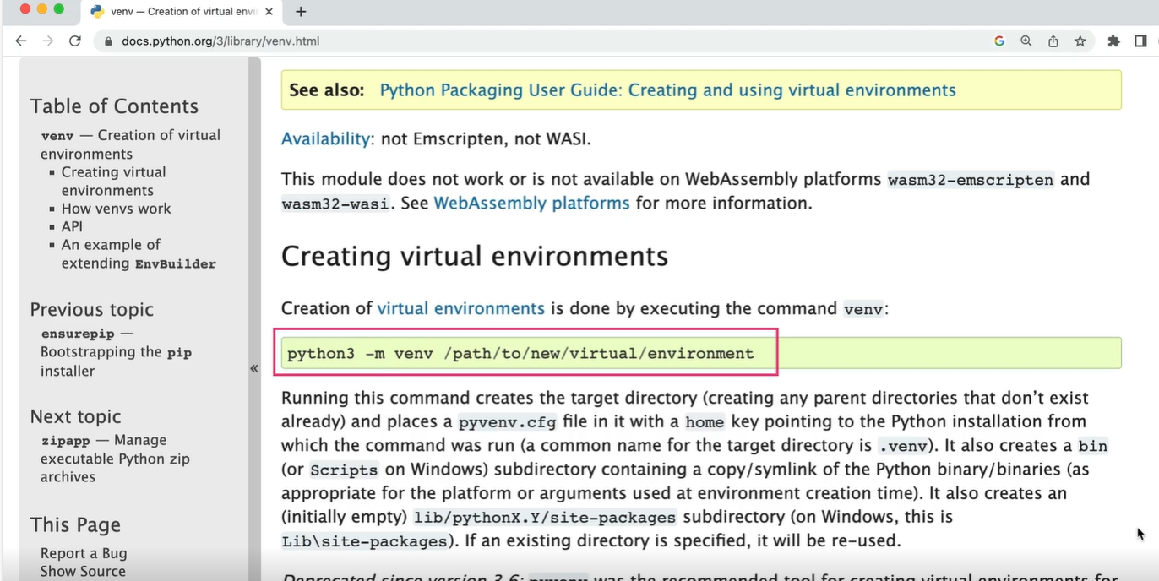
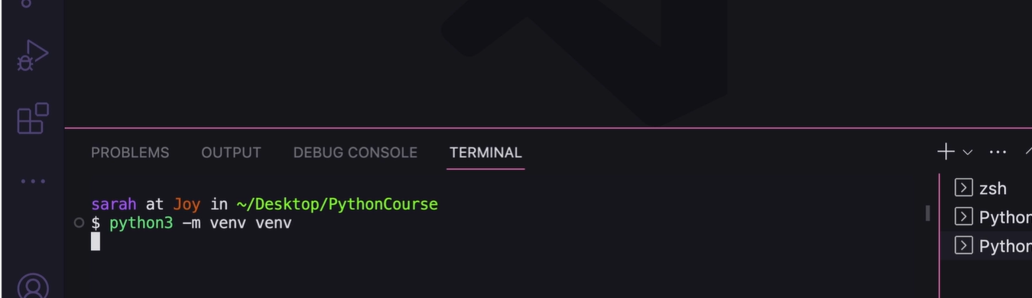

Demo: Use the Open Weather Map API
In this demo, we're going to look at another example of requesting JSON data,
this time from a weather API.
We have VS Code open, and we're going to create a new file called weather.py.
Then to use the free weather API, let's go to their website at weatherapri.com,
and we'll see where to start.
We can click on Pricing in the menu, and we want the free version,
so we'll click Get Started to sign up to use it for free.
You can see it asks for your email address and a few other
things and to agree with their Privacy Policy.
I actually created an account earlier,
so I'm going to log in and show you what that looks like.
Once you log in, you can see your API key.
The API key is what you need to be able to request data from their API,
and a lot of APIs require a key.
We need to copy this and use it in our request URL.
To figure out what goes into the request URL,
we can go to the API Explorer page from the menu,
and we'll see how to make that API call.
First, we paste in our API key,
then we'll add in the location we want the weather for.
We'll put Orlando for our city and then click Show Response.
First, we see the actual URL for the API call.
You can see that it constructed the URL we'll need for our program
that has our API key and the location as Orlando.
We'll want to copy that so we can use it in our Python program.
Then we see the full JSON output,
and there is a lot of information here to sift through.
For our basic weather program,
we're just going to display the current temperature in Fahrenheit,
which we can see is 77, and the description of the weather,
which we can see is Sunny.
Let's go back to VS Code and paste that URL into our script.
First, we'll import requests since we'll need that.
Then we'll create a variable named url, and paste in the URL,
and wrap it in quotes.
Now we can use the requests library to get the data from this URL.
We'll create a response variable and set it equal to calling requests.get,
and pass in our URL.
Then we can get the JSON from the response by creating a JSON
variable and assigning it to calling response.json.
Finally, we can print the JSON.
If we run this, we get our JSON output.
And you can see this isn't formatted like the JSON on the website,
but it has the same values, like the location as Orlando,
the temperature as 77 degrees, and the condition text as Sunny.
Let's go back over to the formatted version on the website so we can
figure out how to get the values we want out of the JSON.
Now we can see we have a dictionary with keys for location and current.
Current is what we want.
And inside this inner dictionary,
we want the temp_f key for the temperature in Fahrenheit.
Let's go back to our program and try that.
First, we'll create a temp variable, short for temperature,
and then set it equal to weather_json.get,
and then the current key,
and then we can chain another call to .get for the temp_f key.
If we run this, we can see that we got the value of 77 degrees,
which is what we wanted.
Next, for the description, we want the current key,
then the condition key, then the text key.
In our program,
we'll add a variable called description and set it equal to
weather_json.get again with the current key,
then the condition key, then the text key.
I know that's a lot of keys to chain together,
but we have nested dictionaries in our JSON.
Let's edit our print statement to put this all together.
We'll say Today's weather in Orlando is,
then the description, and then the temperature,
then degrees.
If we run this, we see Today's weather in Orlando is Sunny and 77.0 degrees.
Great.
Our program is working.
It's getting the Orlando weather from the weather API and then parsing the
JSON response to print out the temperature and description.
Now we can actually improve this program by editing our URL to use a
city variable so that we can change the city easily.
We can split up our URL string and concatenate the city variable in the middle.
Let's change the city to London.
We also need to edit our print statement so that it
says what city the weather is for.
If we run our program again,
we see Today's weather in London is Clear and 46.4 degrees.
Great. Now our program can get the weather for any city we want.
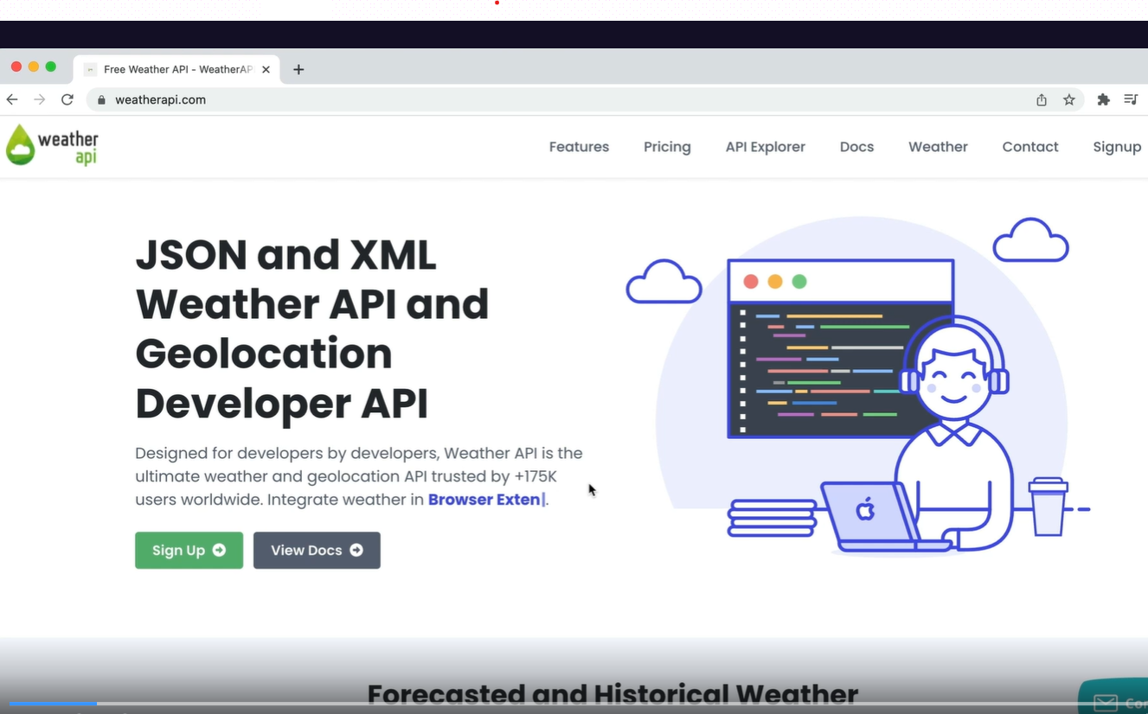
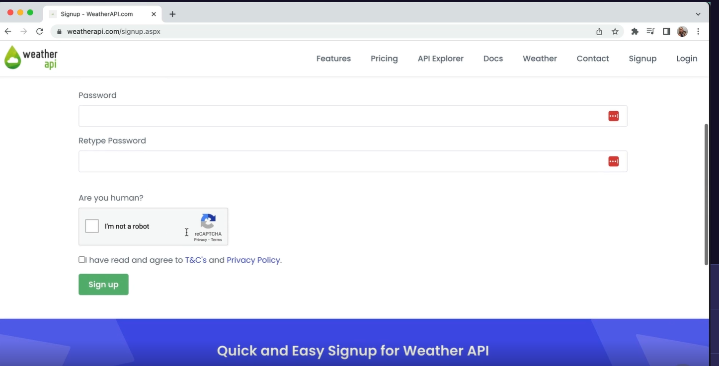
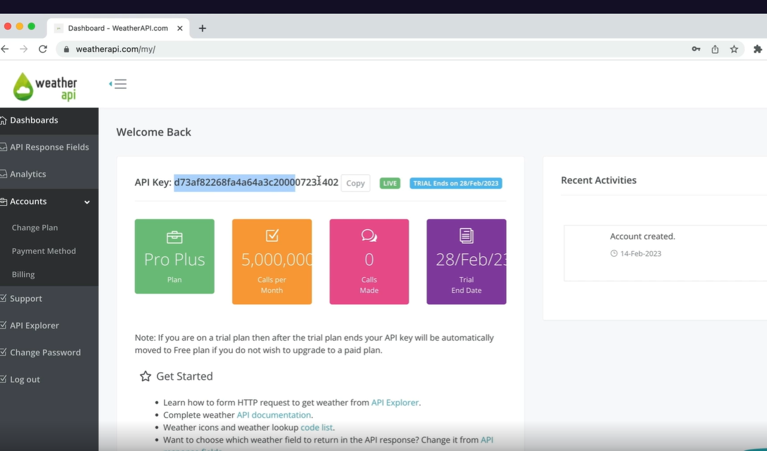
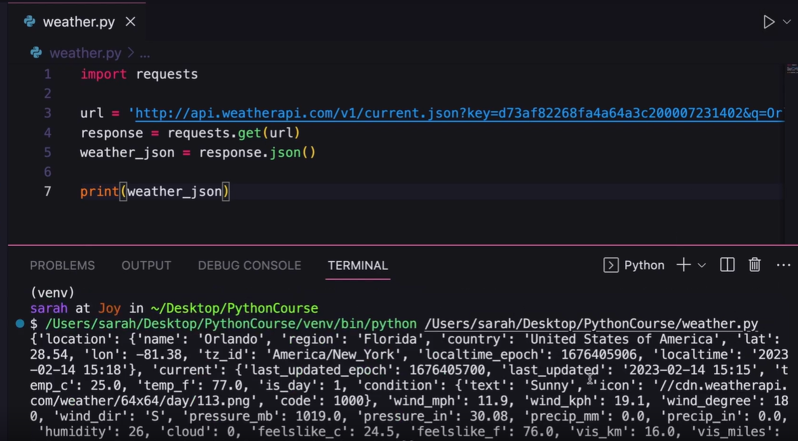
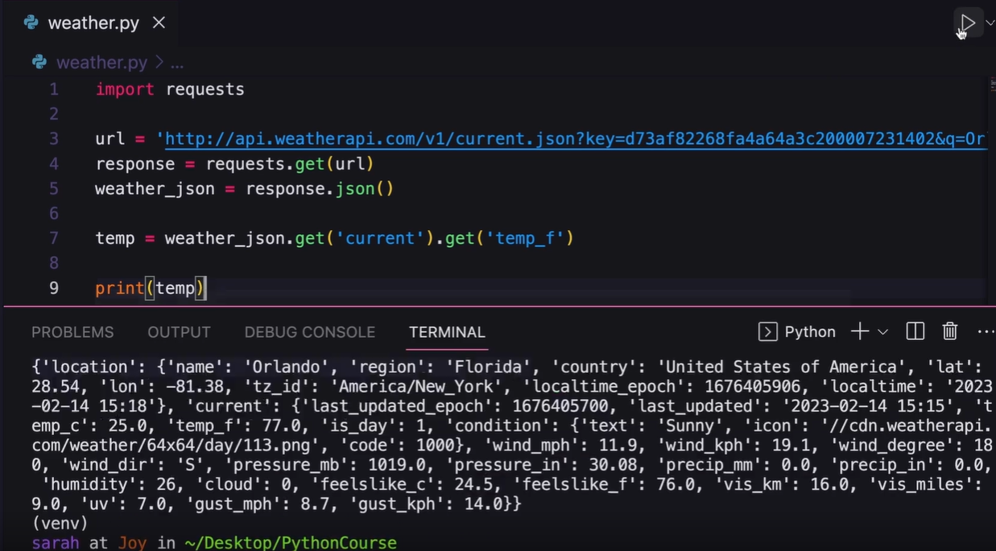
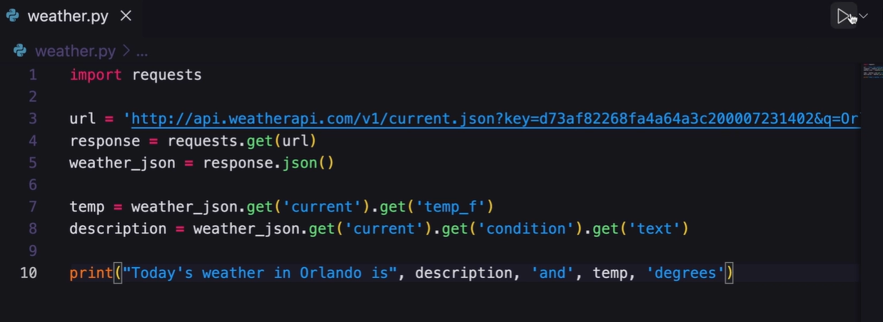
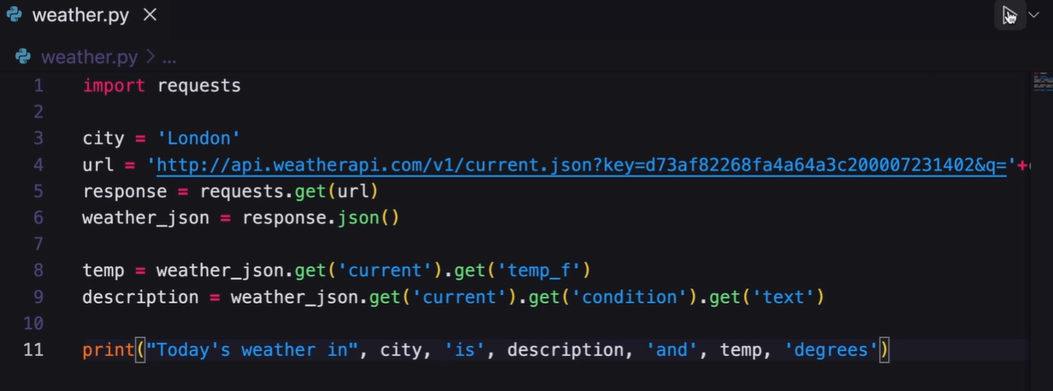
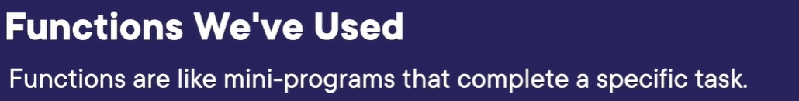
Hello again.
I'm Sarah Holderness, and in this module,
we're going to look at Python functions.
We've already used quite a few functions so far,
and we can think of functions as mini programs.
And although we might not know exactly how they work,
they return the expected results.
One of the functions we've used so far is print,
which takes in a string or multiple strings and prints them to the console.
Input prompts the user for input and returns the string they entered.
Int converts the given number to an integer and returns it.
And randint takes a low and high bound and returns a
random integer within that range.
As we can see, we can define a function to do pretty much anything we want,
and once we define it, we can use it over and over again.
Now let's define our own function.
We want to a simple function that prints a greeting given a name as input.
Defining a function starts with the def keyword,
short for define, then the function name,
and then you can add any parameters.
These are the values that you need to pass into the function.
Then the function body is indented below the definition.
Let's put our function to use in a program.
At the top of greetings.py, we have our function defined.
Then below it, we have our Main program,
which is where the program starts running.
It starts by asking the user to input their name,
and then the greeting function is called.
Note that the greeting function doesn't get run until it's specifically called.
It's important to know that order matters in your program.
You need to define a function first at the top of your file before
you can call that function in your main program,
just like you need to define a variable before you can use it.
Let's look at the order in which our program runs.
After running our program,
it starts with the first line of code that isn't in a function definition,
and then it knows that's the main program.
After that first line is run, Enter your name is printed to the screen,
and then the user enters Sarah, which is saved to the input_name variable.
Then we go to the next line of the Main program,
which is a call to the greeting function,
and the value of input_name is passed in.
Since we called a function, we now go to that function.
Now the name parameter is assigned to the passed in value of input_name,
which was Sarah.
Then we go to the first line of the function,
which prints Hello and the name variable,
so we see Hello Sarah printed to the screen.
Now since the function is finished,
Python runs the next line of the Main program,
which is complete so the program stops executing.
Just like order matters in a program, so does scope.
A variable defined inside of a function is only available
to be used inside of that function.
That's known as local scope.
This means in our greeting program,
the variable name only exists inside the function where it was defined.
So if we try to use the variable name in the main body
of our program by printing name, we get an error that name is undefined.
If a variable is created inside the Main program,
then it is a global variable and has global scope,
meaning it can be used anywhere even inside a function definition.
Here,
let's rewrite the Main program with the variable name defined on the first line,
which means the variable name is now global.
Then we can change our greeting function not to have a parameter.
Instead, it just references the global variable name.
Now if we run this new program, it runs the same as before.
It would ask you for your name.
Here, it saves the name Sarah to the name variable.
Then the greeting function is called, and Hello Sarah is printed.
Finally, the program would end.
Using global variables can get messy.
Right now, we're using the name variable inside of the greeting function,
but what if we want to enter another name and save it to a variable?
We can save it to a variable named name2,
but then how do we use the greeting function to print name2?
We can't pass it in because greeting doesn't take parameters anymore.
So the only way to use the new value of name2 would be to save
name2 to the name variable and then call greeting,
but then the original value saved to the name variable is gone.
Let's try this example again with local scope.
So we'll change the greeting function back to the way
it was to take in a name variable.
Again, we have two different names in our Main program,
name1 and name2,
and now we can call the greeting function to print them both separately.
If we run this, we can see it asks for a name and prints Hello Sarah,
and then It asks for another name and prints Hello Bob.
So now things are a little easier to follow because we can use the
greeting function by passing in different name values.
You may be wondering why you would even bother creating a function,
and there's two main reasons.
The first is that you want to reuse a chunk of code over and over again.
And we just saw how to do that with the greeting function
where we reused it for two different names.
You may be thinking that's not a good example because
greeting only had print inside of it,
and we could have easily just copy and pasted print where we needed it.
But if you imagine a large function with many lines of code,
you don't want to copy and paste that every time you need it.
You want it in one central location where you can call that function repeatedly.
And the second reason is because you want to group your code into logical units,
and we'll see how to do that next.
Here we're looking at another example function,
but in this case, it returns a value.
This function takes two numbers and then returns the sum.
Again, we have the def keyword, the function name,
addition, and the two parameters, a and b,
that we want to add.
Then the function returns the number result of a + b.
The return keyword is used to return a value or even a
sequence of values from a function.
Now if we look at using this function in a program,
we first start by defining our function at the top of the file
and then we prompt the user for two values.
Then we call our addition function with the two values,
and the result is returned and saved to the result variable.
Finally, we print the result to the screen.
Let's run this and see what the flow of the program looks like again.
First, the user is asked to enter the first number,
which is saved, to the num1 variable.
Then the user is asked to enter the second number, which is saved to num2.
Then the addition function is called with num1 and num2.
When we enter the addition function,
the value of num1 is copied to a and num2 is copied to b.
Then the result of a + b is returned.
Back in the Main program, the addition result is saved to the result variable.
Finally, the result 62 is printed to the screen, and then the program ends.
As we said before, we can use functions to organize our code into logical units.
So we can take this main body of code and move it into its own function.
Now all of this program code is contained inside of the main function.
But remember, we still need to call that main function,
and we call the main function after the functions are declared.
If we run this, we would see the output is still the same as before.
The code is just organized into function. Now let's take what we've learned and use it in the demo.
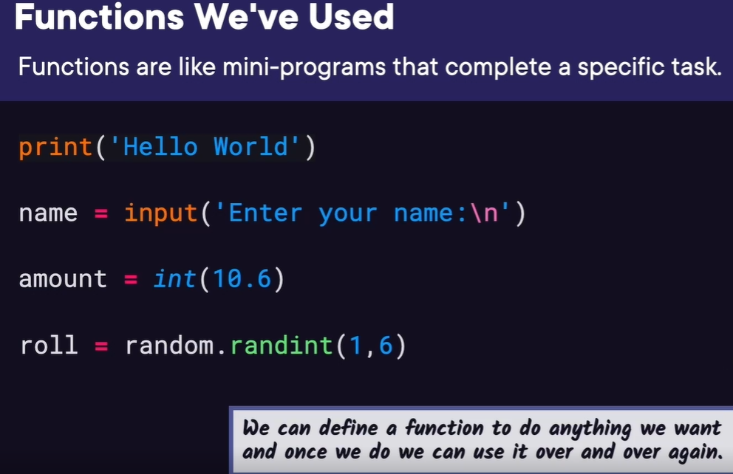
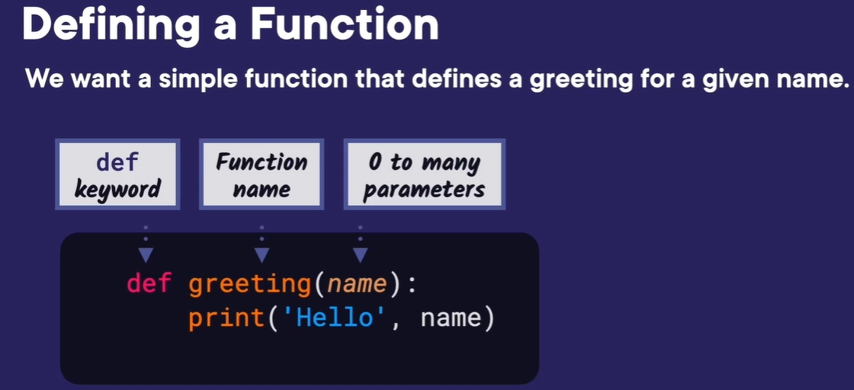
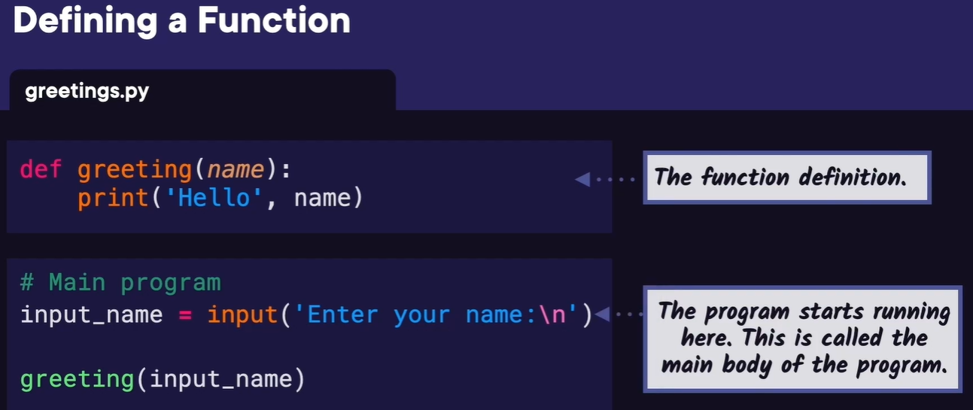
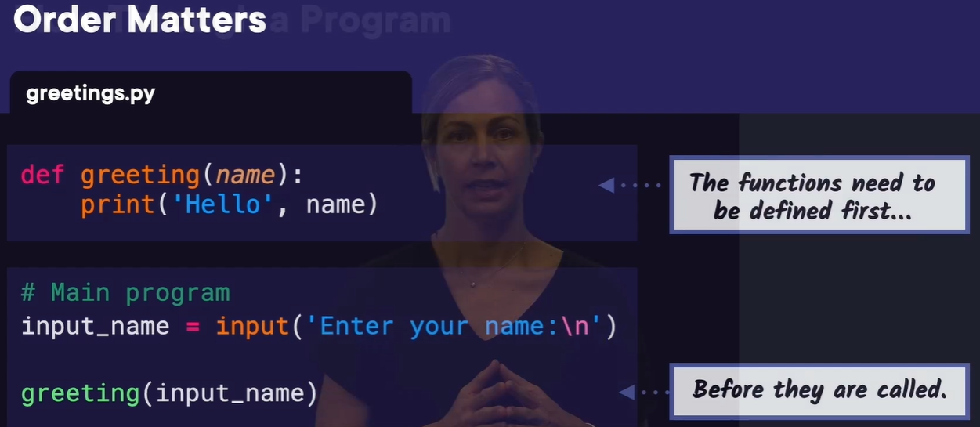
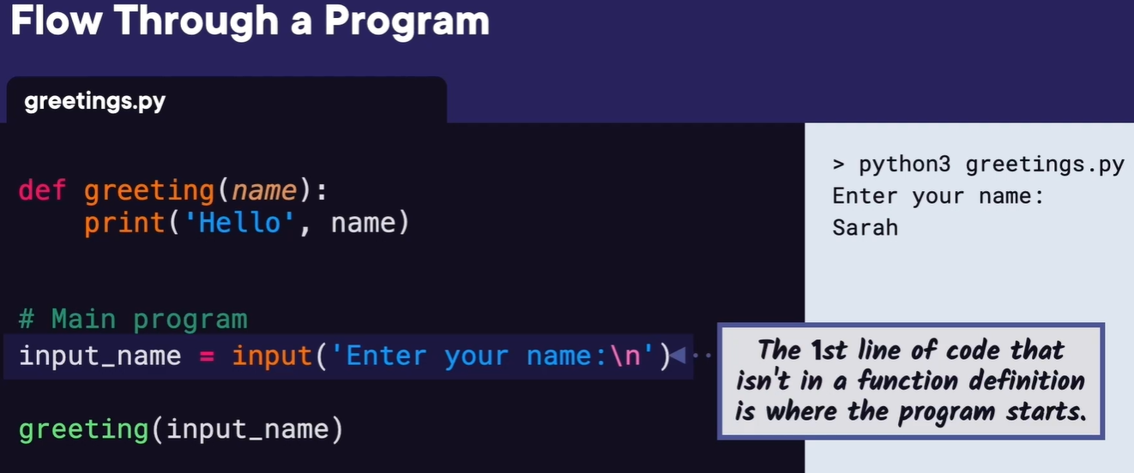
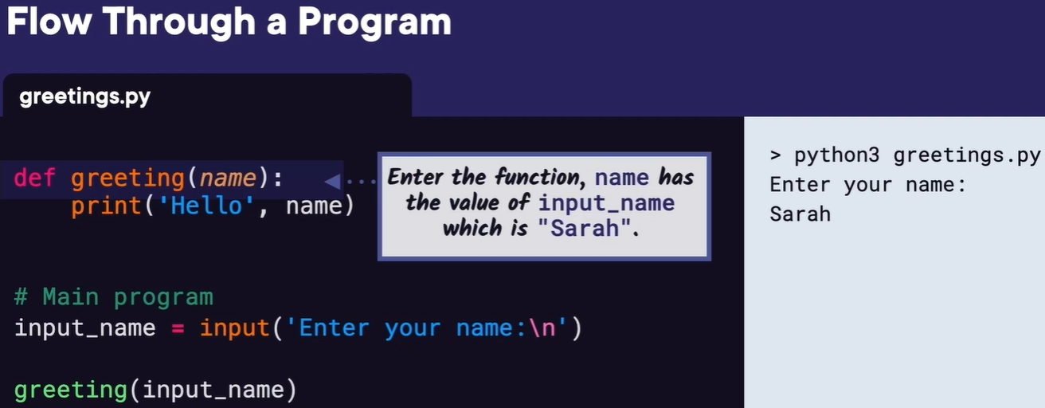
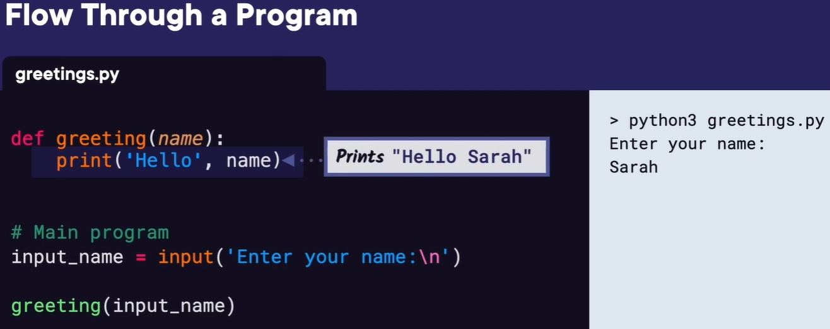

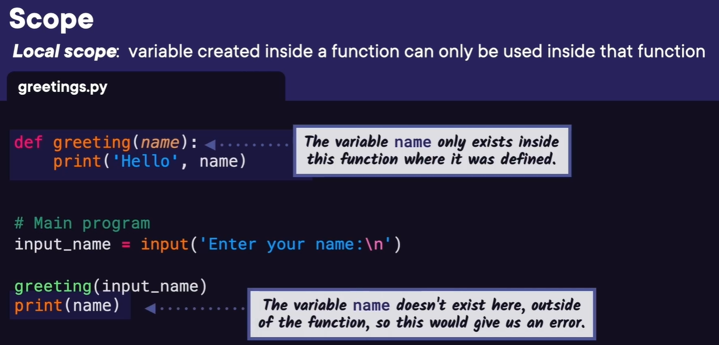
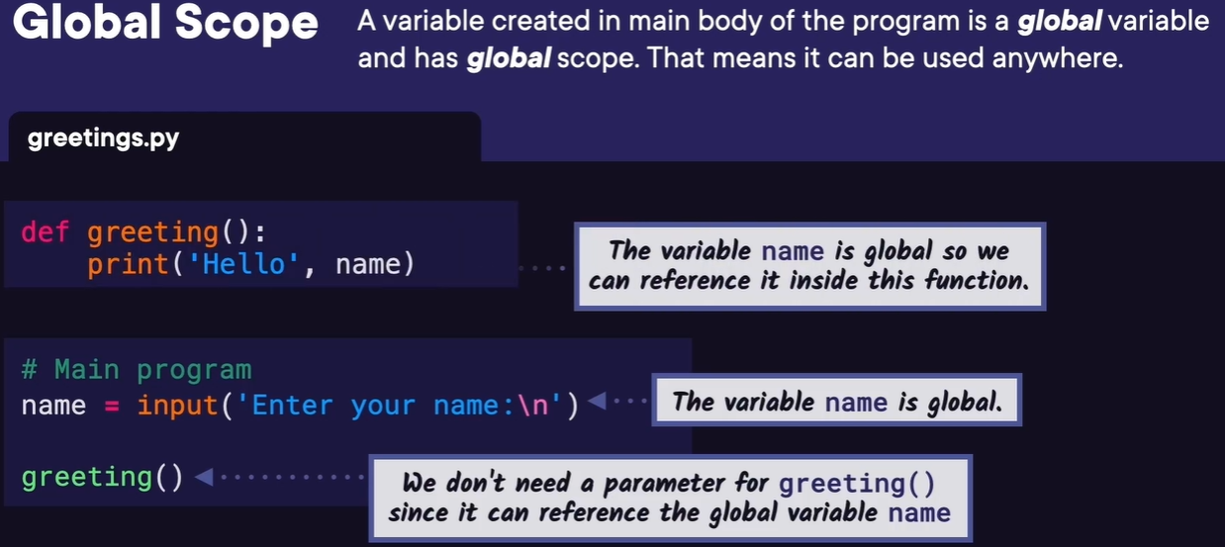
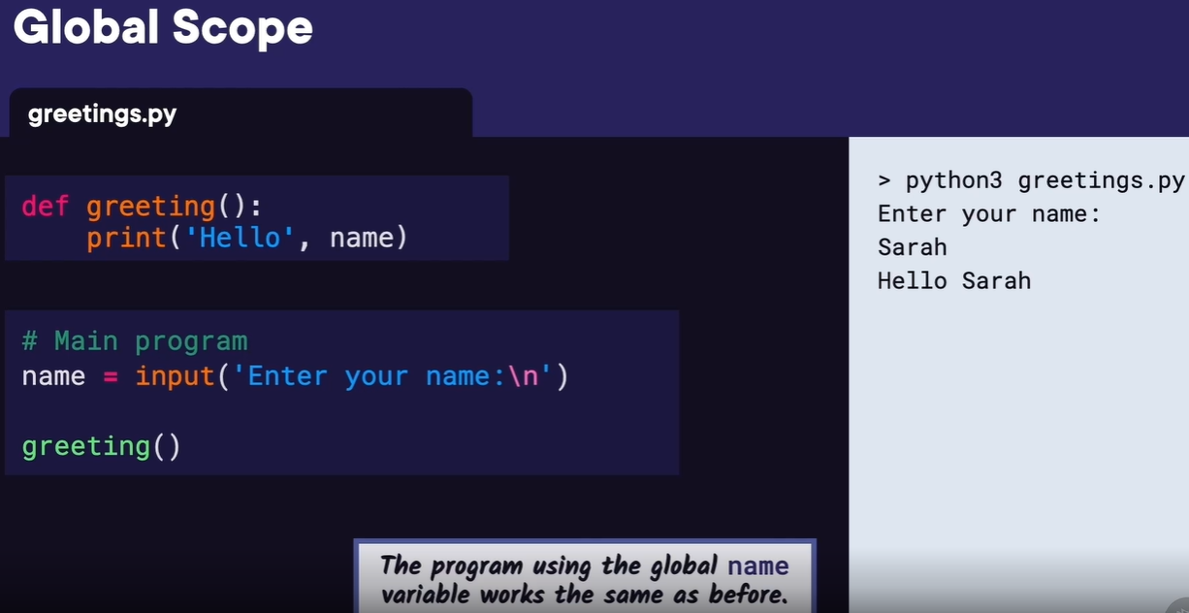
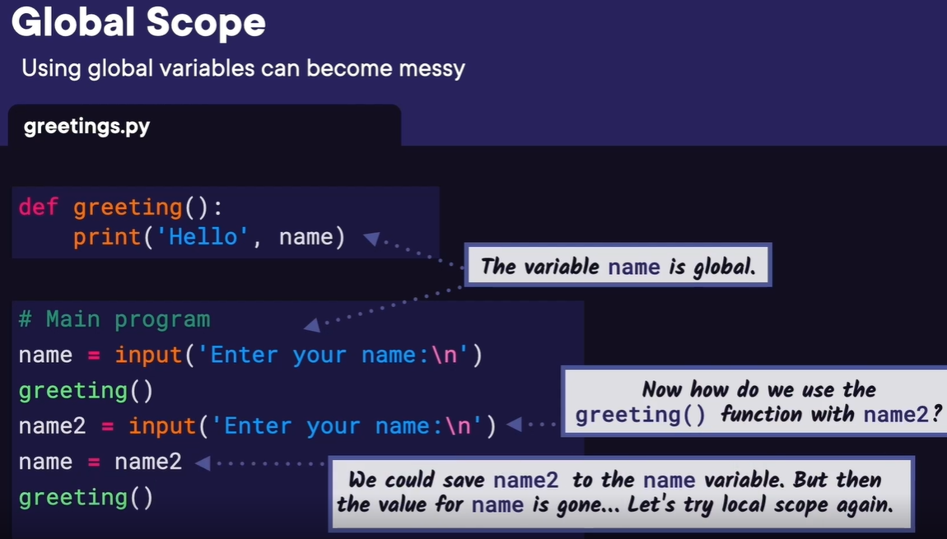
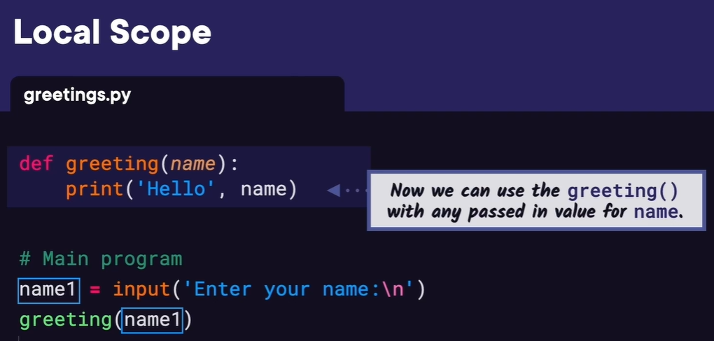
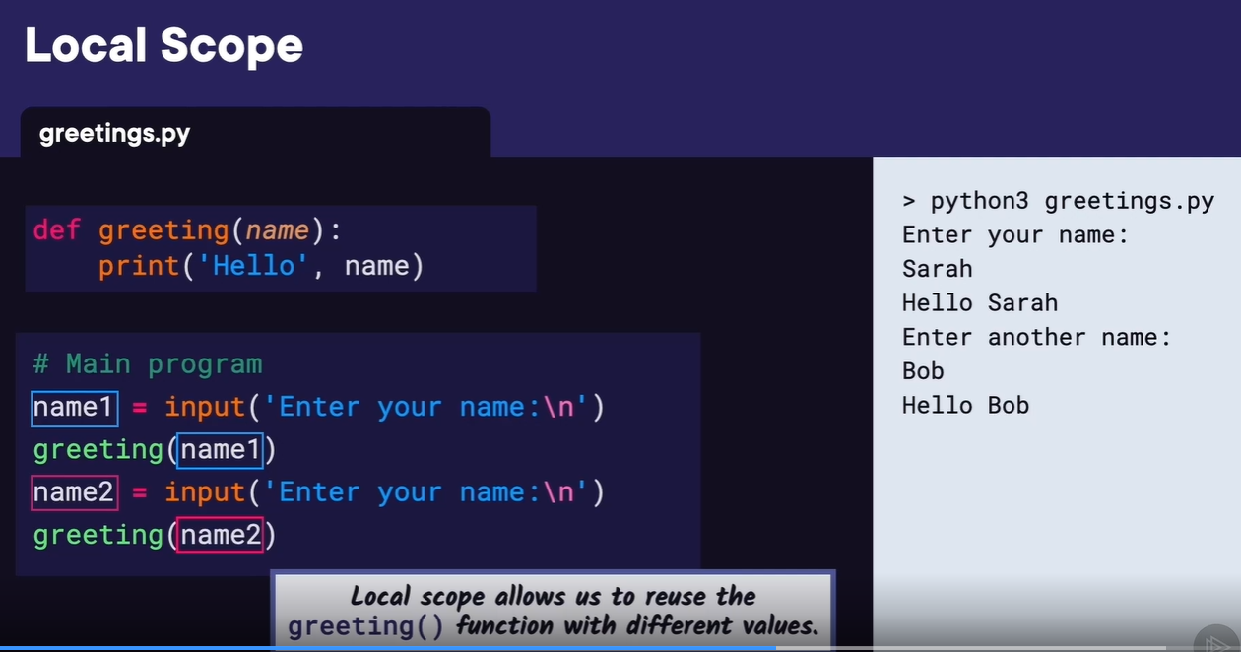
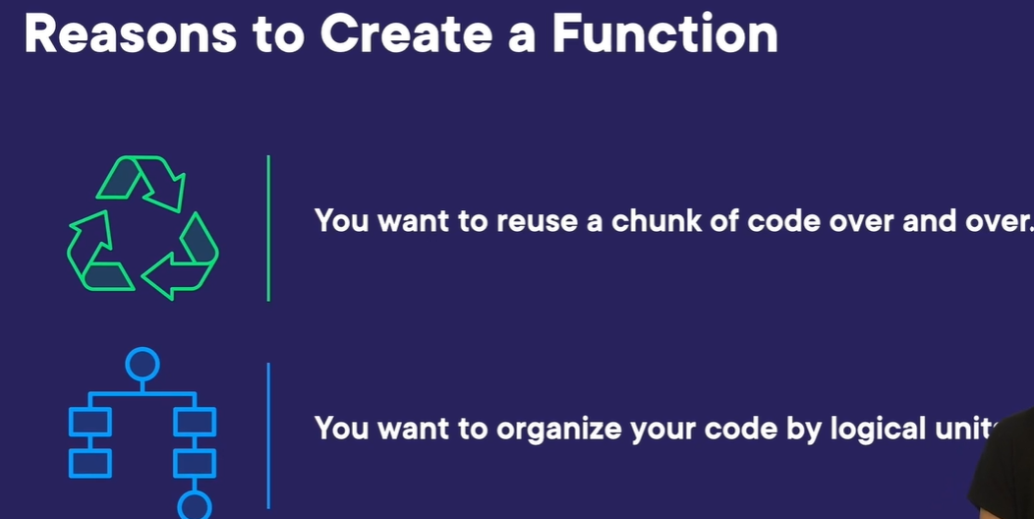
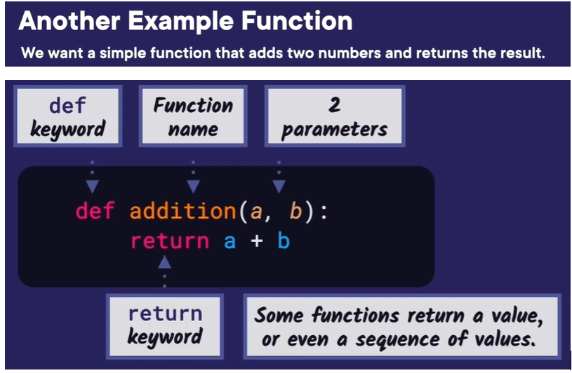
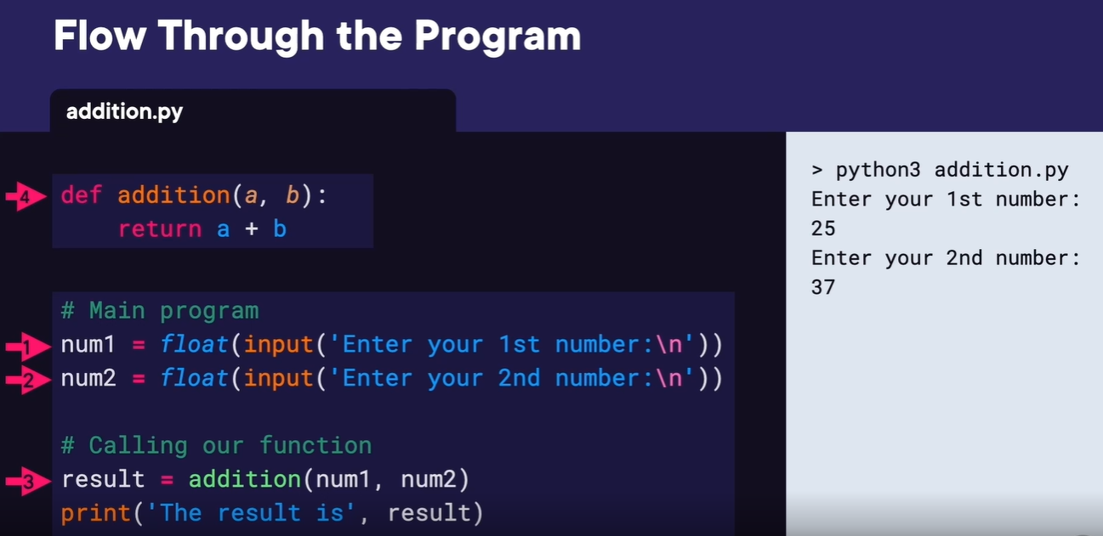

Demo: Create a Dice Rolling Game
In this demo,
we're going to create a basic dice game where two users
will roll a pair of dice to see who wins.
We have VS Code open,
and we're going to create a new file called dice_game.py.
First let's ask the players for their names.
That way,
we can say who rolled what and who won. So we'll call the input function
with Enter player 1's name and save the result to a variable named player1.
Then we can just copy this line and change the variable name to player2,
and change the string to say player2. Now it's time for the players to roll
the dice. To do that, we're going to use the Python random package and the
randint function.
If you remember from module 3, we first need to import random,
and since it's part of the Python standard library,
we don't need to install it, it comes installed with Python. Then we'll create
a roll1 variable which will store the roll for player1. If you remember,
randint generates a random number in a certain range.
Since we want to simulate rolling two 6-sided dice, we'll call random.randint
with 1 and 6 as parameters, that will be the first dice roll,
and then we'll add that to calling it again,
which will be the second dice roll,
and this should give us a total dice roll value between 2 and 12.
Now we probably could have called randint with 2 and 12 as parameters
instead, but getting two random numbers makes it seem more like rolling
two dice. And since we could copy and paste the code for player 2's dice
roll, this means it could be a good time to make a function since we'll
be able to reuse this code. At the top of the file under the import,
let's define a function called roll_dice, and it doesn't need any
parameters.
Then let's copy the code from the rolling the dice below and
paste it inside the function, but instead of roll1, let's
call this variable dice_total.
Then on the next line, we want to return dice_total.
Now back below in the main program, let's call our new function.
So roll_dice will get called and return a dice value, which will get saved
to the roll1 variable. Great, this is looking good so far, so let's do the
same thing for player2's dice roll. Since the players will probably want
to know what they rolled, let's print their rolls. We can call print, pass
in player1's name, then the string 'rolled',
and then the value of roll1, and then let's copy and paste this
and put the same thing, but for player2 and roll2. To check
that everything is working so far, let's go ahead and run this.
We'll enter Cat and Dog for the player names,
just to keep it simple, and then we see the rolls are both
between 2 and 12, which is what we expected.
And if we run this a few more times, we can see we get different random values.
Next we want to add an if statement so we can figure out who won. First
we'll have if (roll1 > roll2), we'll print player1 wins. Then we want to
check if roll2 is greater than roll1, so we'll have an elif statement for
that, and then we'll print player2 wins.
Finally,
we need an else statement that will work for a tie, where we'll print
'You tie!' Let's run this and make sure it works again.
It looks like it's working great, but one improvement we could make
to our program is to move everything inside the main body of our
program into a function called main. Then we need to remember to
actually call the main function at the bottom of our file. Now if we run this again, we see that it's running just like before.
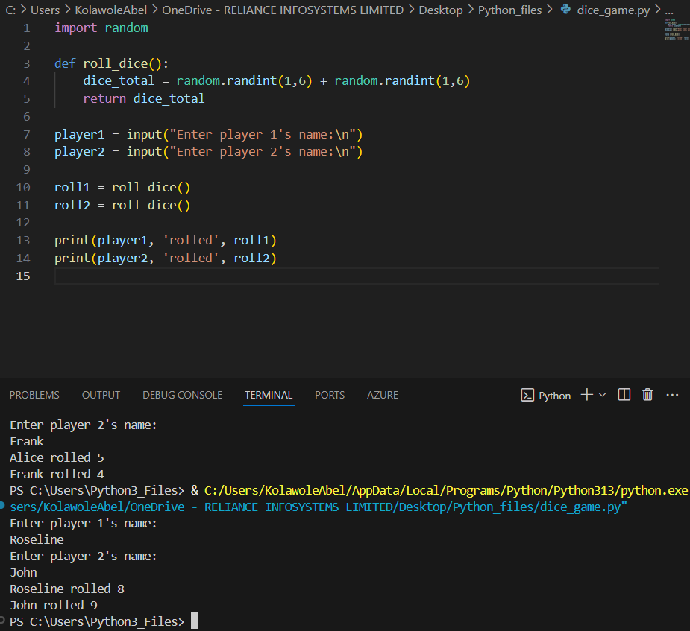
import random

def roll_dice():
dice_total = random.randint(1, 6) + random.randint(1, 6)
return dice_total

player1 = input("Enter player 1's name:\n")
player2 = input("Enter player 2's name:\n")

roll1 = roll_dice()
roll2 = roll_dice()

print(player1, 'rolled', roll1)
print(player2, 'rolled', roll2)

if roll1 > roll2:
print(player1, 'wins!')
elif roll2 > roll1:
print(player2, 'wins!')
else:
print("It's a tie!")

Welcome back.
In this module, we're going to cover objects and classes.
As programs get large,
it's impossible for one person to understand all of the complexity behind them.
In order for programmers to do very complicated things,
such as develop robots or video games,
it's helpful for them to think of related pieces of code as objects.
Let's think of an example where objects might be used.
If you've played a game like Fruit Ninja,
you know that pieces of fruit fly onto the screen and you
need to tap them in order to chop them up.
A piece of fruit could be an object in the program,
and the fruit object would store information about each piece of fruit,
like its type and position, and maybe if it was sliced or not.
We can think of objects in terms of state and behavior.
Objects have state and behavior in real life and in object-oriented programming.
Look around you, and what objects do you see?
Maybe you see your cellphone or your dog sleeping on its bed,
and now let's think of their state and behavior.
A cellphone might have its model, color,
and storage capacity as its state,
and its behavior might be the things that it does,
such as ring, receive notifications, or send data.
A dog's state might include its name, breed,
and whether it's hungry or not, and its behavior would be barking,
whining, or wagging its tail.
Let's say we want to create a simple robot dog toy,
and maybe you can imagine it rolling in on its motorized wheels,
playing a barking recording, and wagging its little tail.
Funny enough, it would probably have similar state and behavior to a real dog.
Let's look at what this robot class might look like and how we would use it.
Before we can create objects, we need to define a class.
And then we can create instances of that class, which are also called objects.
Here we're going to define our Robot_Dog class,
and then we can create a Robot_Dog object.
To define a class, you type the class keyword and then the class name,
which is Robot_Dog here, and then a colon.
Then usually, you define the init method, short for initialize.
Init lets us initialize our robot's properties,
Name, Breed, and Hungry could be our properties,
but let's just start with Name and Breed now to keep it simple.
Self is always the first parameter in an init method,
and it refers to the instance of the class that we're
creating or the current object.
The other parameters are the values for the
properties that we want to initialize.
We're going to start with the name and breed now.
Then we initialize the properties of the new object
self to the passed-in values.
It's a little confusing because the passed-in parameters have
the same name as the self object's properties.
Many people use those same names on purpose,
but we could rename the passed-in parameters to have a
different name to make it less confusing,
so we'll add _val, short for value.
Now we can create a Robot_Dog object,
and we do that by typing the name of the class Robot_Dog,
parentheses, and then the values for the parameters Name and Breed.
We'll put Spot for Name and Chihuahua for the Breed,
and we're going to assign the Robot_Dog object to the variable name my_dog.
We can print the my_dog object's properties to make sure the class is working,
and dot lets you access those properties for name and breed.
And if we run this, we see Spot and Chihuahua printed to the screen,
which is what we expected, so our class seems to be working so far.
Now let's create a class method for one of the robot dog's behaviors, barking.
We define a class method the same way we define a
function using the def keyword.
The difference is a method is a function that belongs to a class.
A class method also has self as the first parameter.
Inside our method, we're going to keep it simple and just print Woof Woof!
for now.
Now back in our main program, we still create our Robot_Dog object,
my_dog, and print its properties name and breed.
Now we'll call the bark method we just created.
We call a method by typing the object's name,
my_dog, then dot, then the method name, bark,
and then parentheses.
If we run this, we can see the dog.name,
and breed properties are still printed, but we can also see Woof,
Woof!
was printed to the screen, which means our bark class method is working.
Now that we've seen how to create classes and objects, let's take what we've learned and apply it in the next demo.
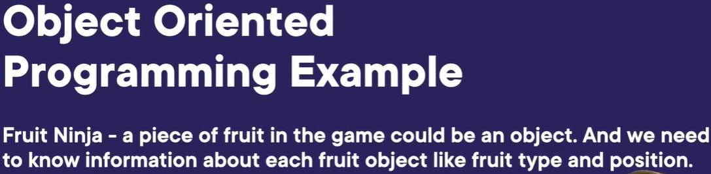
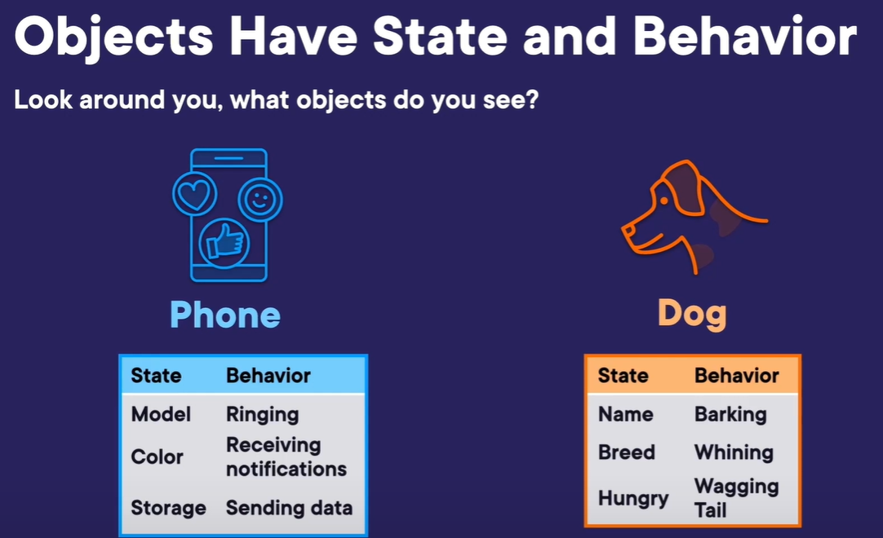
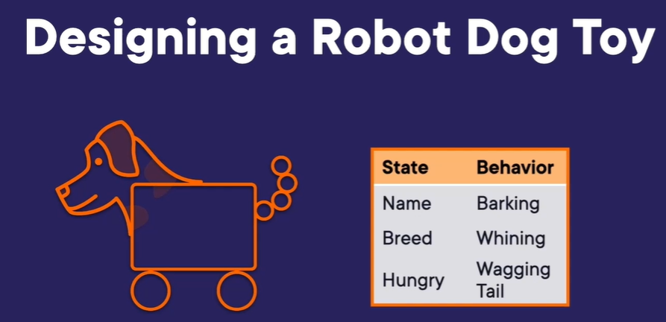
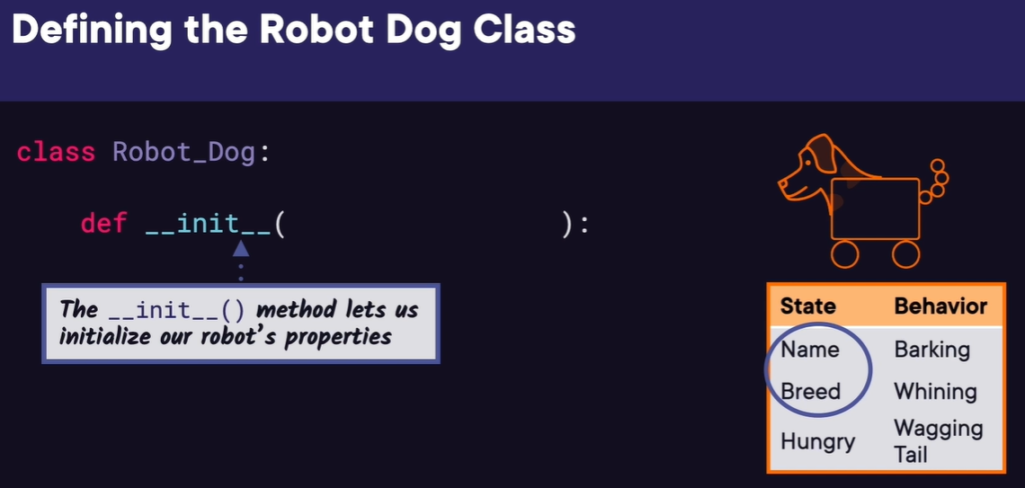
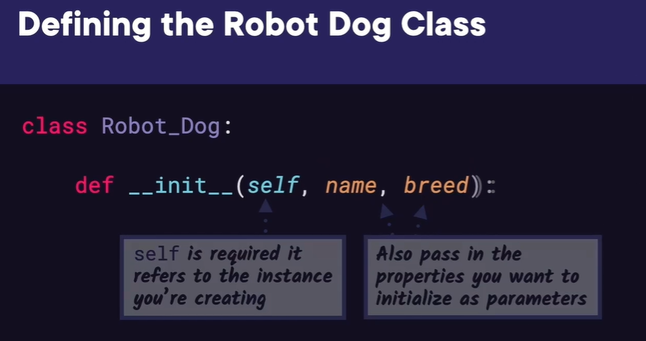
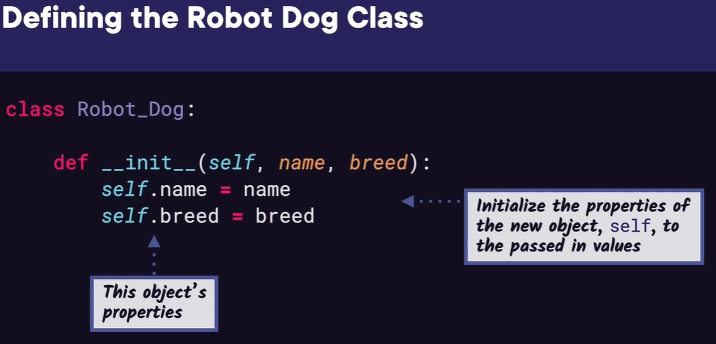
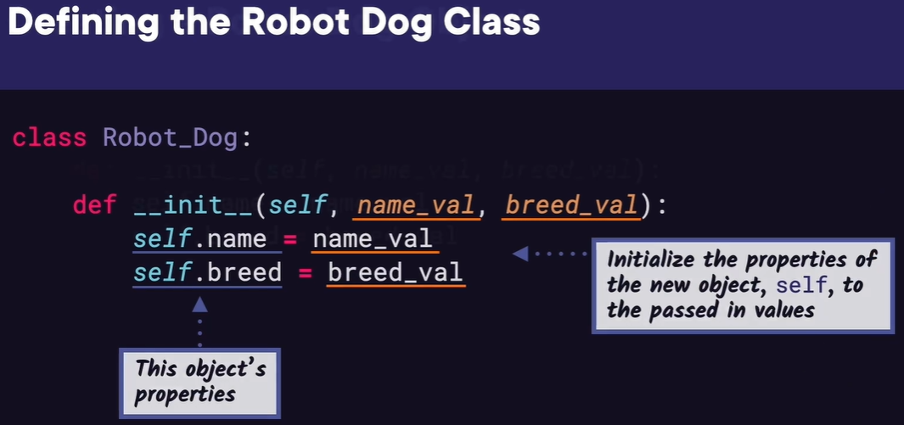
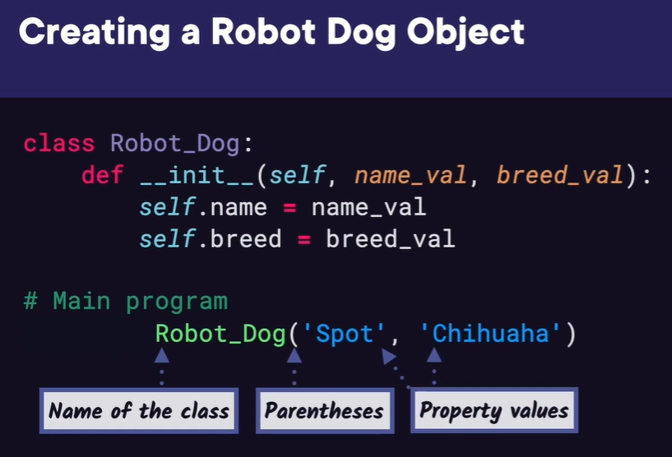
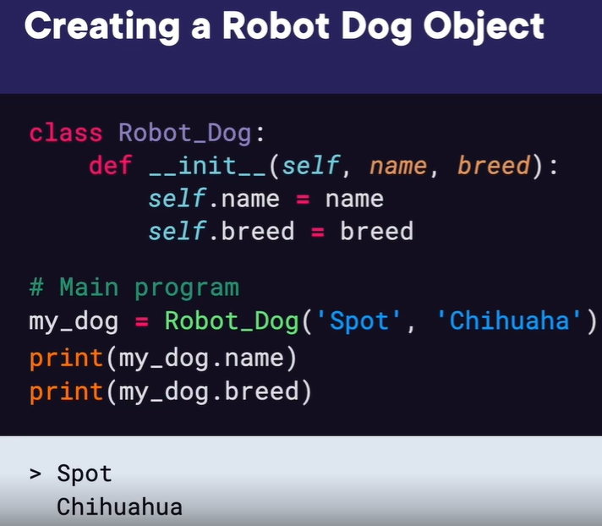
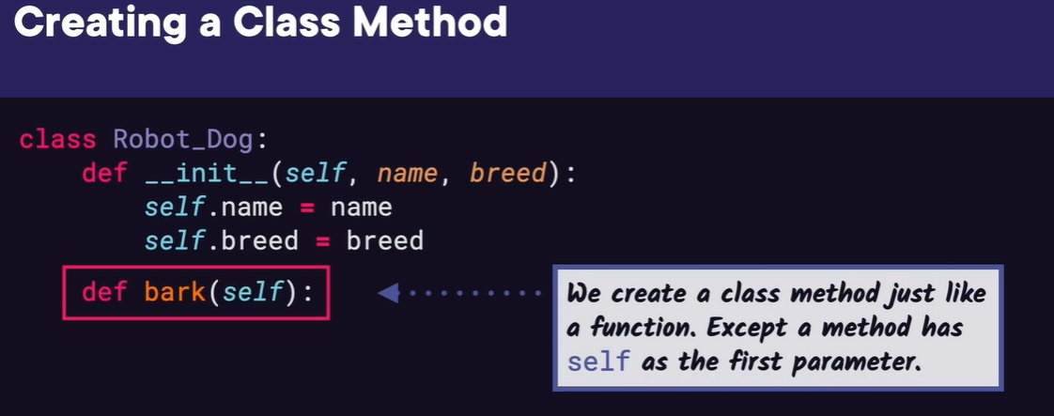
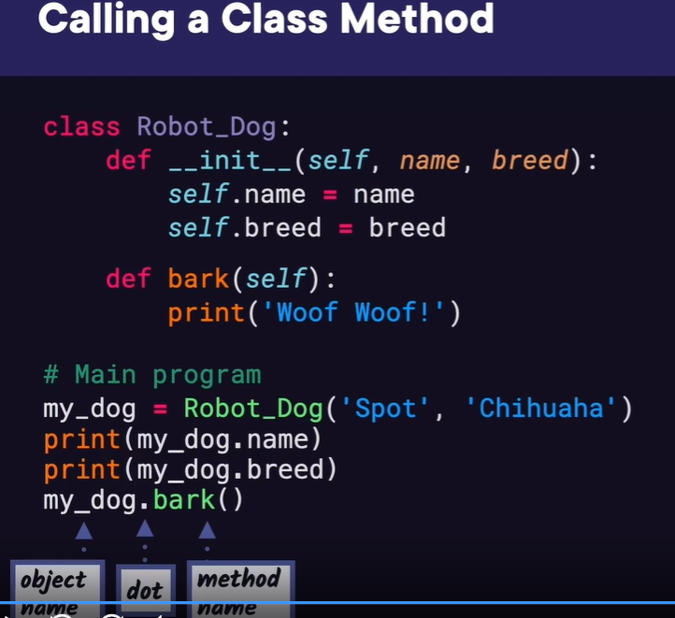

Demo: Company Payrol with Classes
In this demo,
we want to create a Company class to manage its employees and write their
weekly paychecks. To do that, we'll also need an Employee class.
Let's start by creating the Employee class in a file called employee.py.
We'll define class Employee and write an init method that takes in the
their first and last name and their salary amount.
Then we'll initialize the employees properties to those passed-in values.
We'll also create a method called calculate_paycheck.
This will calculate an employee's weekly paycheck amount.
So we'll have it simply return the salary property/52, assuming that the
employee's salary is simply split evenly by the 52 weeks in a year.
That's all we'll have in the Employee class. Now we
can create the Company class.
We'll start by creating a new file called company.py. Since we want our
Company class to have access to the Employee class, we'll need to
import it, and we can do that with from employee import Employee. The
lowercase employee is the file name,
and the uppercase Employee is the class name. Then we'll define the class
Company. In the init method, we don't need any parameters,
but we do want to initialize a property called employees,
which we'll set equal to an empty list.
This will be for storing the employee objects for the company.
Since we have a list of employees, we want to a way
to add employees to that list.
So we'll define a method called add_employee that takes in an employee
object, which we'll call new_employee. Then we can simply append that
new employee to the employees list property.
Let's go ahead and test what we have so far by creating a company object
in the main program. We'll define the main function so that we can
clearly define where the main program starts.
Then we'll call our company object, m_company, and set it
equal to calling the Company constructor.
Now that we have a company object, let's create some
employees to add to the company.
We'll call our first employee employee1 and set it equal to calling
the Employee constructor with first name Sarah,
last name Hess,
and salary $50,000. Then we need to add this employee to the company by
calling my_company.add_employee with employee1 in parentheses.
Let's copy and paste this code and add two more employees.
The second employee will be Lee Smith with a $25,000 salary.
And the third employee will be Bob Brown with a $60,000 salary.
Let's go ahead and print my_company.employees and run this and see what
we get. As you can see, the output doesn't show much except that we
have a list of employee objects in memory.
But this is a good start.
At least we know our company's employee list has employee objects in it.
Now we can define a proper display method that will
actually print out each employee's name.
We define display_employees.
First, it will print current employees.
Then It will loop over each employee, which will call i in the
self.employees list. Inside the loop, we'll print i.fname and i.lname.
We'll also print a line after the loop to show that that's the end of the
list. Back in the main program, we can delete the print statement and
call my_company.display employees.
If we run this, we can see the three current employees names
displayed in a list, which looks great so far.
To complete our program, we want to write a method in the
Company class to pay the employees by printing out each
employee's weekly paycheck amount.
Let's define a method called pay_employees at the bottom of the Company class.
It doesn't need any parameters since each employee in the
employees list knows its own paycheck amount.
First, we'll print paying employees.
Then, we'll loop over each employee in the employees list. Inside
the loop, we'll print Paycheck for and the employee's first name
and last name. On the next line,
we'll print Amount and then i.calculate_paycheck.
Finally, we'll print a line below the amount so we know
that's the end of that employee's paycheck.
Let's call this new method from the bottom of our main
program. Running our program, we see each employee's name and
paycheck amount printed to the screen.
This looks great except the paycheck amount is a float,
and we want this to be formatted to look like money with two decimal places.
We can do this with an f string. An f string in Python allows you to add
variables to a string with curly brackets like this.
If we run this, we can see the output is exactly the same as before.
We have the amount followed by the float paycheck value.
Now comes in the formatting. First, let's add a $ sign.
That's not part of the formatting,
but we left that out. Then inside the curly brackets
after the value we want to print,
we add a colon. To the right of the colon, we add the
format that we want. We can add a comma,
meaning we want thousands separated with a comma,
then .2f meaning we want floats rounded to two decimal places.
Now if we run this, we can see the paycheck values
look like dollar amounts. Great.
Now our output looks good and our program is working to organize a company's employees and write their weekly paychecks.
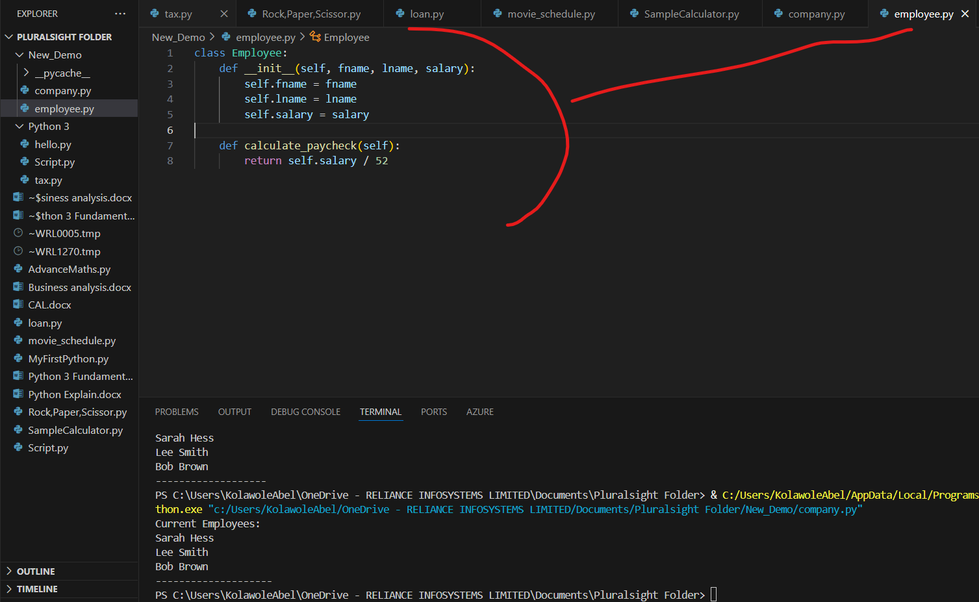
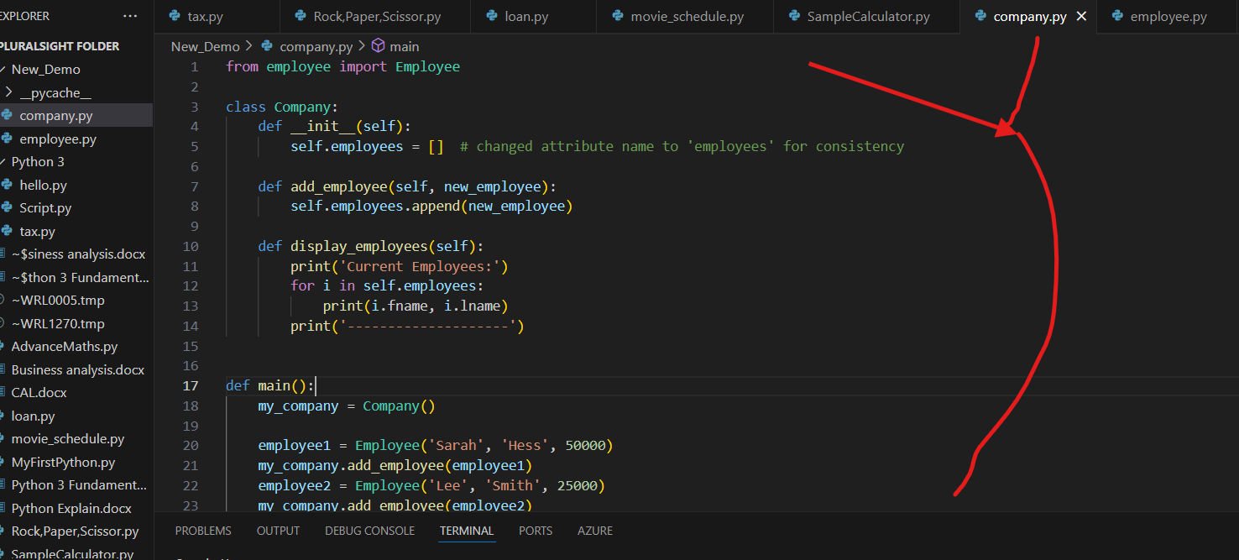
FOR EMPLOYEE.PY
class Employee:
def __init__(self, fname, lname, salary):
self.fname = fname
self.lname = lname
self.salary = salary

def calculate_paycheck(self):
return self.salary / 52
FOR COMPANY.PY
from employee import Employee

class Company:
def __init__(self):
self.employees = [] # changed attribute name to 'employees' for consistency

def add_employee(self, new_employee):
self.employees.append(new_employee)

def display_employees(self):
print('Current Employees:')
for i in self.employees:
print(i.fname, i.lname)
print('--------------------')

def main():
my_company = Company()

employee1 = Employee('Sarah', 'Hess', 50000)
my_company.add_employee(employee1)
employee2 = Employee('Lee', 'Smith', 25000)
my_company.add_employee(employee2)
employee3 = Employee('Bob', 'Brown', 60000)
my_company.add_employee(employee3)

my_company.display_employees() # added parentheses to call the method

main()

You can advance these
from employee import Employee

class Company:
def __init__(self):
self.employees = [] # changed attribute name to 'employees' for consistency

def add_employee(self, new_employee):
self.employees.append(new_employee)

def display_employees(self):
print('Current Employees:')
for i in self.employees:
print(i.fname, i.lname)
print('--------------------')

def pay_employees(self):
print('Paying Employees:')
for i in self.employees:
print('Paycheck for:', i.fname, i.lname)
print('Amount:', i.calculate_paycheck())
print('----------------------')

def main():
my_company = Company()

employee1 = Employee('Sarah', 'Hess', 50000)
my_company.add_employee(employee1)
employee2 = Employee('Lee', 'Smith', 25000)
my_company.add_employee(employee2)
employee3 = Employee('Bob', 'Brown', 60000)
my_company.add_employee(employee3)

my_company.display_employees() # called the method correctly
my_company.pay_employees()

main()

Output
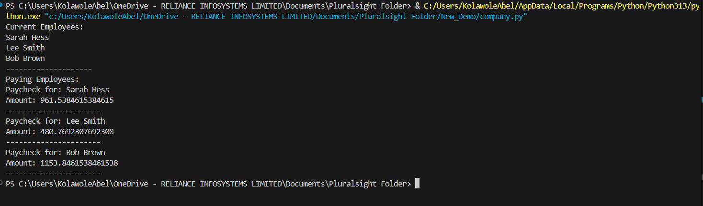
Line 20 modified:
from employee import Employee

class Company:
def __init__(self):
self.employees = [] # changed attribute name to 'employees' for consistency

def add_employee(self, new_employee):
self.employees.append(new_employee)

def display_employees(self):
print('Current Employees:')
for i in self.employees:
print(i.fname, i.lname)
print('--------------------')

def pay_employees(self):
print('Paying Employees:')
for i in self.employees:
print('Paycheck for:', i.fname, i.lname)
print(f'Amount: ${i.calculate_paycheck():,.2f}')
print('----------------------')

def main():
my_company = Company()

employee1 = Employee('Sarah', 'Hess', 50000)
my_company.add_employee(employee1)
employee2 = Employee('Lee', 'Smith', 25000)
my_company.add_employee(employee2)
employee3 = Employee('Bob', 'Brown', 60000)
my_company.add_employee(employee3)

my_company.display_employees() # called the method correctly
my_company.pay_employees()

main()
Result
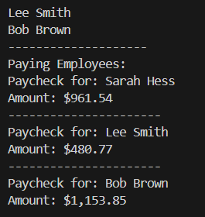

Class Inheritance
Welcome back. In this module, we're going to cover class inheritance. Just
like in the real world, in object-oriented programming,
the relationship between objects is important, and we're going to talk about
two types of relationships between objects, Is-a and Has-a.
In the previous demo, we looked at has-a relationship with
our company class. Our Company object has employees, so when
we created our Company class,
we created a list of Employee objects as a property of that class.
Another example might be a Robot class has a Battery
object. In an Is-a relationship,
a class is a more specific type of something else.
For example,
a robot dog class is a robot and a robot cat class is a more
specific type of the robot class, too. The Is-a relationship
is also called inheritance.
Let's take a closer look at what inheritance is. In this inheritance example,
we would have a general robot base class and then a robot dog and robot cat
class that derive from that parent class. Using inheritance like in this
example, allows us to create a hierarchy of classes that share a set of
properties and methods. We do this by deriving a class from another class. The
base class is also sometimes called the parent class, and the derived classes
are sometimes called the child classes.
Let's look at some of the specific behaviors that the robot dog and robot
cat classes have, and which ones they have in common.
Those are the ones that we're going to want to take out and put in
the general robot class. For the robot dog class, we have walk,
manage their battery, say their name, bark,
and eat bacon. For the robot cat class, it has the same behaviors for walk,
manage the battery, and say their name, and then different behaviors for meow,
and eat fish. Again, we'll move those common
behaviors to the general robot class.
This will allow us to reuse code so we don't have to
write the same code over and over again.
And then those behaviors that are specific to dog robots and
cat robots will go in their specific classes.
This might not make sense now because this is kind of an abstract concept,
so let's look at the code so we can see this in action.
First we'll start with the parent robot class, which will add the behaviors
for walking and saying their name. To create the parent robot class, it's the
same as creating any old class. You type class,
and then the class name, which is Robot here,
and then a colon. Then we'll define the init method to
initialize our robot's properties.
We'll initialize name to the passed-in value.
We'll also have a property for the robot's position,
which is an XY coordinate and will start at 00.
Also in the init method, the robot will say his
name by printing it to the screen.
We'll also define another method for the Robot class, walk. Walk
will take an x, which will be how much the robot will move in
the x direction. Inside the method, we'll update the position 0
to add the value of x.
Then we'll print out the robot's new position.
To create a child class that derives from a parent class, we put the
parent class that we're inheriting from in parentheses.
So here we have class Robot_Dog(Robot). We can also add our own
init method here, but if we leave it out,
it will call the robot's init method by default, so we'll leave it out for now.
Then we'll add a method specific to Robot_Dogs called make_noise,
which will print 'Woof woof!' Now that we have our Robot and Robot_Dog
classes created, let's go ahead and create a Robot_Dog object.
We'll call the Robot_Dog constructor and pass it the name we want for our
robot, which we'll call Bud. We can call any of the robots or the
Robot_Dogs methods, so we called walk and make_noise.
Now we can put all the code we just wrote into one file. Let's go ahead and
run that and see what the flow of the program looks like. First we create
the Robot_Dog object. That would take us to the Robot_Dog init method, but
we didn't implement it, so we inherit the Robot parent class init method.
We go there to create the Robot_Dog object. First we initialize its name
property to Bud, then its position property to 00,
and then we print My name is Bud!, which we can see output to the screen.
Next we call my_robot_dog.walk with a value of 10 and that takes us to
the parent Robot class's walk method, which adds the input value of 10 to
position 0. Then it prints the new position,
and we can see the new position is output to the screen.
Finally,
we call my_robot_dog.make_noise. Then we can see that that
takes us to the child class, Robot_Dog,
and its make_noise method, which prints Woof Woof!, and we
can see Wolf Woof! output to the screen.
We can see with inheritance how seamlessly the methods are called from
either the parent class or the child class depending on where the
implementation is. We saw how a method can be called from the parent
class if it doesn't exist in the child class.
But what if it exists in both? That is called method overriding.
Let's say we add a method called eat to the Robot class that
simply prints I'm hungry! We'll also call my_robot_dog.eat from
our main program. If we run this,
we see My name is Bud! is still printed when the
robot dog is created, and afterwards, I'm hungry! is printed.
Now let's add the same method eat to the child Robot_Dog class,
where we'll print 'I like bacon!' This is what is called method
overriding, which allows you to customize a method's
implementation in the child class,
and this eat method will be run for all Robot_Dog objects
instead of the generic Robots.eat method. If we run this
after My name is Bud is printed, I like bacon! is also printed.
What if we also want to call the parent Robot's eat method? We can
do that too by using the super method. Calling super gives us
access to the parent class's methods.
Now if we run this,
we see both I'm hungry is printed from the parent Robot class,
and I like bacon! is printed from the child Robot_Dog class. In summary,
we looked at two of the main benefits of inheritance.
It lets us model real-world relationships,
and it lets us reuse code well so we don't have to write
the same code over and over again.
Next up, join me in the demo where we can program an example using class inheritance.
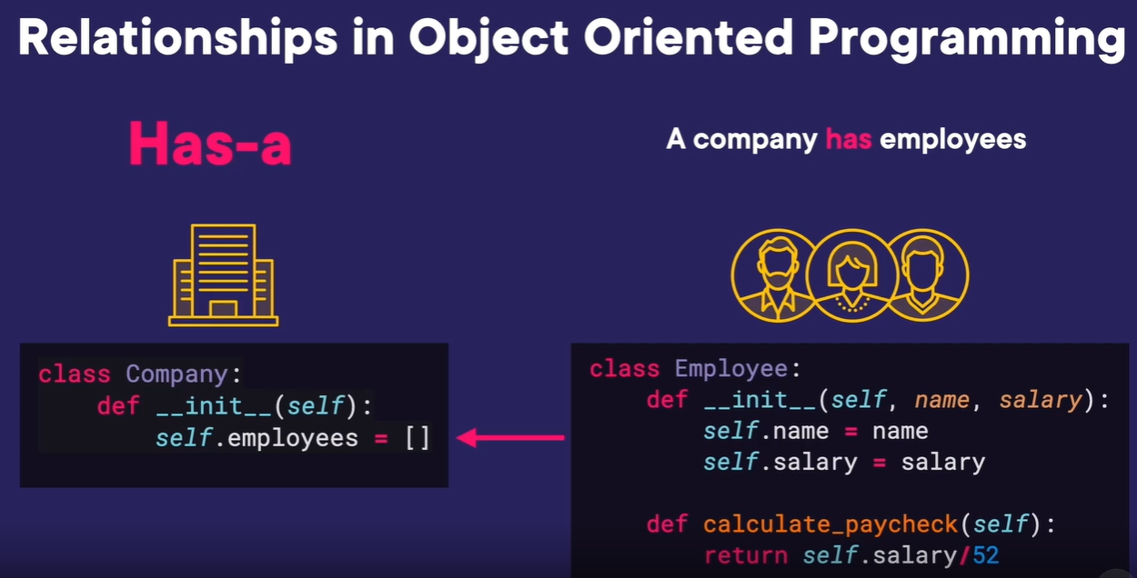
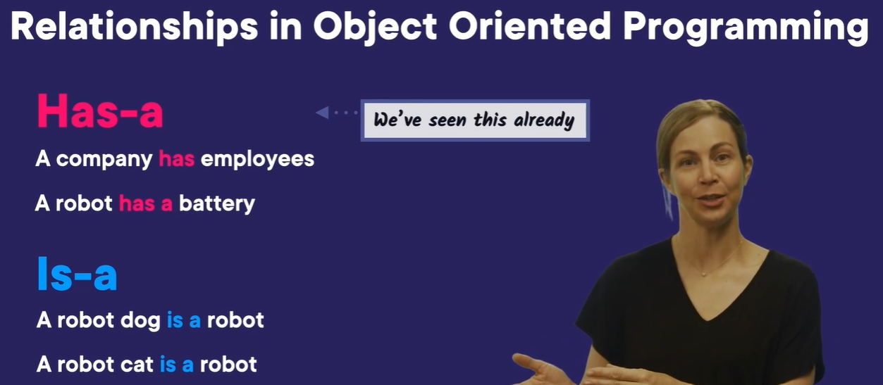
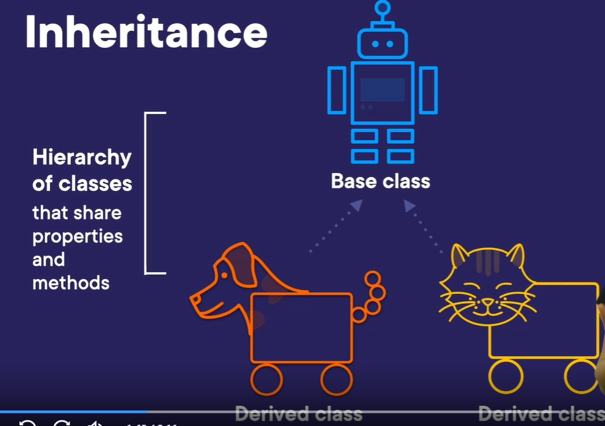
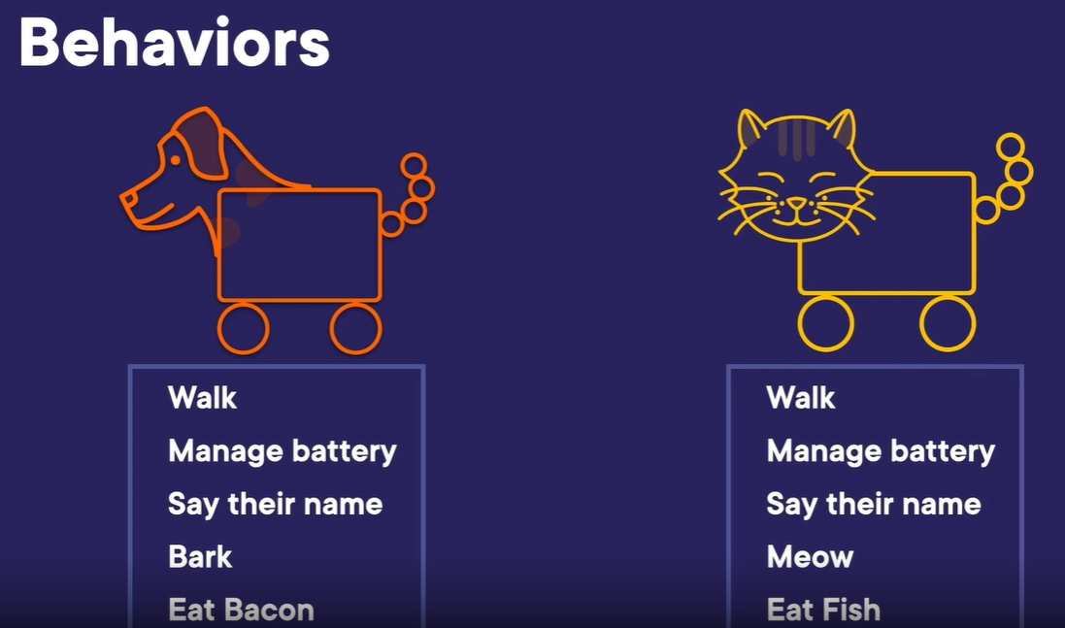
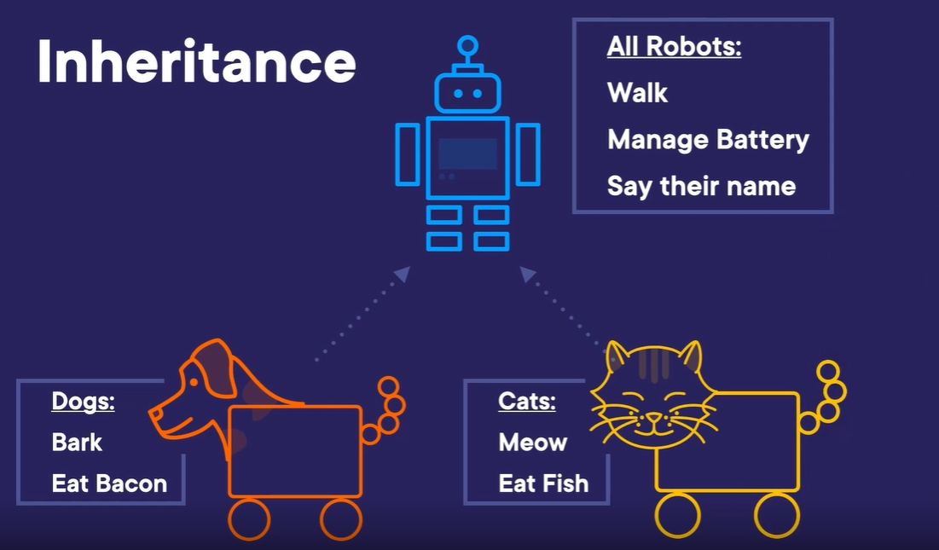
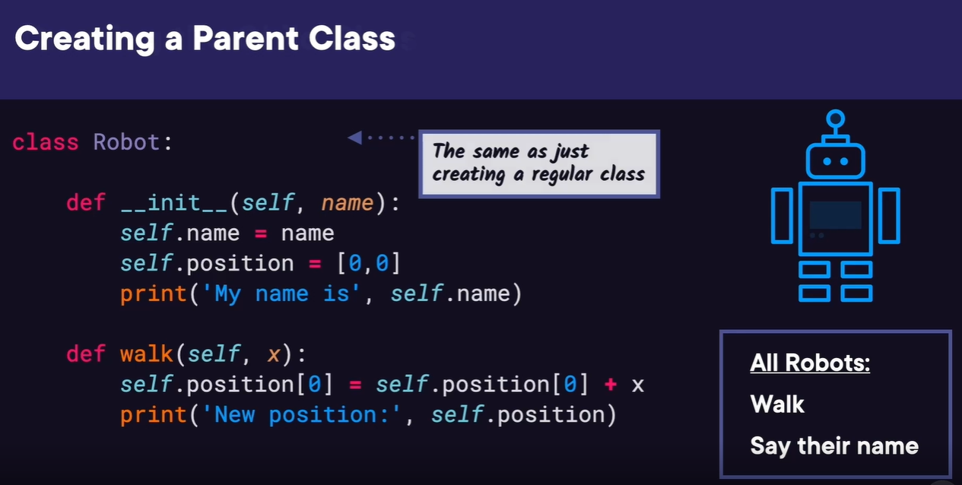
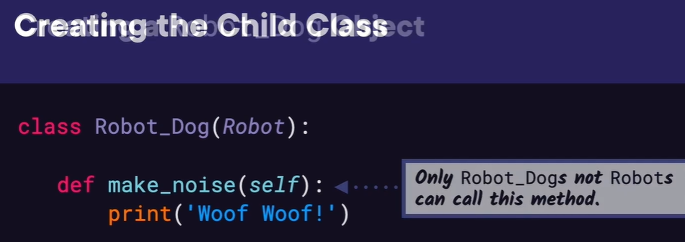
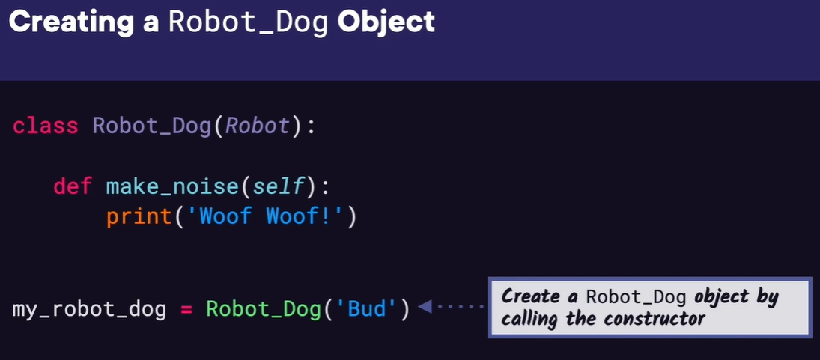
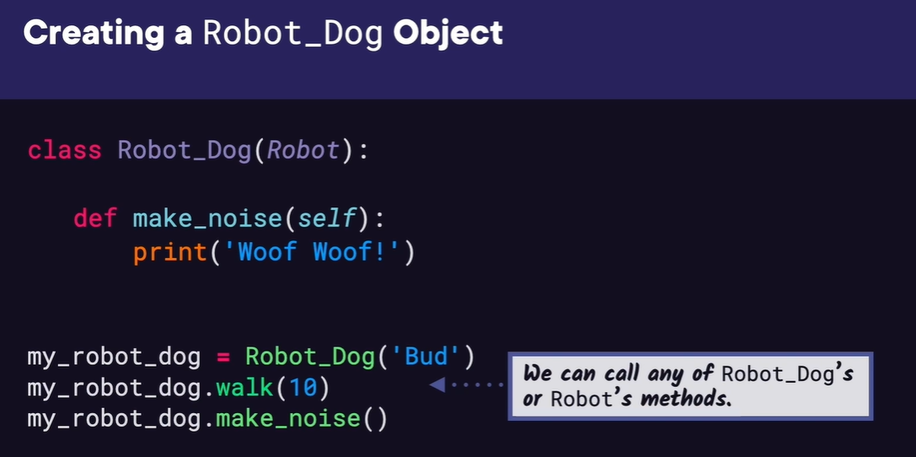
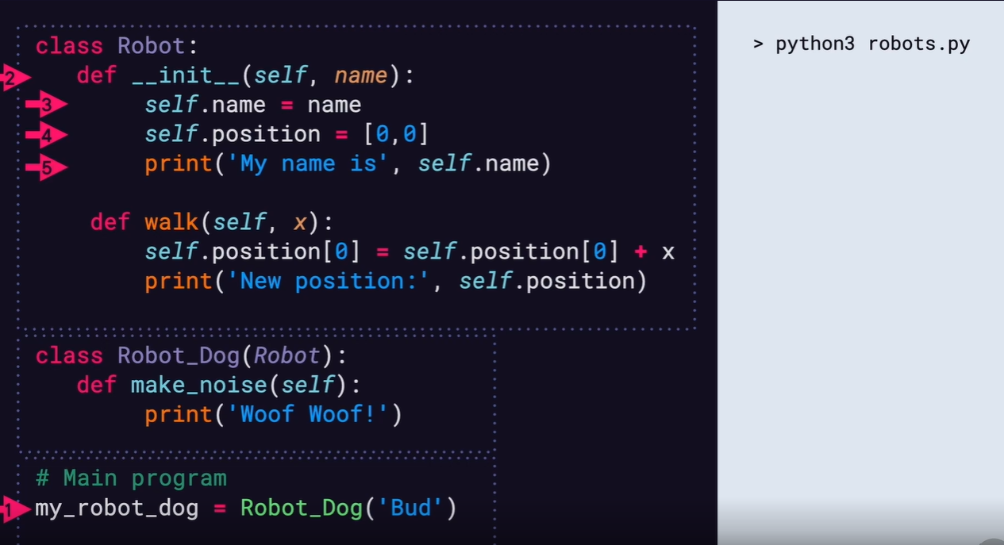
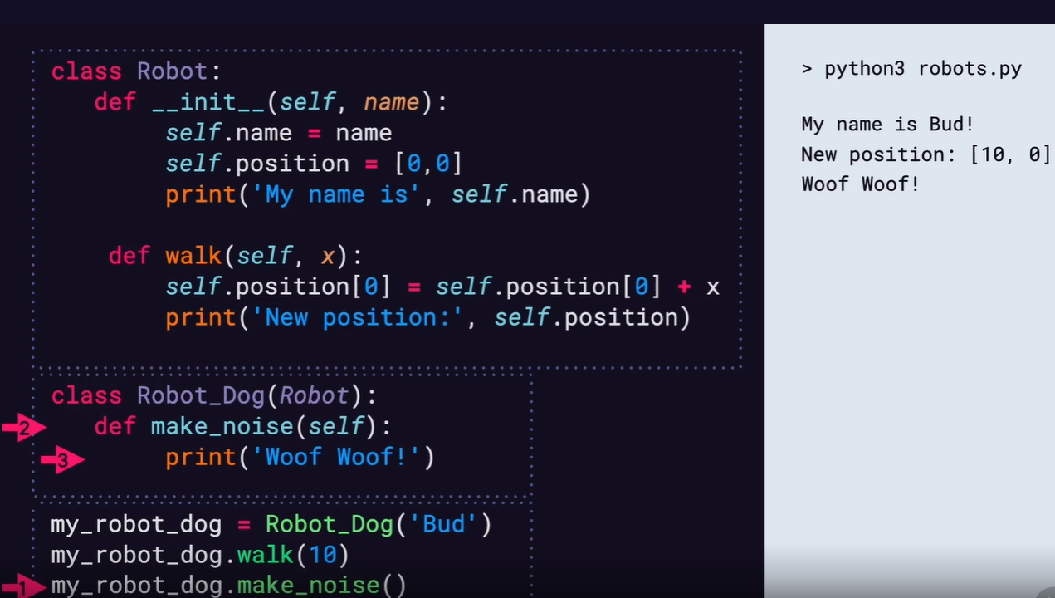
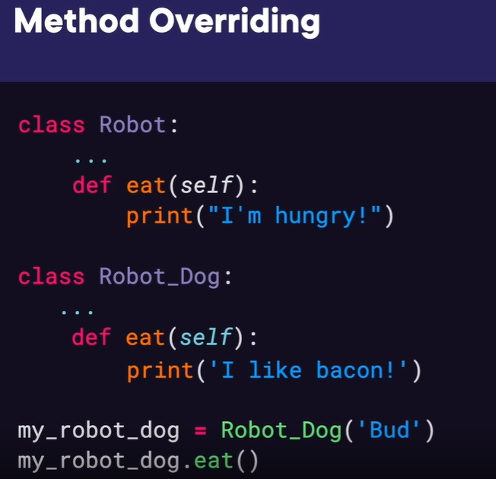
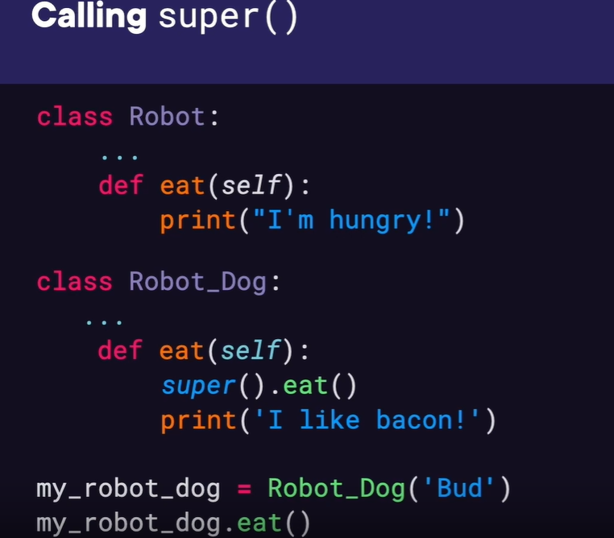
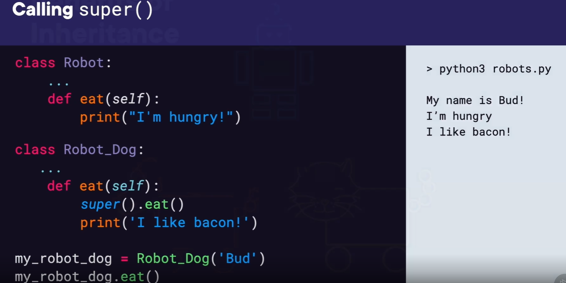
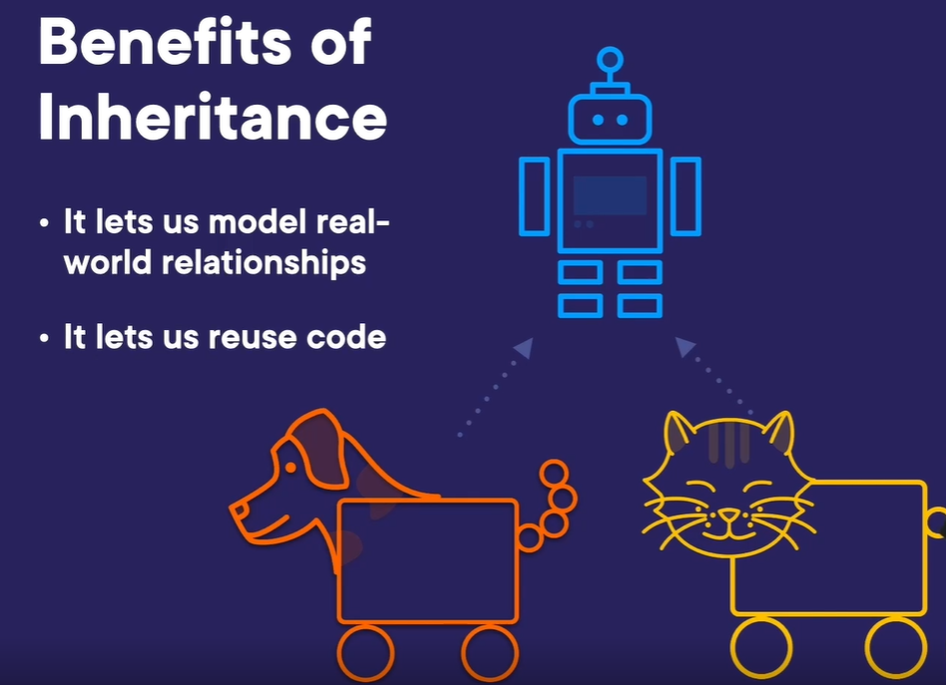

Demo: Company Payroll with Inheritance
In this demo,
we're going to use inheritance to add different types of
Employee classes to our employee.py file.
Our company now not only has employees that earn a salary,
but also hourly and commission employees.
So we want to create a general Employee class for the three
types of employees to inherit it from, salary employee,
hourly employee, and commission employee.
To start, let's rename our Employee class to SalaryEmployee.
Then above this class, we'll add our general Employee class.
It's init method will simply take in first name and last name as parameters,
and it will initialize the first name and last name
properties to the passed-in values.
Then we want the SalaryEmployee class to derive from employee,
so we'll add the Employee class in parentheses.
Next, in the init method,
we can actually get rid of the lines that initialize the
name properties and simply call the general Employee's init
method with super().__init__, and then pass in fname,
and lname in parentheses.
The rest of the class can stay the same.
We still want to define the calculate_paycheck method to
return the salary amount divided by 52 weeks.
Now we want to add the classes for our new types of employees,
hourly employee and commission employee.
For hourly employee,
we'll type class HourlyEmployee(Employee) since we also want this
class to inherit from the general Employee class.
Then the init method will take in fname,
lname, and the number of hours the employee worked in a week,
which we'll call weekly_hours and their hourly_rate.
Inside the init method, we can again call super().__init__ with fname and lname,
which will call the general Employee's init method.
Next, we'll initialize the weekly_hours and hourly_rate properties.
We also want to define the calculate_paycheck
method for the HourlyEmployee class.
It will simply return the weekly_hours times the hourly_rate.
Before we add the CommissionEmployee class,
let's make sure our new class structure is working.
Let's open company.py and add our new SalaryEmployee and
HourlyEmployee classes to the import statement,
then let's look at the main function.
Currently,
we have three employees defined using the general Employee constructor.
But this would give us an error because these would actually be salary
employee's since they're passing in a salary amount,
so we can change employee1 to call the SalaryEmployee constructor.
Let's also test our HourlyEmployee class,
so we'll change employee2 to call the HourlyEmployee constructor.
And instead of salary amount,
we'll pass in 25 for the number of hours worked and $50 for the hourly rate.
For employee3,
let's also call the HourlyEmployee constructor with 40
hours worked and $15 as the hourly rate.
Let's run this.
And we see the current employee names printed,
and their paycheck amounts look correct too.
Great.
Our new Employee classes are working.
Let's go ahead and add our last employee class CommissiomEmployee.
Instead of inheriting from the general Employee class,
CommissionEmployee is going to inherit from SalaryEmployee since commission
employees make a regular salary with commission added on top.
Doing this will also show that it's possible for there
to be multiple levels of inheritance.
When we define the init method, if we Tab over,
VS Code will autocomplete the method to just call the super().__init___ method,
which is somewhat helpful,
but we want to edit this to pass in two more parameters,
the number of sales as sales_num and commission rate as com_rate.
Then we do want call super().__init__ with fname,
lname, and salary,
which will call the SalaryEmployee's init method to initialize those values.
Actually, if we scroll up and look at SalaryEmployee's init method,
we see it also calls super().__init__ , so there's
a lot of code reuse happening.
Back in our init method,
we also need to initialize the sales_num and com_rate properties.
Next, we need to define calculate paycheck.
If we type def calculate and Tab over to autocomplete,
you can see it automatically adds return super().calculate_paycheck,
but we don't want to return that value.
This will return the SalaryEmployee's calculate_paycheck value,
so we'll assign this to a variable called regular_salary.
On the next line,
we'll calculate the total_commission as self.sales_num*self.commission_rate.
Finally, we can return regular_salary + total_commission.
Now that our CommissionEmployee class is complete,
let's add it to our Company in company.py.
First, we'll add CommissionEmployee to our import.
Then in main, we can change employee3 to be a CommissionEmployee,
and we'll pass a salary amount of $30,000,
number of sales 5, and commission amount as 200.
Let's run this and see if our new class works.
We can see our employee names are printed out
correctly, and our paychecks look accurate.
Great.
We were able to use inheritance to add different types of employees to our company.
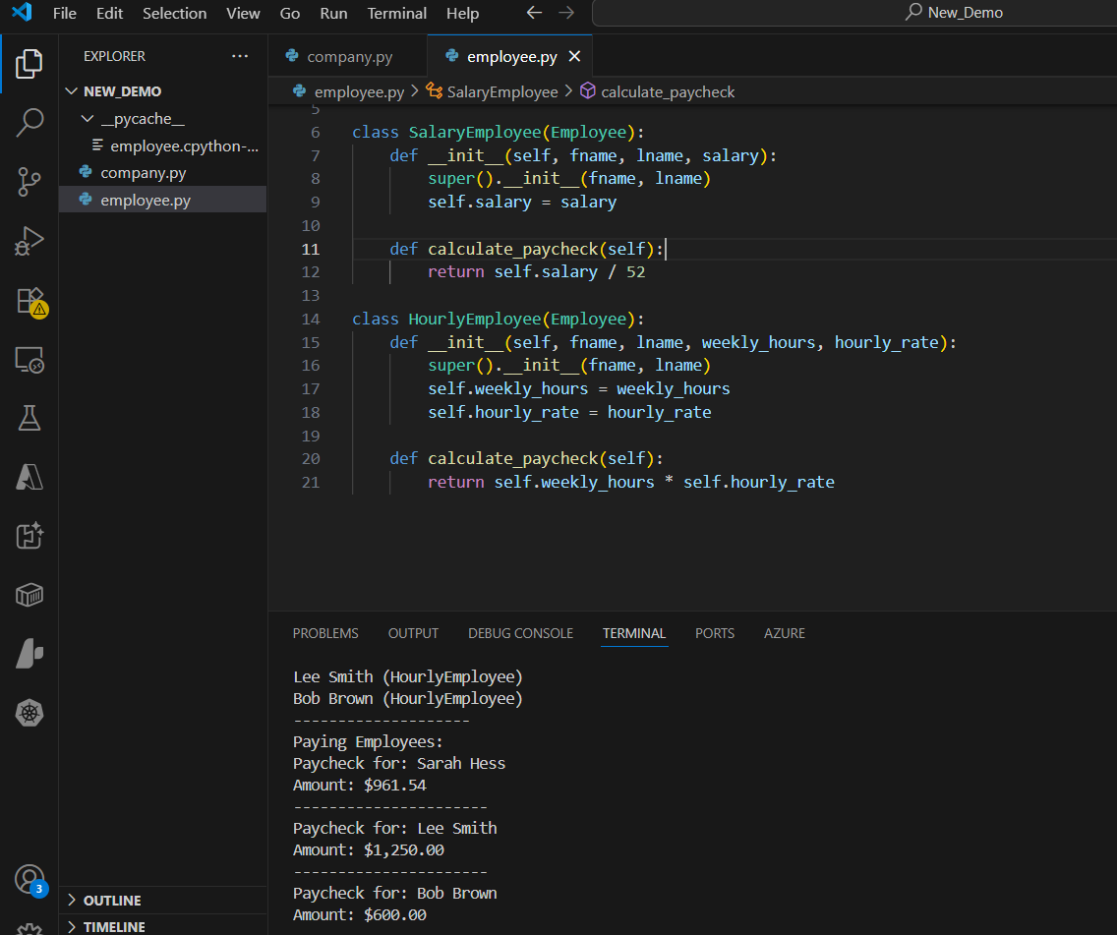
class Employee:
def __init__(self, fname, lname):
self.fname = fname
self.lname = lname

class SalaryEmployee(Employee):
def __init__(self, fname, lname, salary):
super().__init__(fname, lname)
self.salary = salary

def calculate_paycheck(self):
return self.salary / 52

class HourlyEmployee(Employee):
def __init__(self, fname, lname, weekly_hours, hourly_rate):
super().__init__(fname, lname)
self.weekly_hours = weekly_hours
self.hourly_rate = hourly_rate

def calculate_paycheck(self):
return self.weekly_hours * self.hourly_rate
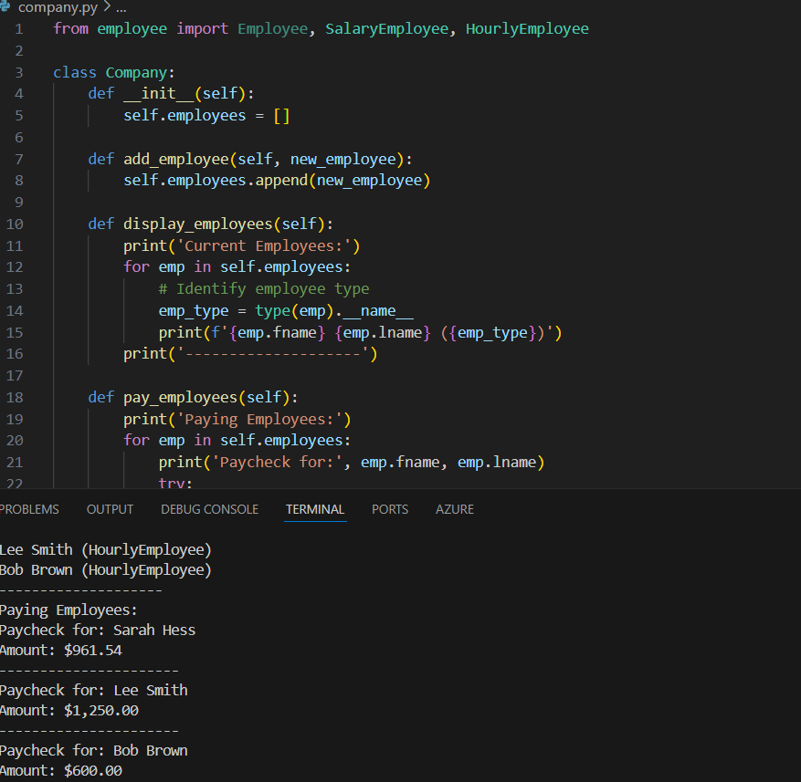
from employee import Employee, SalaryEmployee, HourlyEmployee

class Company:
def __init__(self):
self.employees = []

def add_employee(self, new_employee):
self.employees.append(new_employee)

def display_employees(self):
print('Current Employees:')
for emp in self.employees:
# Identify employee type
emp_type = type(emp).__name__
print(f'{emp.fname} {emp.lname} ({emp_type})')
print('--------------------')

def pay_employees(self):
print('Paying Employees:')
for emp in self.employees:
print('Paycheck for:', emp.fname, emp.lname)
try:
amount = emp.calculate_paycheck()
print(f'Amount: ${amount:,.2f}')
except AttributeError:
print('Error: Could not calculate paycheck.')
print('----------------------')

def remove_employee(self, fname, lname):
self.employees = [emp for emp in self.employees if not (emp.fname == fname and emp.lname == lname)]
print(f'Employee {fname} {lname} removed.')

def main():
my_company = Company()

employee1 = SalaryEmployee('Sarah', 'Hess', 50000)
my_company.add_employee(employee1)

employee2 = HourlyEmployee('Lee', 'Smith', 25, 50)
my_company.add_employee(employee2)

employee3 = HourlyEmployee('Bob', 'Brown', 40, 15)
my_company.add_employee(employee3)

my_company.display_employees()
my_company.pay_employees()

# Example of removing an employee
# my_company.remove_employee('Lee', 'Smith')
# my_company.display_employees()

if __name__ == "__main__":
main()
Advance version
Employee.py:
class Employee:
def __init__(self, fname, lname):
self.fname = fname
self.lname = lname

class SalaryEmployee(Employee):
def __init__(self, fname, lname, salary):
super().__init__(fname, lname)
self.salary = salary

def calculate_paycheck(self):
return self.salary / 52

class HourlyEmployee(Employee):
def __init__(self, fname, lname, weekly_hours, hourly_rate):
super().__init__(fname, lname)
self.weekly_hours = weekly_hours
self.hourly_rate = hourly_rate

def calculate_paycheck(self):
return self.weekly_hours * self.hourly_rate

class CommissionEmployee(SalaryEmployee):
def __init__(self, fname, lname, salary, sales_num, com_rate):
super().__init__(fname, lname, salary)
self.sales_num = sales_num
self.com_rate = com_rate

def calculate_paycheck(self):
# Call the parent method to get base salary
regular_salary = super().calculate_paycheck()
total_commission = self.sales_num * self.com_rate
return regular_salary + total_commission
COMPANY EMPLOYEE.PY
from employee import Employee, SalaryEmployee, HourlyEmployee, CommissionEmployee

class Company:
def __init__(self):
self.employees = []

def add_employee(self, new_employee):
self.employees.append(new_employee)

def display_employees(self):
print('Current Employees:')
for emp in self.employees:
emp_type = type(emp).__name__
print(f'{emp.fname} {emp.lname} ({emp_type})')
print('--------------------')

def pay_employees(self):
print('Paying Employees:')
for emp in self.employees:
print('Paycheck for:', emp.fname, emp.lname)
try:
amount = emp.calculate_paycheck()
print(f'Amount: ${amount:,.2f}')
except AttributeError:
print('Error: Could not calculate paycheck.')
print('----------------------')

def remove_employee(self, fname, lname):
original_count = len(self.employees)
self.employees = [emp for emp in self.employees if not (emp.fname == fname and emp.lname == lname)]
if len(self.employees) < original_count:
print(f'Employee {fname} {lname} removed.')
else:
print(f'Employee {fname} {lname} not found.')

def find_employee(self, fname, lname):
for emp in self.employees:
if emp.fname == fname and emp.lname == lname:
return emp
return None

def update_employee_salary(self, fname, lname, new_salary):
emp = self.find_employee(fname, lname)
if emp and isinstance(emp, SalaryEmployee):
emp.salary = new_salary
print(f'{fname} {lname}\'s salary updated to ${new_salary}.')
else:
print(f'Employee {fname} {lname} not found or not a SalaryEmployee.')

def main():
my_company = Company()

employee1 = SalaryEmployee('Sarah', 'Hess', 50000)
my_company.add_employee(employee1)

employee2 = HourlyEmployee('Lee', 'Smith', 25, 50)
my_company.add_employee(employee2)

employee3 = CommissionEmployee('Bob', 'Brown', 30000, 5, 200)
my_company.add_employee(employee3)

my_company.display_employees()
my_company.pay_employees()

# Example of removing an employee
# my_company.remove_employee('Lee', 'Smith')
# my_company.display_employees()

# Example of updating a salary
my_company.update_employee_salary('Sarah', 'Hess', 55000)

if __name__ == "__main__":
main()

Working with Files
Welcome back.
In this video we're going to look at exceptions.
If you've gotten this far and you haven't had any errors, then I'm shocked.
Often we see syntax errors caused by typos in our code,
and when the Python interpreter comes upon one of those typos,
it doesn't know what we meant to do.
If we run this code with a typo,
we see the that the SyntaxError calls out that we have an unmatched parentheses,
and the error output tells you the file and line number
and points to the exact character,
which is very helpful in tracing down the error.
Exceptions occur when the syntax is correct.
So the Python interpreter knows what we're trying to do,
but the operation we were trying to do threw an error.
Here, looking up a key that doesn't exist in a dictionary throws an error.
When we run this, we can see the exact location of the error,
and the type of error is KeyError.
This specific output is very helpful in us finding and fixing the error.
One way of fixing an exception like this is catching it in a try/except block.
We can edit the example we just saw to use a try/except block.
First, we type the keyword try, then colon.
Then indented below we have the code that may cause an error.
Then we add the except block with the except keyword and a colon.
Inside the except block we'll add a print statement
with the error message indented below.
Let's give this a try, and we see the error message is printed,
and now the program can keep running.
To summarize,
the format of a try/except block is very similar to an if statement.
You have the try keyword, colon, and then any code that may cause an error,
then you have the except block with the except keyword,
colon, and printing any error message you want,
and then the program continues to run normally after that try/except block.
The reason we want to catch errors with the try/except block is
that if we get an error that we don't catch,
that error will cause our program to crash and stop running.
With the try/except block, whether there is an error we caught or not,
the program keeps running after that try/except block.
If we run this example,
we can see The key BTW does not exist is printed and then
The program keeps going... is printed.
Now we changed the code slightly to look up a key that does exist.
So in this example there's not an error.
So the definition of LOL is printed and then The program keeps
going... is printed after the try/except block.
The finally keyword can be used after try/except blocks to run
any code when the try/except block is final.
The finally block will be executed whether there was an error or not.
Here we can print all of the acronyms we have defined in the finally block.
That finally keyword can be used to close objects or clean up resources,
which we'll see when we read from files in the next video.
You may be wondering where the exceptions we get come from.
As a Python developer we can raise an exception,
or we also say throw an exception, if a certain condition occurs.
For example,
the developer that wrote the source code for dictionaries decided to
raise a KeyError exception when a key doesn't exist.
Let's create a program where we need to throw an exception.
In our program we're going to create a function that does whole number
division by printing out the number result and the remainder.
If we call this remainder_division function with the parameters 10 and 3,
we don't get an error and we see the result 10 / 3 is 3
remainder 1 printed to the screen.
If we instead call the remainder_division function
with 0 as the second parameter,
we get a ZeroDivisionError because it's not possible to divide by 0.
Instead of causing an unexpected error,
we check if the divisor is equal to 0 and then raise an
error by using the raise keyword.
We'll raise a ZeroDivisionError.
By checking for errors that we expect, it makes our code easier to understand,
read, and troubleshoot.
We can also create custom exceptions by calling the Exception constructor and
then passing in the message we want to display as a string.
Here our message is Divisor cannot be 0.
And if we run this,
we can see Exception: Divisor cannot be 0 printed to the screen.
Now that we've seen how to use exceptions,
that will help us when we work with files next and the exceptions that may come up there.
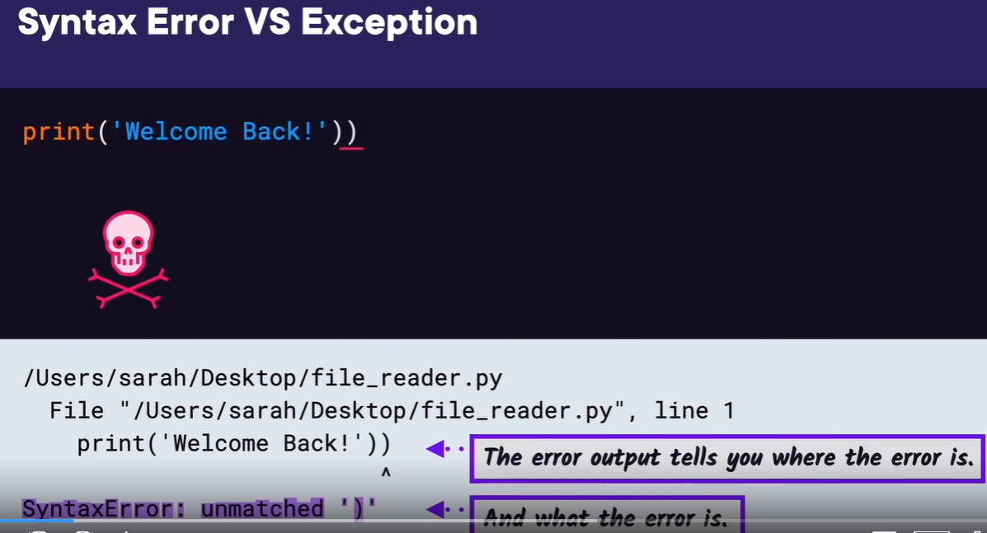
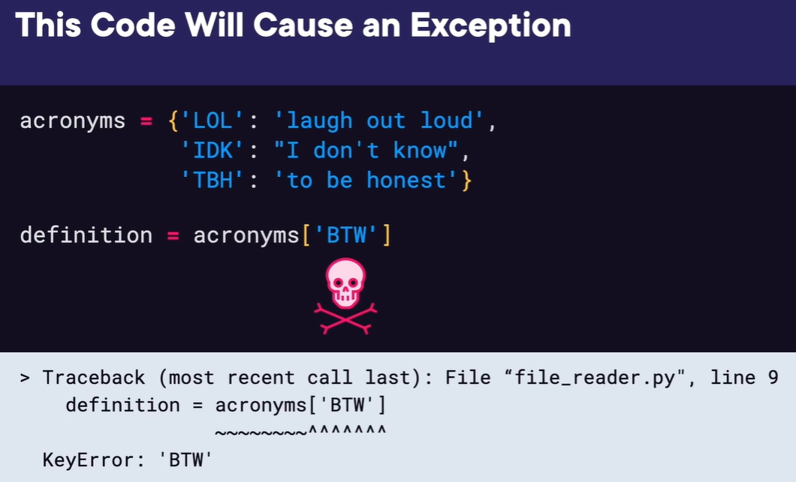
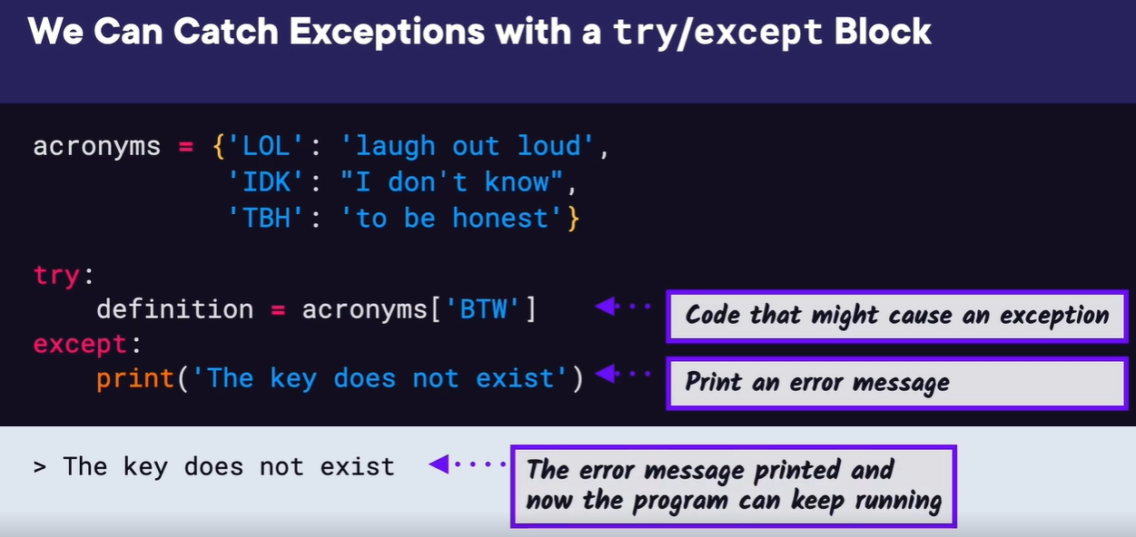
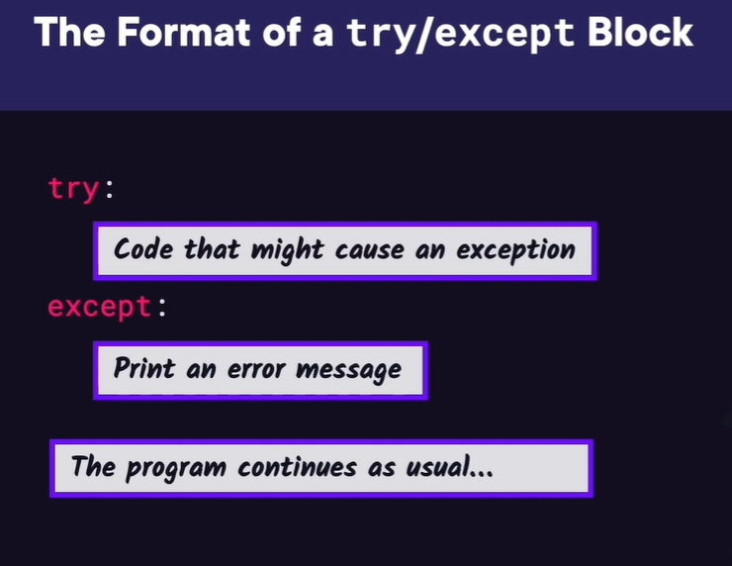
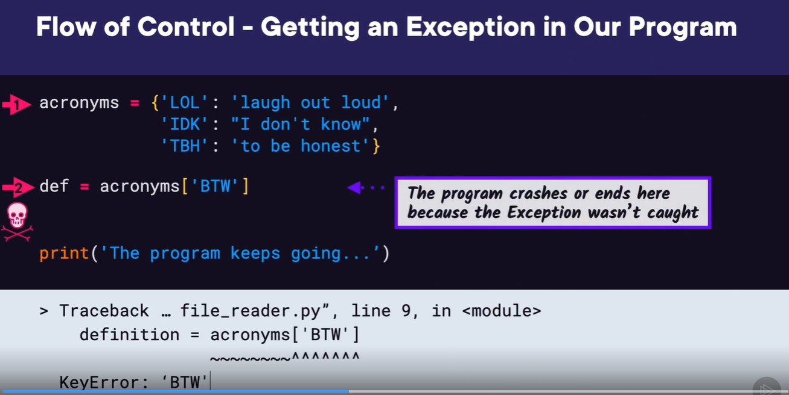
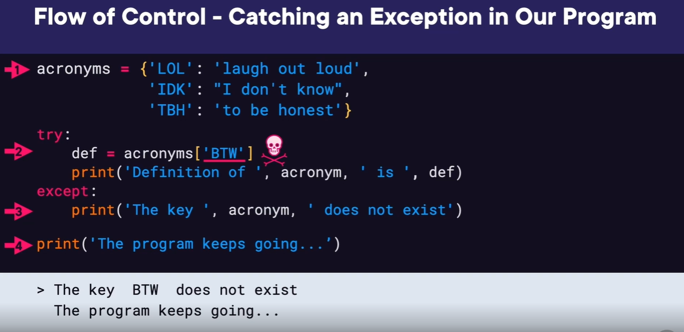
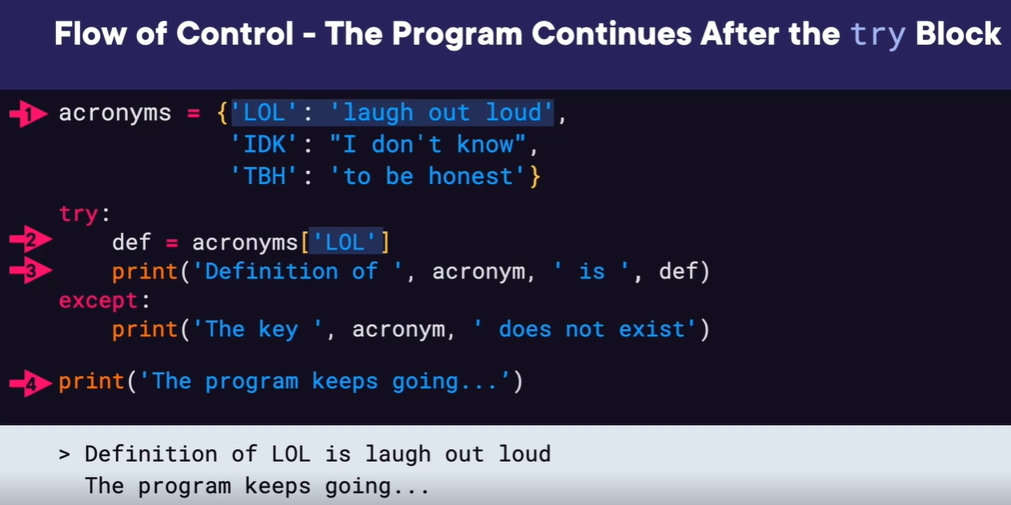
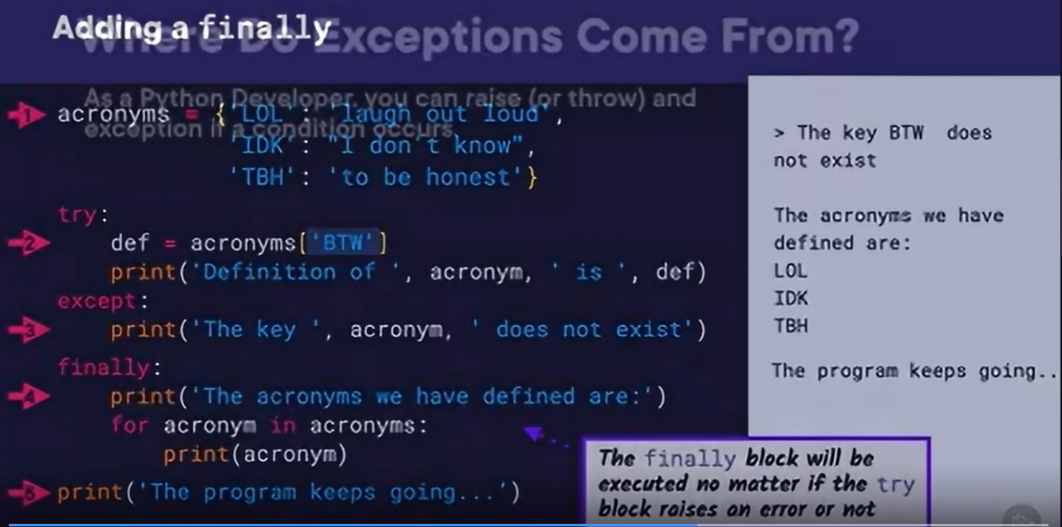
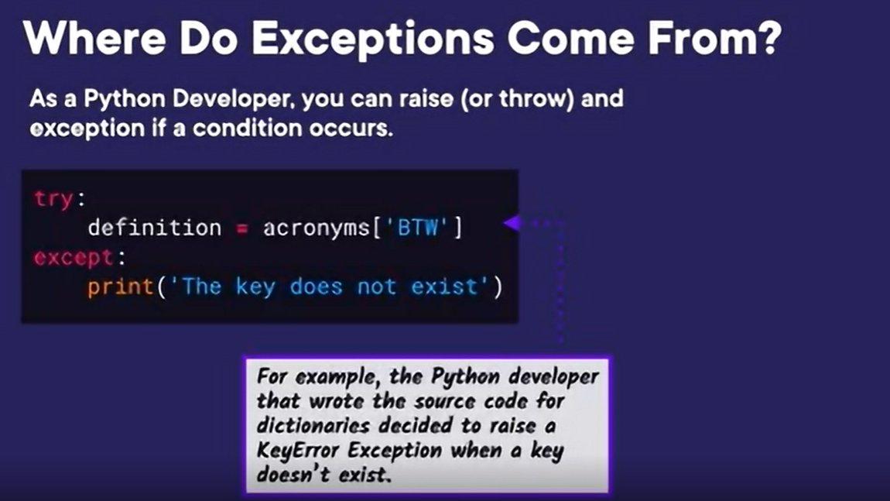
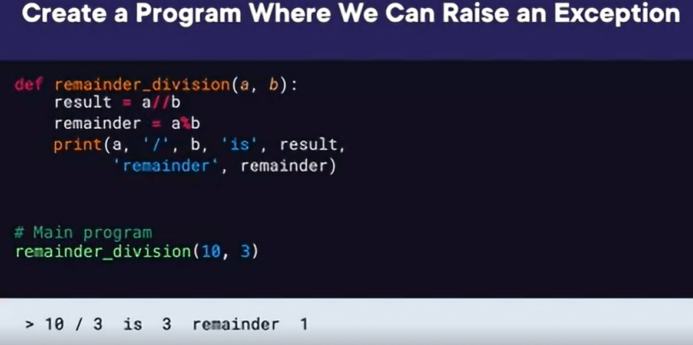
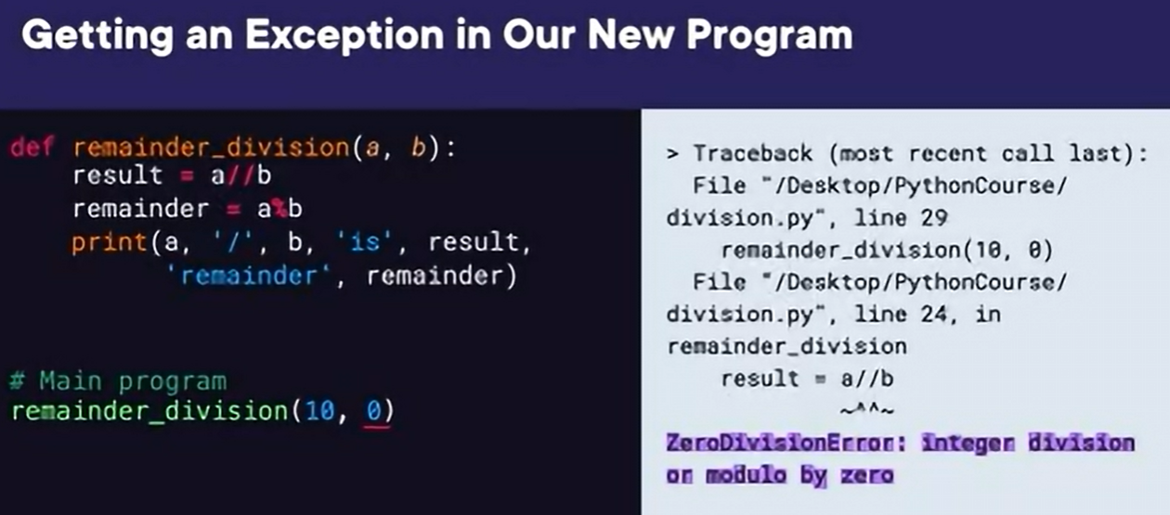

READING A FILE
Welcome back.
In this video, we're going to look at reading and writing files.
Since we're studying software engineering,
we've been keeping track of all the acronyms that we've come across
so far, since there are so many. We have those acronyms along with
their definition stored in a text file.
Now we want to create a program that allows a user to enter
an acronym they want to look up, and it'll print the
definition. Here the user enters FIFO,
then our program opens our file and searches for FIFO, and when it finds it,
it prints the definition, First In First Out. Then if the user enters a typo,
the program prints acronym not found.
So if we roughly list out the steps we need for our program, we
have number 1) ask the user to input an acronym,
2) open the file for reading,
3) loop over each line of the file, 4) check if the
current acronym matches the user's acronym,
and finally, print out the definition.
Since we know how to get input, let's skip to step 2 and look at how to
open a file. But before we can read and write to files, we need to be
able to tell our program where our file is located. We may know that
our file is located on the desktop, but what is the path we should use
to get to the desktop.
If you look at Finder or File Explorer,
you can see the full path to the file is Users/sarah/Desktop,
and then input.txt,
and we use forward slashes in Python to write out the full path.
If we look at the file path as a diagram,
we can see the root directory at the top, and then Users/sarah/Desktop,
and then finally,
our file. If the file path starts at the root like this one, then it's an
absolute path. On Windows, the absolute path will look slightly different,
with the root directory containing C:/, which points to the current drive.
If our program is in the same directory as the file we want to access, which
is input.txt in this example, then we can use a relative path.
Since the program and the input file are in the same path,
then we just refer to the file by its name, input.txt,
without the rest of the path.
We can also use relative paths to navigate to a file inside a folder.
Here the path from my_program to input.txt just requires going into the folder,
my_files, since it's in the same folder as our program, so the path would be
/my_files/input.txt. Now that we know how to locate our input file, let's
continue working on our program and figure out how to open that file. The
open function returns a file object,
and we can use that file object to read from and write to the file. It's very
important to close a file object once it's been open, so we want to set up
the code to do that when we open the file. Python has a special way of
opening files using the with keyword that will make sure the file is closed
when all of the file operations are finished, even if an exception is raised.
The longer way of closing a file is using a try/finally block where the file
operations are in the try block and then the file is closed in the finally
block by calling file.close. Using the with keyword is just a shortcut for
doing the same thing and making sure our file is closed.
Now that we know how to open and close a file, let's look at the
different ways to read from a file. The read method returns the
whole file as a string by default,
or it will return the specified number of bytes. So if we run this, we
can see the whole file is printed to the screen. The readline method
returns the next line of the file as a string. Readlines returns a list
of strings containing all of the lines in the file. We can then loop
over this list and print each line. Since this type of loop is used so
often, there's a shortcut; we can instead just loop over the File
Object.
Now we know how to do everything in our program. We can open
the file, read each line of the file, and check if the user's
input matches the current acronym.
Putting this all together, we'll first ask the user what acronym they want to
look up. Then we'll open the file using the with keyword.
Once the file is open,
we can loop over each line in the file using for line in file. Then we
need to check if the acronym the user is looking for is in the current
line. We can check if a string is a substring of another string by
simply using the in keyword. We can come back to this later and make
this matching more strict.
Finally, if there's a match,
we'll print the current line of the file which contains the definition.
If we run what we have so far,
we can see it successfully finds FIFO and prints the
definition. We want to add a couple more features to our
program. First, after we print the definition,
we can stop looking and break out of our for loop. Second, we want to
print a message if we can't find the acronym, so we're going to create a
Boolean variable called found, and set it equal to False. Then inside
the loop, if we find the acronym, we'll set found to True.
Finally, we can check if not found, then print the acronym doesn't exist.
In the next demo, let's take our program and add on to it so a user can write their own acronyms to the file.
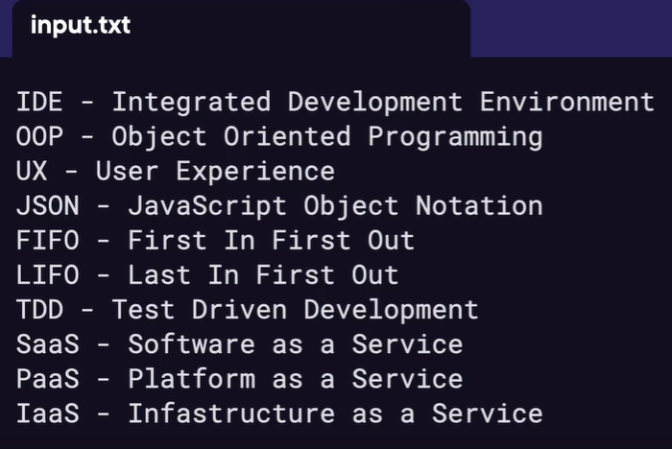
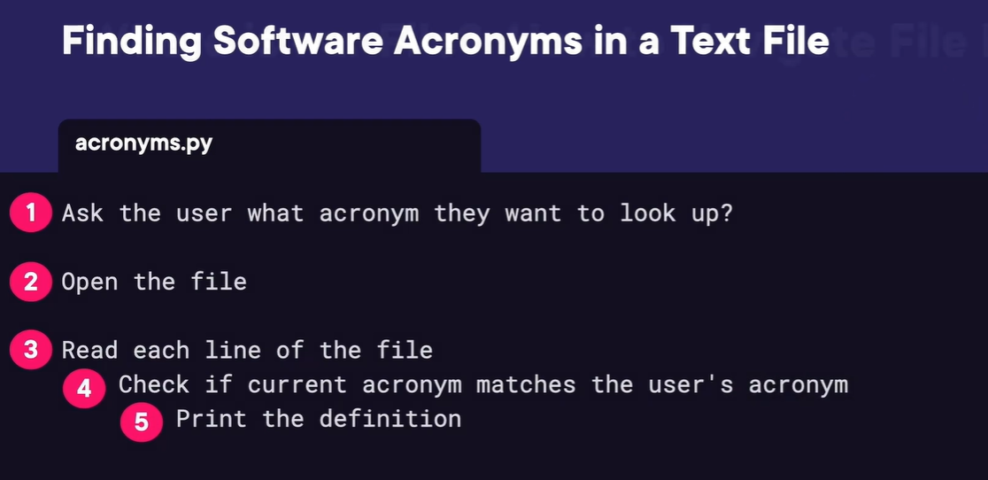

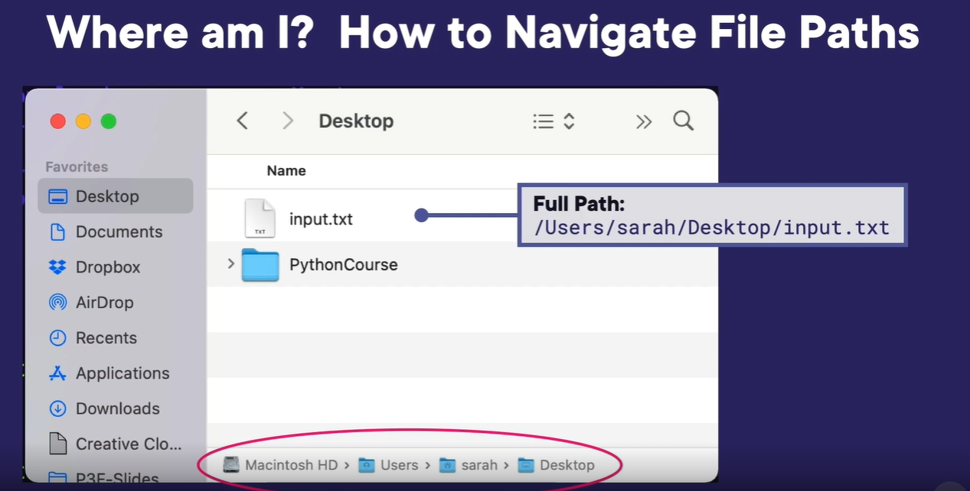
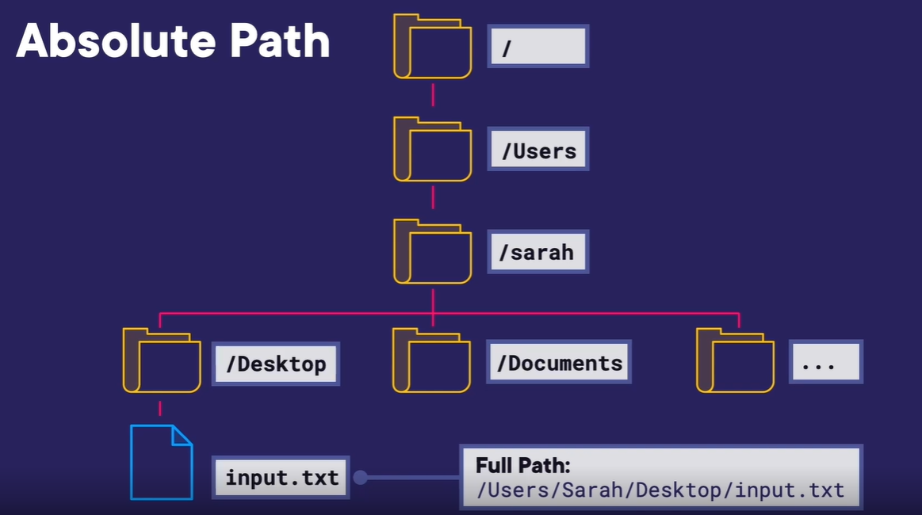
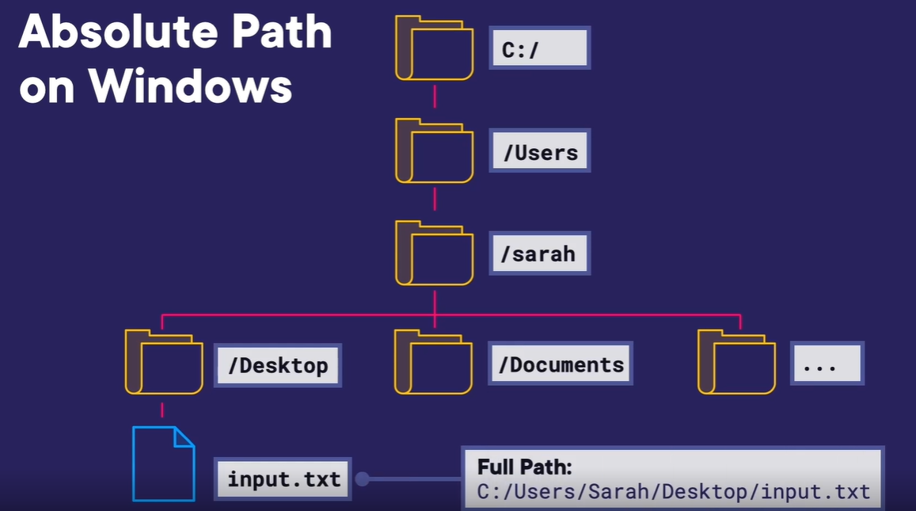
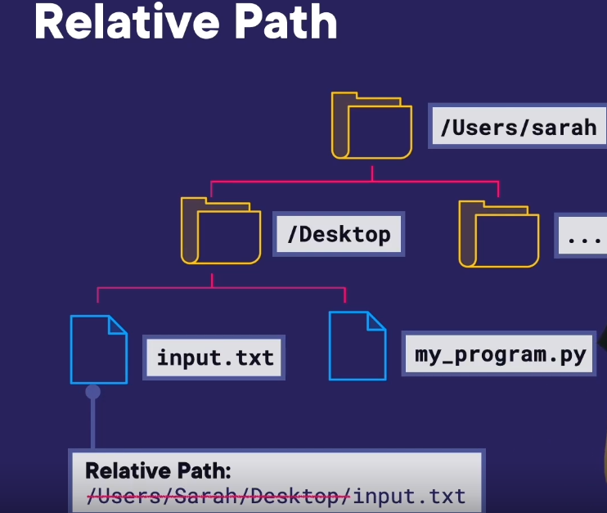
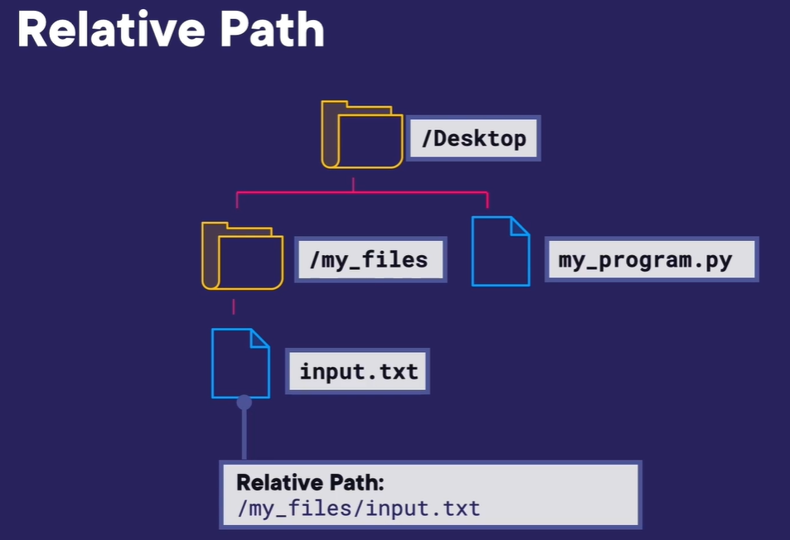
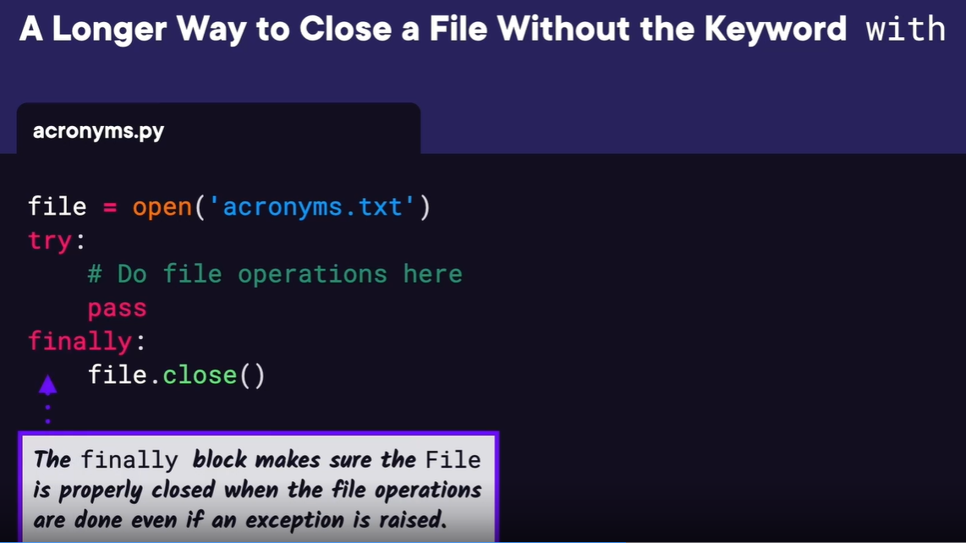
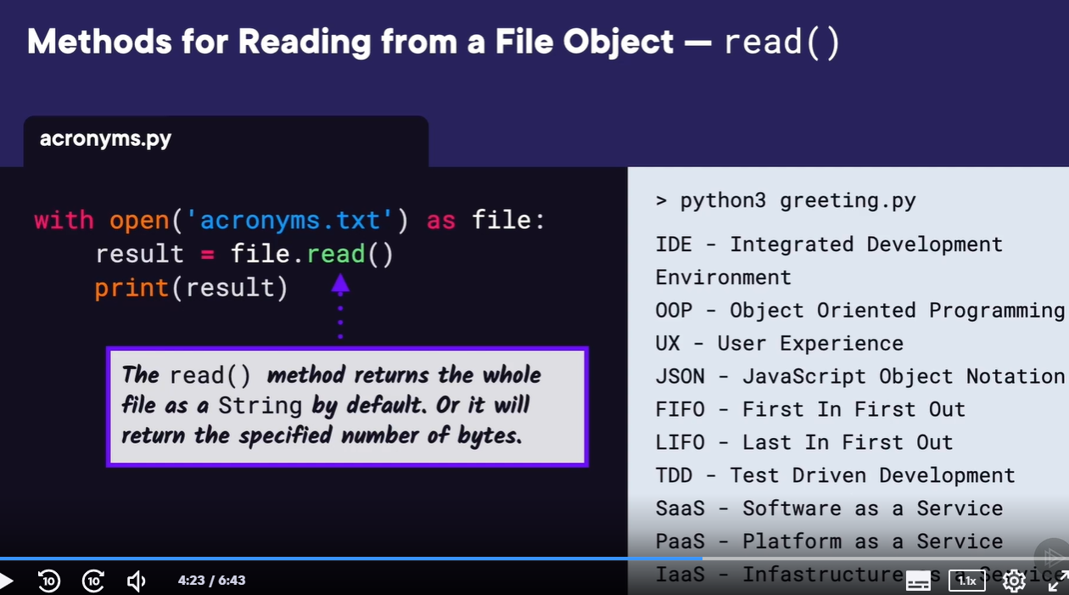
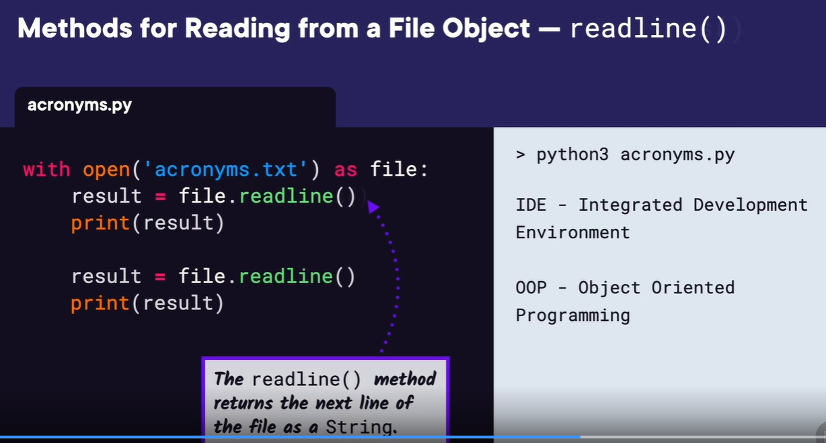
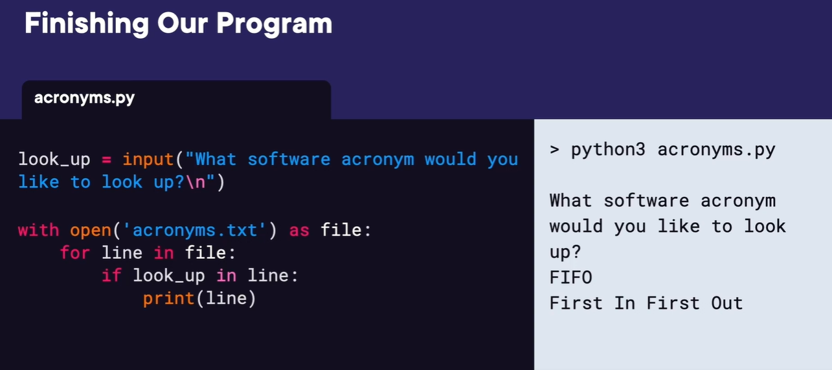
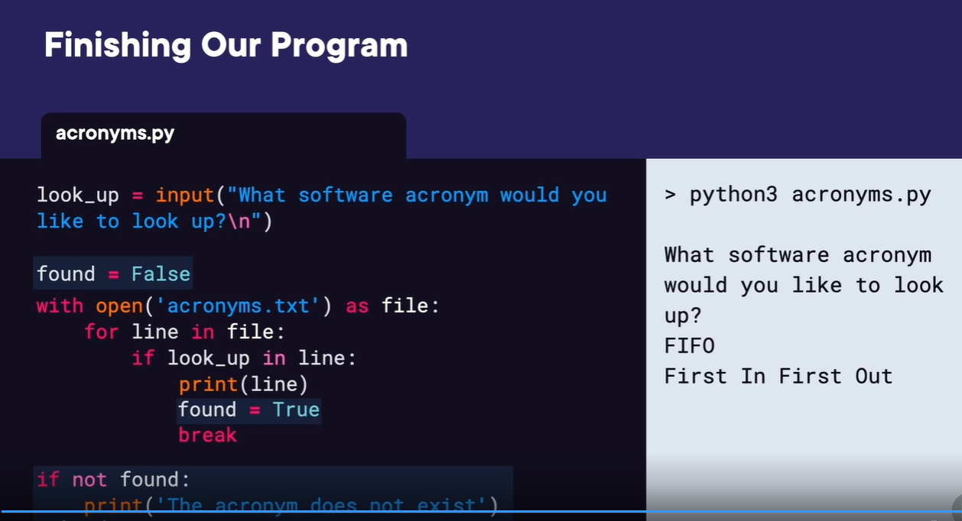

Welcome back.
In this video, we're going to look at working with files in Python.
Python has a few built-in modules for handling files, os, shutil, and pathlib.
We're going to show how to use some of the functionality
in the os module with an example program that requires
listing contents of a directory, making new directories,
moving files, and getting file attributes.
Let's say we currently have a mess of files in the Desktop folder,
and we want to clean them up by moving those files to a new
folder called CleanedUp on the desktop.
If we roughly list out the steps we'll need to create this program,
we first have create the folder CleanedUp,
then list all the files in the Desktop folder,
loop over those files, and then move each file to the new CleanedUp folder.
Before we start working on our program,
let's first look at how to do some of these file operations in general.
We can use the os module,
which provides some functionality to interact with our
operating system to make directories, list files,
and move files.
So we'll start by importing os.
Then we can make a new folder called CleanedUp by calling os.mkdir,
short for make directory,
and we'll pass in the absolute or full path to our new directory,
which is /Users/sarah/Desktop/CleanedUp.
If we want to list all of the entries in a directory,
entries meaning files and folders,
we can use the os.scandir function and pass in the
path that we want information about.
This returns an iterator or pointer to a list of file objects.
We can loop over this list to print all of the entry names.
And if we run this, we can see all of the files and directories printed.
Let's also edit our print statement to check if the
entry is a file or a directory.
We'll call os.path.isfile with our entry.
Then if true, we'll print File:, then the entry.name.
Otherwise, we can check if os.path.isdir,
short for is directory,
and if true, will print Directory and then the entry.name.
Let's run this and see what we get.
We can see we only had one directory, PythonCourse, and the rest are files.
We can use the function os.path.join to create an absolute
path from a path string and a file name.
You may be wondering why we don't just use string
concatenation to create our absolute path,
and the reason is that the join function can add any missing
slashes or get rid of any extra for us.
Here we want to move the new.txt file from the desktop to the CleanedUp folder.
We're going to use os.path.join to create a path for the original location
of the file on the desktop and for the destination path.
Then using the os.rename function allows us to rename a file,
but it also allows us to move a file from the
original location to a new destination.
Let's revisit the steps we need to create our program.
First, we have create the CleanedUp folder.
Then we have list all the files on the desktop,
loop over each of those files, and then move each file to the CleanedUp folder.
Now that we know how to do each of these things using the os module,
let's get started.
Let's start by creating variables for where we're moving our files from and to.
Then we'll create the new CleanedUp directory using os.mkdir.
In order to loop over all of the entries on the desktop,
let's list the entries in the Desktop folder.
Now we can edit that line of code to combine listing
the entries with the for loop.
In order to move the files, we need to create the paths first.
So we'll create location_original and location_destination using os.path.join.
Finally, we can move the files using os.rename.
Let's also check that we're only moving files, not directories.
So we'll add an if statement to check os.path.isfile for location_original.
Let's run this and look at our program in action.
We can currently see our Desktop folder has one folder
named PythonCourse and five files.
Let's run our program.
And we can see now we have just two folders on the desktop,
and our new CleanedUp folder has all of our files moved inside of it. Next in the demo, let's add some features to our file cleanup program.


